PEOPLE FOR JESUS MINISTRY,
P.O. BOX 1008,
Narok, 20500, KENYA,
EAST AFRICA
TEL: 254-721-204447 OR 254-736-574413
E-mail: peopleforjesusintmin@gmail.com

YOUR REF: ________ OUR REF: NRK/UP.3/2016 DATE: 30TH SEPTEMBER 2016

Dear Saints, Friends, well-wishers, and Partners,

GREAT IS THE LORD AND GREATLY TO BE PRAISED FOR USING US AS HIS VESSELS.
Receive warm and blessed greetings from People For Jesus Ministry (PFJM) family. We are busy as always with preaching the gospel of the Kingdom of God in different places and in many diverse acts of demonstrating Christian love. The Church has been very busy with activities such as regular Church daily, weekly and monthly programmes and projects for poor/needy communities. The Church Missions Emphasis month was held in May, June and August 2016.

JULY 2016
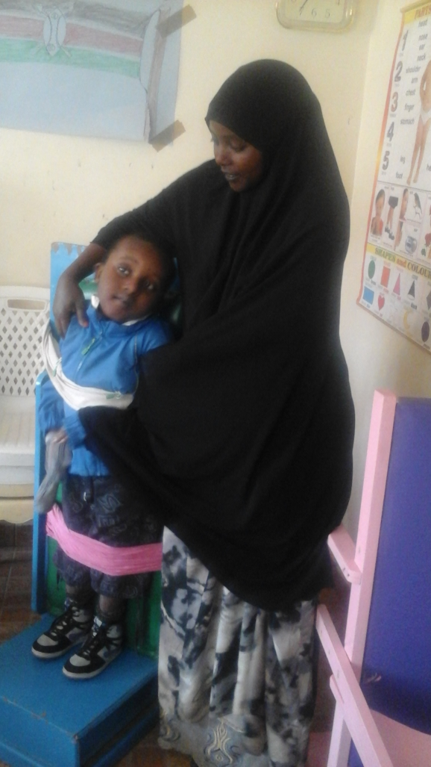
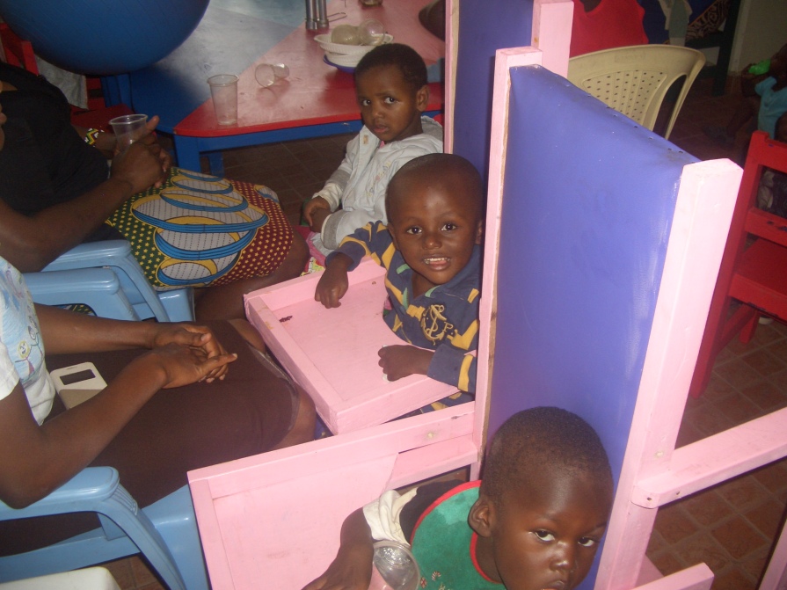

PHOTOS ABOVE:JULY 2016: LEFT; MUSLIM WOMAN DEMONSTRATING HOW OUR CHURCH DISABLED CENTRE IN NAIROBI KAYOLE USED TO TIE HER DISABLED CHILD TO STAND UP BEFORE NEW EQUIPMENT ON THE RIGHT HAND SIDE PHOTOS WERE PURCHASED BY THE CHURCH IN JULY 2016 WITH SUPPORT FFOM CHURCH PARTNERS.

The Church is keen on supporting needy orphans, widows/widowers, the poor(destitutes) and vulnerable children. Every God-given opportunity available to the Church for such acts of love is always utilized well as an aspect of the proclamation of the gospel of Jesus Christ for the glory of God. THE CHURCH DISABLED (MENTALLY AND PHYSICALLY CHALLENGED) PROJECT CENTRE IS DOING WELL IN NAIROBI. THE CENTRE IS NOW KNOWN AS HEKALU DISABLED SUPPORT CENTRE. DONATIONS FROM OUR PARTNERS ENABLED US TO BUY ITEMS/EQUIPMENT AT THE CENTRE IN NAIROBI AT KAYOLE. OUR BRANCH CHURCH IN NAIROBI AT KAYOLE IS DOING A GOOD WORK AT THE HEKALU DISABLED SUPPORT CENTRE. WE WANT TO BUY LAND TO BUILD A REHABILITATION, SCHOOL AND TRAINING CENTRE COMPLEX FOR THE DISABLED PEOPLE. CURRENTLY, WE NEED WHEEL CHAIRS AND SUPPORT FOR CURRENT AND MORE TEACHERS. WE TAHNK OUR GOOD PARTNERS FOR STANDING WITH US BY THE SUPPORT YOU HAVE GIVEN TO US IN THIS PROJECT.

AUGUST 2016
PFJM MISSIONS EMPHASIS MONTH: 3RD AUGUST—9TH 2016
The PFJM Church believes in obeying the Great Commission of the Lord Jesus Christ by preaching the gospel to every tribe, every language, every nation and every kindred. We mobilize different Christians from different parts of the world to participate in our one-month annual missions emphasis activities. This year, 2016, we held the Missions Emphasis month from 20th May to 10th June 2016 and on August 3rd through to 9th August. We expose Christians from all walks of life from different parts of the world to many different aspects of missions, outreach and preaching opportunities. In the year 2016, we have had teams from different parts of Kenya, Scotland and Northern Ireland. The short term missions/outreach programme is under the PFJM Missions/Outreach Council.

In the year 2016, we exposed the participants to three regions in Kenya namely Nairobi County, Narok County and Kisumu County. The 2016 Missions Emphasis participants were involved in many areas of ministry such as Church pastors/elders and leaders training seminars, Jesus Film show, Church revival meetings, children ministries, pulpit preaching, rural (village) and town evangelistic gospel preaching, new Church plant, support for the poor and the sick, construction of school latrine facilities, supply of school resources such as laptops, printer, balls, etc, treatment of livestock and supply of high quality veterinary medicine, teaching in school, helping the old people in society, support orphans and widows, orphanages plus many other activities.

ADULT/LITERACY EDUCATION: THE MAASAI VILLAGE ADULT/LITERACY CLASS IS GOING ON. 85% OF THE CLASS ARE WOMEN AND GIRLS. THE PROBLEM OF EARLY MARRIAGES AMONG THE MAASAI GIRLS NECESSITATES THAT THEY DROP OUT OF SCHOOL OR NEVER MAKE IT TO SCHOOL SO THAT THEY GET MARRIED AND EARN THEIR FAMILY A WEALTH OF MANY COWS PAID AS DOWRY. THE CHURCH IS ADDRESSING THAT EDUCATION GAP BY CONDUCTING CLASSES FOR THOSE WHO HAVE EITHER DROPPED OUT OF SCHOOL OR THOSE WHO NEVER MADE IT TO ANY SCHOOL. THANKS TO THOSE WHO HAVE BEEN ABLE TO SUPPORT US. PLEASE JOIN US IN THIS ENDEAVOUR AT USD$60 OR £50 PER MONTH PER CLASS.

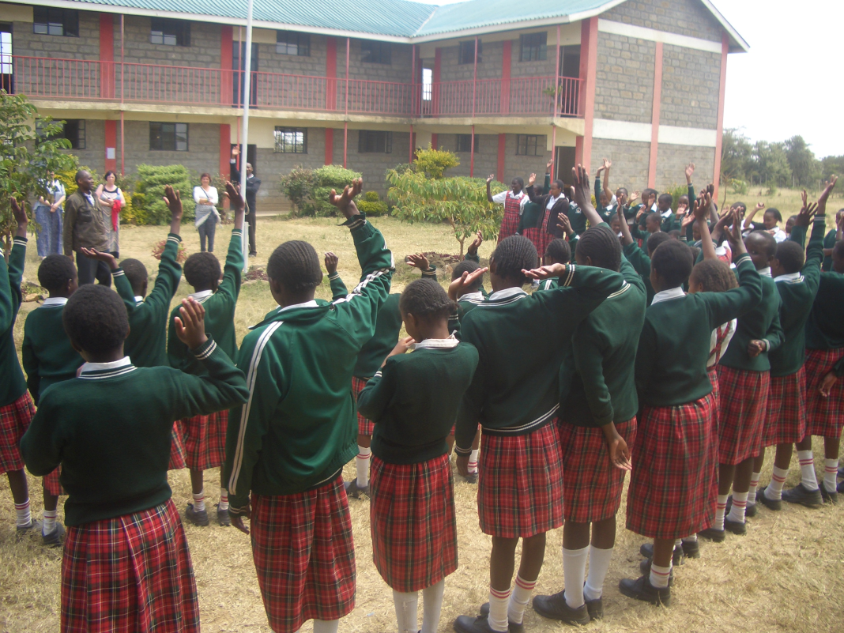

PHOTO ABOVE : PASTOR TOM PREACHING AT A PRIMARY SCHOOL FOR RESCUING MAASAI GIRL CHILD FROM EARLY MARRIAGES DURING MISSIONS EMPHASIS AUGUST 2016 AT NAROK KENYA.

NAROK TOWN CHURCH LAND AND SANCTUARY
NAROK TOWN CHURCH IS STILL SEEKING FOR SUPPORT FOR THE PURCHASE OF LAND AND THE CONSTRUCTION OF A CHURCH SANCTUARY. PLEASE KEEP US IN PRAYERS SO THAT WE RAISE US$35,000 FOR THE CHURCH BUILDING PROJECT. CHURCH MEMBERS HERE IN NAROK KENYA CONTINUE TO CONDUCT SOME FUNDSDRIVES. CURRENTLY, THE LAND THAT WE WANT TO BUY COSTS £12,000. THE CHURCH HAS RAISED SOME FUNDS AND WE NOW NEED £5000 SO THAT WE BUY CHURCH LAND. ONCE WE GET THAT AMOUNT, WE WILL BUY THE LAND IN THE PHOTO IMMEDIATELY. IT IS HALF ACRE PIECE OF LAND IN NAROK TOWN AREA.
PLEASE JOIN US IN RAISING THE FUNDS.

WE WANT TO CONSTRUCT THE PFJM HEADQUARTERS CHURCH, PRAYER CENTRE, BIBLE TRAINING CENTRE AND COMMUNITY DEVELOPMENT OFFICES FOR EMPOWERING AND SUPPORTING NEEDY/POOR COMMUNITIES IN KENYA, AFRICA AND AROUND THE WORLD.

PEOPLE FOR JESUS MINISTRY MISSION/OUTREACH TEAM COUNCIL
People For Jesus Ministry has a mission team or Mission Council that plans and implements local, regional and international missions programmes. That includes crusades, church planting, prayers and intercessory prayers, community evangelistic Outreach programmes and projects. The team mobilizes, recruits, sends and support long-term and short-term missionaries and teams to different parts of the world. The Mission Team also hosts volunteer missionaries from every part of the world. The Mission Council meets every month to pray, plan and implement Church mission/outreach programmes. Please contact us for details on how you can participate.

26th August 2016: We had a powerful women seminar at Narok town Church. Pastor Tom plus other invited guest speakers conducted the meeting.

21ST AUGUST 2016: Was our missions/outreach giving day in which the missions/outreach council members traveled to all our branches in Kenya to preach on missions/outreach and to collect funds for Church missions/outreach work. On the same day we opened our newly built Eldoret western Kenya branch which acquired a new plot of land and a new building was constructed on it.

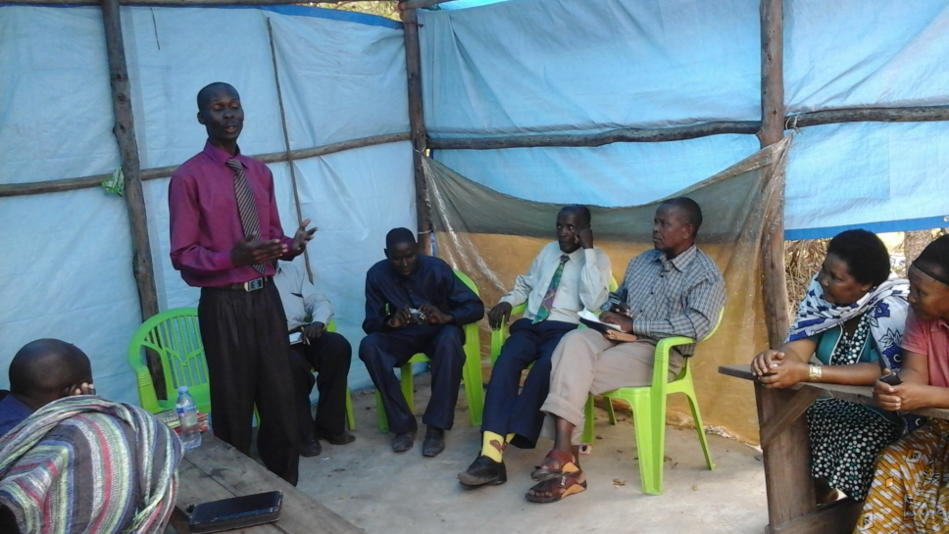

PHOTO ABOVE: Pastor Johnson, missions/outreach Director teaching PFJM Church leaders in Tanzania in August 2016.

ORPHANS/VULNERABLE CHILDREN AND STUDENTS SUPPORT AND SPONSORSHIP:
The Church launched a serious 'school drop outs back to school' campaign programme in February 2014 as an additional project of the Church sponsorship programme. The programme targets pupils/students who dropped out of school for various reasons especially among the Maasai communities in Narok county which has nomadic tendencies of the Maasai community. We also support similar pupils/students outside Narok county but very few. We have thus far managed to support some pupils/students beneficiaries in the programme. Thanks to those who responded to our plea to help school drop outs plus those who have not been able to make it to school to go to school. We have not yet reached out target and many more children who need to go to school are increasing. YOU CAN GIVE AS LITTLE AS £15 PER MONTH OR £180 PER YEAR, US$25 PER MONTH OR US$300 PER YEAR TO ENABLE A STUDENT GO BACK TO GOVERNMENT DAY SECONDARY SCHOOL. About half of the funds is used for the purchase of school uniforms. You can also help a child go back to primary school by giving US$100 per year.

SEPTEMBER 2016

6TH THROUGH TO 9TH SEPTEMBER 2016: WE HAD A POWERFUL CHURCH LEADERSHIP CONFERENCE IN KISUMU CITY CONDUCTED BY OUR PARTNERS COVENANT OF PEACE INTERNATIONAL FELLOWSHIP. WE ALSO CONDUCTED A BIG OPEN AIR PREACHING IN KISUMU CITY WHICH IS NEXT TO LAKE VICTORIA.

SOME OF THE YEAR 2016 P.F.J.M PLANS

>>> Missions/Outreach Council: Church plants in Kenya at Eldoret and Ngong' in Kenya. Church plant in Pakistan in October 2016. Church planting survey in Liberia, and Uganda. Church plant visits in Kenya in Nyamkebe, Nyakach, Eldoret, and Nairobi.
>>> Adult/Literacy education classes among the Maasai community of Narok Kenya.
>>>Funds-drives for the Narok town Church purchase of land and building of Church Sanctuary.
>>> Supply computers and begin computer learning classes at PFJM Narok town Church.
>>> Education sponsorship programmes. Support programmes for poor and needy people/communities.
>>>Visit and support mobilization for disabled/physically challenged children/people in Nairobi Kenya.
>>>Bible school establishment in Kenya and in Dar-Es- Salaam Tanzania
>>>Children Vocational Bible School camp.
>>>Youth camp on 6th to 10th December 2016
>>> Other Youth, women, children, programmes. End year celebration, Big meal celebration, etc.
>>>> Annual Church Leadership Conference at Narok Kenya on 23^{rd—}25th November 2016.
>>> Annual General meeting in PFJM Narok town Church on 26th November 2016.

KANDARIA SECONDARY SCHOOL UPDATES
Kandaria secondary school has just benefitted from a government special intake into the university students who were short by one or two marks to make it into the univesrity. Several students from Kandaria secondary school got government sponsored admissions into private unisersities. One student being sponsored by the Church was a beneficiary though she is struggling to make it because they have to pay for food and acommodation on their own which is a lot of money. They reported to the univesity on 19th September 2016. She is pursuing degree in Education arts.
The school has built three other additional latrines apart from the one they built in May/June 2016. The additional latrines are one for teachers and two for girls. Thanks to the partners who intervened and supported the project.

The school needds two extra classrooms, library books, dining hall dormitory for students and other facilities. Thanks to all who continue to support the school. Laboratory equipment such as microscopes, etc are also needed.

WIDOWS AND THE POOR PEOPLE'S PROJECTS NEED YOUR SUPPORT
PFJM has established a self-help project called ''Cluster Dynamics'' which are designed to pull together groups of 5, 10 or 15 people from within a community group who are mutually in great need. The groups are tasked with developing a micro-project which will generate income for the group in order that they can support themselves and their families.
The groups mainly made up of destitute women, are poor for a number of reasons but mainly due to the tragedy of HIV/AIDS which affects each family in one way or another. Some suffer from the disease themselves, others as a result of losing their husband by HIV/AIDS. The result is that the remaining partner (usually wife and mother) is left to support a number of children. PFJM can help these groups get established by providing one time initial set up grant of £450, 900 and 1350 respectively, allowing them to get going with their project and bring in the much needed income that will grow the project and support the group and their dependants. PFJM will closely monitor the projects to ensure that they are profitable to the groups. You can invest in this worthy course that can profitably change lives of the poor widows and others for a life time. Currently, we have the groups of 5, 10 and 15 ready to move with any support that comes to them. ON 2ND JANUARY 2017, THE SECOND ACTIVE CLUSTER GROUP WILL BE SHARING AN ANNUAL PROFITS. PLEASE HELP THESE POOR PEOPLE TRANSFORM THEIR LIVES BY YOUR ONE TIME SUPPORT.

PASTOR TOM IS TRUSTING GOD FOR THE COMPLETION OF HIS RESIDENTIAL HOUSE WHERE HE CAN LIVE. HE DOES NOT HAVE A PROPER HOUSE FOR HIS FAMILY. HE LIVES IN RENTED HOUSE IN NAROK. HE NEEDS YOUR PRAYERS FOR GOD TO PROVIDE FUNDS AND RESOURCES FOR HIS CLAY BRICK HOUSE TO BE COMPLETED. THE FOUNDATION IS ALREADY DONE AND REMEMBER IT HAS BEEN LIKE THAT FOR THE LAST FOUR YEARS.PLEASE JOIN MY FAMILY IN PRAYERS!!!

PRAYER/PRAISE ITEMS AND
PLANS & HOW TO BE PART OF THIS WORK
The mission work we are involved in is too dynamic and enormous for us to do on our own. We surely appreciate your partnership by prayer, support, and personal involvement.

- Narok Town Headquarters Church Land Purchase and Church Building at a cost of United Kingdom Pounds £22,000 or US$35,000. We thank all who have thus far donated. We have identified a piece of land in Narok town which costs US$15,000. The land is not yet bought due to insufficient funds. We still need more funds.
- Monthly Pastor's Family Support of US$300 (rural areas) or US$480 (urban areas)
- Orphans and Destitute children monthly support £20 or US$35. This year we have many needy children in the programme awaiting support.
- Needy College/University Students support and High School Students support needed.
- New Church Planting Mission in Pakistan at Lahore . Pakistan pastor being trained by PFJM so that he takes over the work. Other Church plants in Africa e.g.. in Ngong', Kitale, Iretet Narok, and Katolo in Kenya, Uganda in Lira,Dar-Es-Saalam and Zanzibar in Tanzania etc.
- We need Church Sanctuary and Primary school buildings in Tanzania Church. School, orphanage, clinic and guest house Building proposals in Narok and in Kisumu areas in Kenya.
- Mission Emphasis Programmes and community development projects in Kenya going on throughout the year.
- Thank God for the successful 2016 May/June Missions Emphasis month programme.
- PFJM Tanzania Church needs prayers: To be officially registered by the Tanzania government. That church needs to build a main sanctuary in Dar-Es-Saalam. GIVE THANKS TO GOD FOR HAVING ENABLED US TO PLANT A CHURCH IN DAR-ES-SALAAM DURING OUR MISSION TRIP THERE ON 23RD TO 30TH AUGUST 2016.
- Thank God for the leadership trainings, Crusades, Revival meetings we have been able to conduct in different parts of Kenya in May, June, August and September 2016.
- Pray for Church Annual General Meeting to be held on 26th November 2016 and the annual Church leadership conference to be held in Narok Kenya on 23rd to 25th November 2016.
- Pray for the Big Meal 2016 events for the needy children feeding and awards programme on Christmas Day. Also pray for the End of Year seminar and end year prayer vigil.

SPECIAL THANKS TO ALL OF YOU FOR YOUR PRAYERS, AND FINANCIAL SUPPORT WHICH ENABLED US TO SUPPORT THE DISABLED CHILDREN IN PFJM KAYOLE CHURCH IN NAIROBI TO HAVE FOOD FOR SEVERAL WEEKS . YOU HAVE ENABLED US TO MEET EDUCATION, MATERIAL, PLUS OTHER NEEDS OF MAASAI COMMUNITIES IN NAROK AND AROUND THE NATION OF KENYA. YOU HAVE ALSO ENABLED US TO PREACH THE TRUE GOSPEL AS WE MAKE DISCIPLES OF CHRIST IN KENYA AND IN OTHER NATIONS.
BECAUSE OF YOUR PRAYERS AND SUPPORT, WE WERE ABLE TO DO WHAT WE DO. WE ASK YOU TO KEEP ON STANDING WITH US FOR THE SAKE OF THE WORK OF GOD'S KINGDOM AND FOR MINISTERING TO POOR/NEEDY COMMUNITIES.

WE CONTINUE TO TRULY VALUE YOUR PARTNERSHIP (PHILIPPIANS 1:5). THANK YOU!!!

