PEOPLE FOR JESUS MINISTRY,
P.O. BOX 1008,
Narok, 20500, KENYA,
EAST AFRICA
TEL: 254-721-204447 OR 254-736-574413
E-mail: peopleforjesusintmin@gmail.com

YOUR REF: ________ OUR REF: NRK/UP.2/2015 DATE: 30TH JUNE 2015

Dear Saints, Friends, well-wishers, and Partners,

Receive blessed greetings from us People For Jesus Ministry (PFJM) family. The work of welcoming people into God's Kingdom continues to grow. Many activities have been going on for regular Church daily, weekly and monthly programmes and projects. Some of the evangelistic activities are enlisted in the updates while many others are not. The Church continues to work in communities with many poor orphans, widows, pupils, students, and people at risk who need our support but we thank God that we are able to help some of them with your partnership.

APRIL 2015
5th APRIL 2015: The Sunday school children ministry of the Narok town Church visited the branch church in the remote Maasai village of Olooltoto. It was a great time of songs and dance. The village Church was encouraged. It was also a day of changing the leadership of that village Church. The village Church is doing well and growing strong in the faith and in numbers.
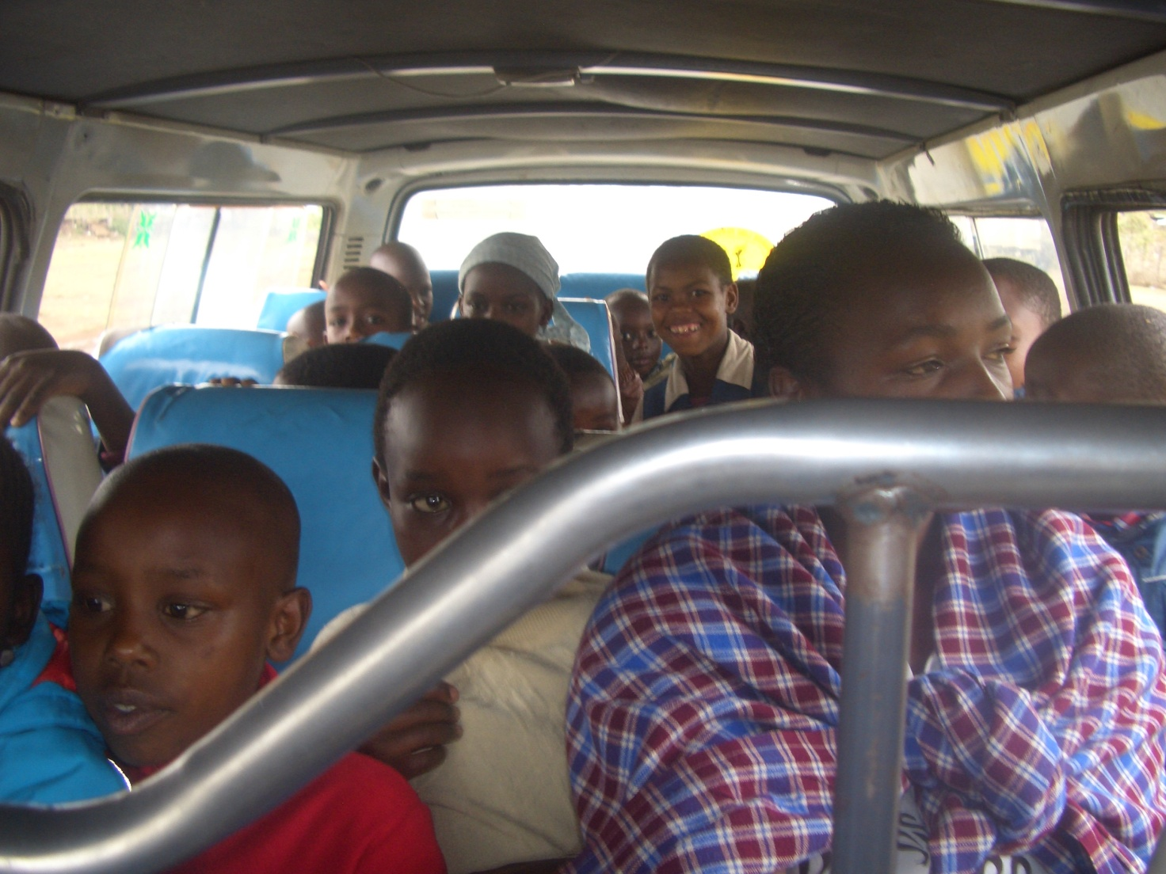
PHOTO ABOVE:Narok town Church Sunday school children travelling to Maasai village branch Church of Olooltoto on 5th April 2015.
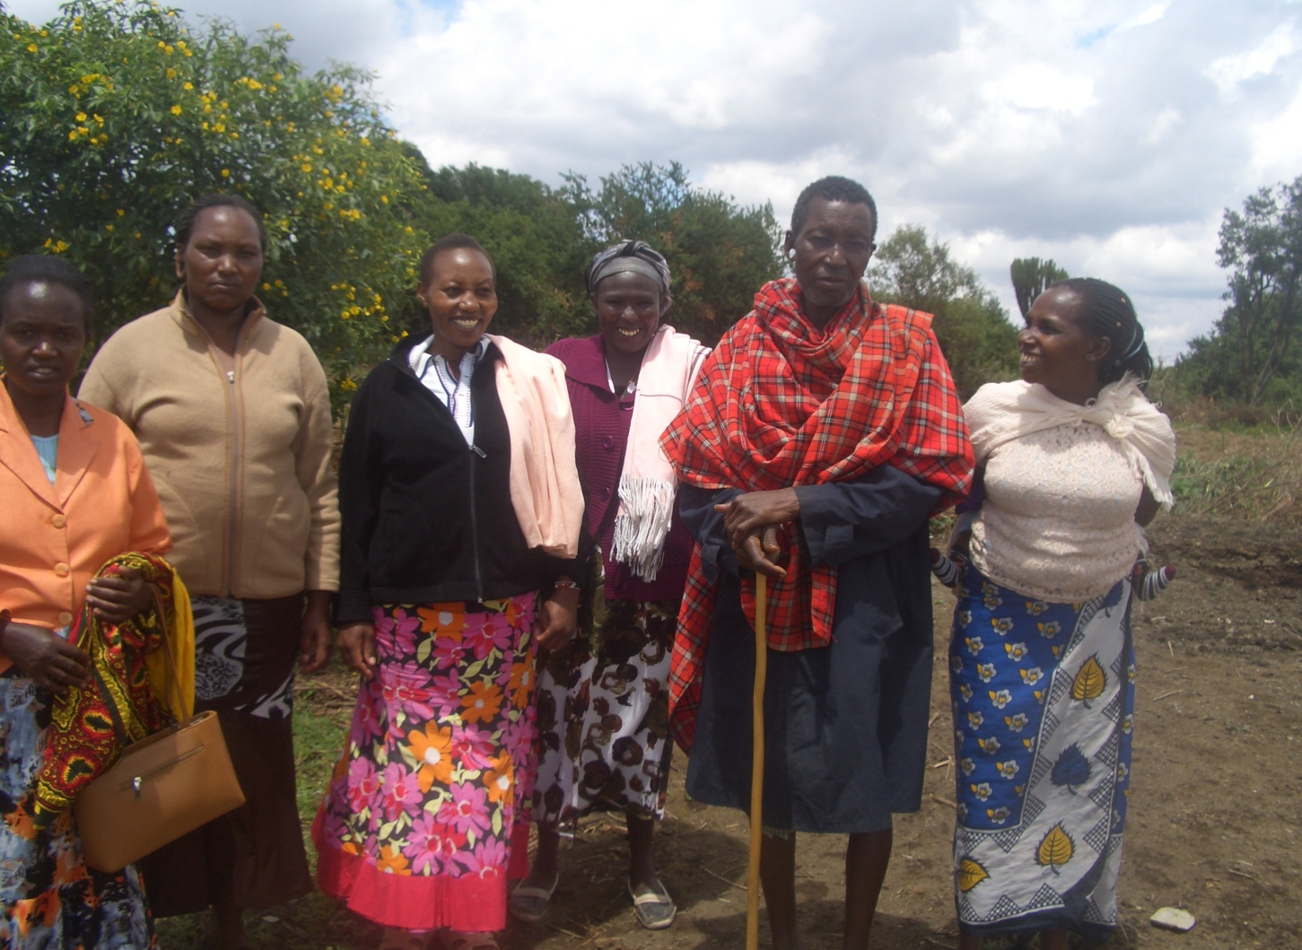
PHOTO ABOVE:The Maasai elder being visited by the Church members on Easter Monday 6th April 2015. It was ELDERLY MEN'S DA Y organized by the Church as an annual outreach programme in Easter. Ten Maasai elderly men were visited in Narok. Other branch Churches also conducted their similar programmes.
ELDORET MISSION/OUTREACH TRIP:24TH, 25TH, 26TH AND 27TH APRIL 2015.
Pst. Tom and Eunice Naserian, who are members of Church missions/outreach council were sent to western Kenya area of Eldoret for a follow-up programme of the branch Church over there. Leadership training, revival meetings, prayer meetings, evangelistic outreach plus other activities were conducted.
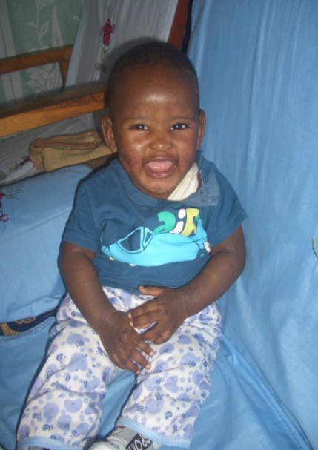
PHOTO ABOVE: JOSHUA HUGH. GROWING STEADY THOUGH HAS FACED HEALTH CHALLENGES
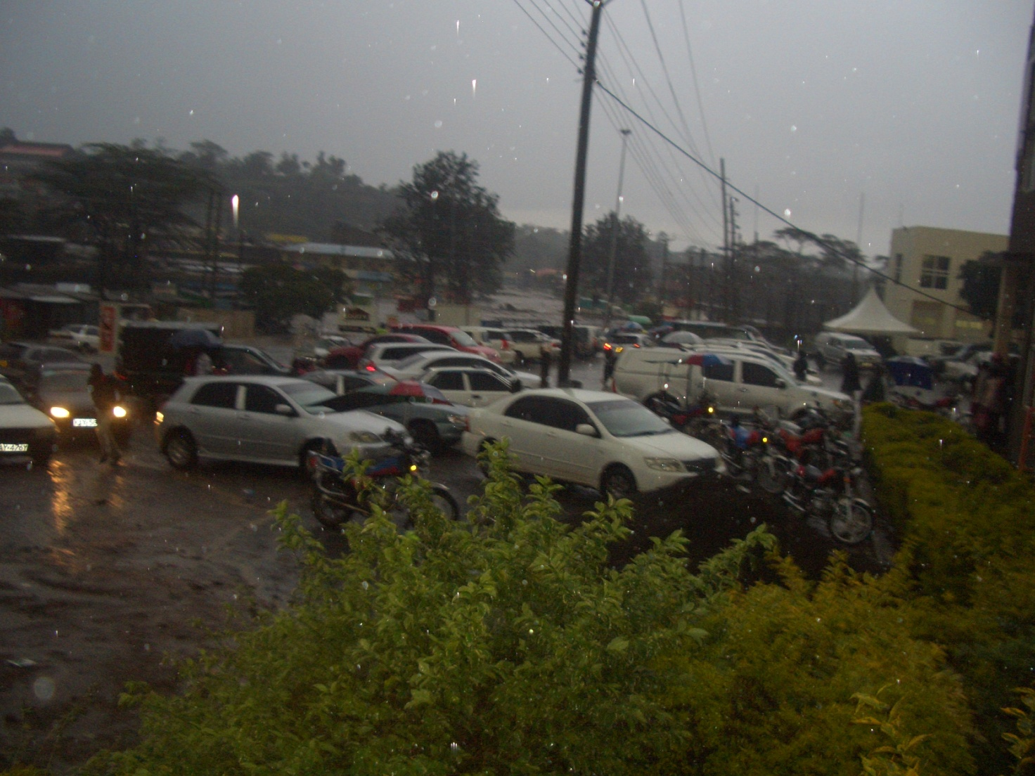
PHOTO ABOVE: The vehicles brought to higher grounds as floods devastated Narok town in Kenya in Late April and early May. About 50 people lost their lives and property of unknown value destroyed.

MAY 2015

KANDARIA MIXED SECONDARY SCHOOL UPDATES
Kandaria secondary school now has temporary teacher's residential houses. The temporary houses have been built using iron sheets and timber 2015. In May 2015, Kandaria Secondary school emerged the best in academic performance at the top of 20 secondary schools in Kadibo division of Kisumu East district in Kenya. A joint examination test was conducted in Kadibo division in May. The school now has science laboratory. More classrooms/laptops and laboratory equipment needed at the school. The school also needs volunteer teachers. WE APPRECIATE OUR PARTNERS WHO HAVE BEEN SUPPORTING THE SCHOOL.
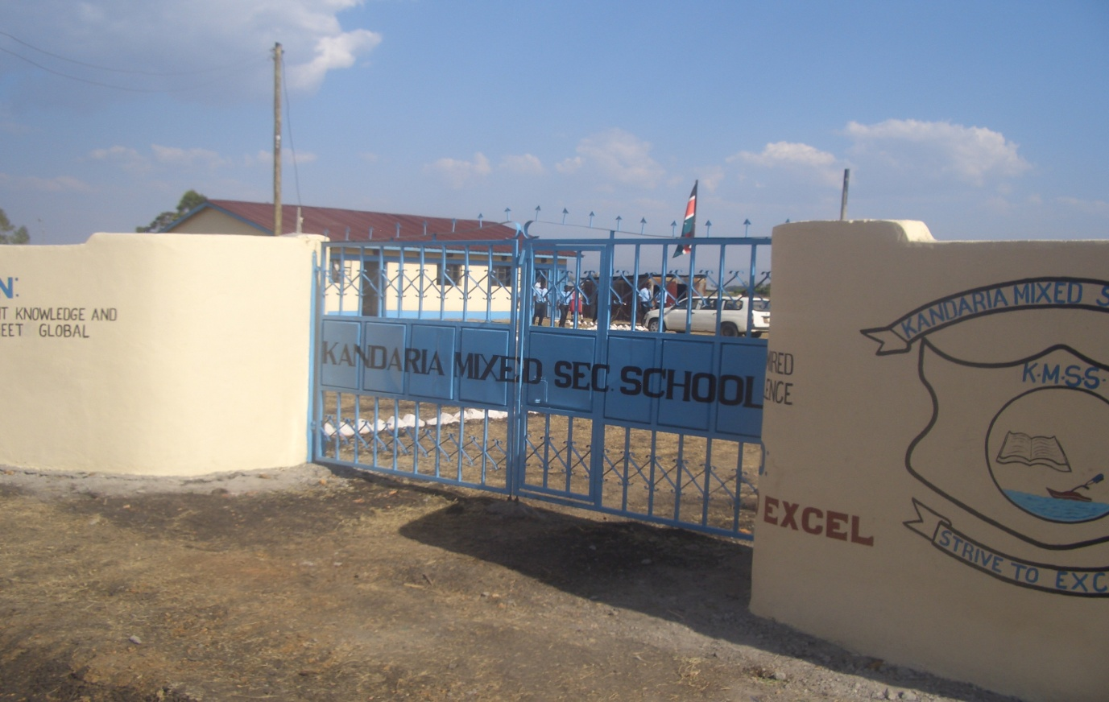
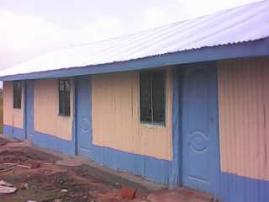

PHOTO ABOVE: KANDARIA SECONDARY SCHOOL TEACHERS' NEW TEMPORARY RESIDENCE BUILT WITH THE HELP OF PARTNERS.

NAROK TOWN CHURCH LAND AND SANCTUARY
NAROK TOWN CHURCH IS STILL SEEKING FOR SUPPORT FOR THE PURCHASE OF LAND AND THE CONSTRUCTION OF A CHURCH SANCTUARY. PLEASE KEEP US IN PRAYERS SO THAT WE RAISE US$35,000 FOR THE CHURCH BUILDING PROJECT. CHURCH MEMBERS HERE IN NAROK KENYA CONTINUE TO CONDUCT SOME FUNDSDRIVES.

PEOPLE FOR JESUS MINISTRY MISSION/OUTREACH TEAM COUNCIL
People For Jesus Ministry has a mission team or Mission Council that plans and implements local, regional and international missions programmes. That includes crusades, church planting, prayers and intercessory prayers, community evangelistic Outreach programmes and projects. The team also mobilizes, recruits, sends and support long-term and short-term missionaries and teams to different parts of the world. The Mission Team also hosts volunteer missionaries from every part of the world. The Mission Council meets every month to pray, plan and implement Church mission programmes. Please contact us for details on how you can participate.

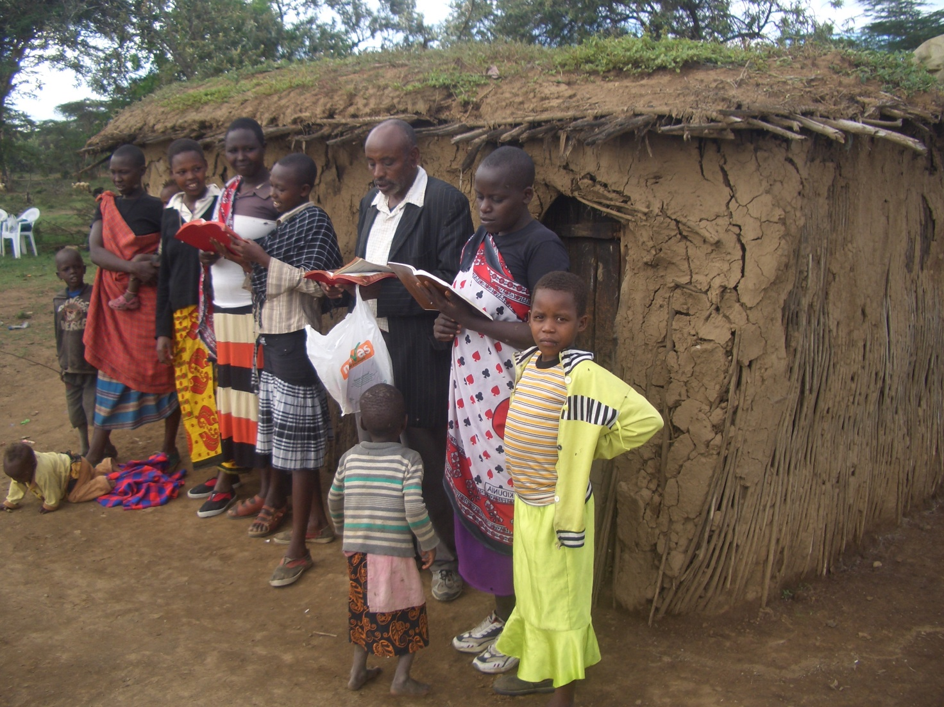
PHOTO ABOVE: A MIDWEEK CHURCH FELLOWSHIP AT THE MAASAI VILLAGE CHURCH OF OLOOLTOTO IN NAROK KENYA

ORPHANS/VULNERABLE CHILDREN AND STUDENTS SUPPORT AND SPONSORSHIP:
The Church launched a serious 'school drop outs back to school' campaign programme in February 2014 as part of the Church sponsorship programme. The programme is targeting pupils/students who dropped out of school for various reasons especially among the Maasai communities in Narok county. We have thus far managed to have support some pupils/students beneficiaries in the programme. Thanks to those who responded to our plea to help school drop outs plus those who have not been able to make it to school to go to school. We have not yet reached out target and many more children who need to go to school are increasing. YOU CAN GIVE AS LITTLE AS £15 PER MONTH OR £180 PER YEAR, US$25 PER MONTH OR US$300 PER YEAR TO ENABLE A STUDENT GO BACK TO GOVERNMENT DAY SECONDARY SCHOOL. About half of the funds is used for the purchase of school uniforms. You can also help a child go back to primary school by giving US$100 per year.

ADULT/LITERACY EDUCATION: THE MAASAI VILLAGE ADULT/LITERACY CLASS IS GOING ON. 23 ADULTS AND YOUTH REGISTERED FOR THE CLASS B. 95% ARE WOMEN AND GIRLS. THE PROBLEM OF EARLY MARRIAGES AMONG THE MAASAI GIRLS NECESSITATES THAT THEY DROP OUT OF SCHOOL OR NEVER MAKE IT TO SCHOOL SO THAT THEY GET MARRIED AND EARN THEIR FAMILY A WEALTH OF MANY COWS PAID AS DOWRY. THE CHURCH IS ADDRESSING THAT EDUCATION GAP BY CONDUCTING CLASSES FOR THOSE WHO HAVE EITHER DROPPED OUT OF SCHOOL OR THOSE WHO NEVER MADE IT TO ANY SCHOOL.
JUNE 2015
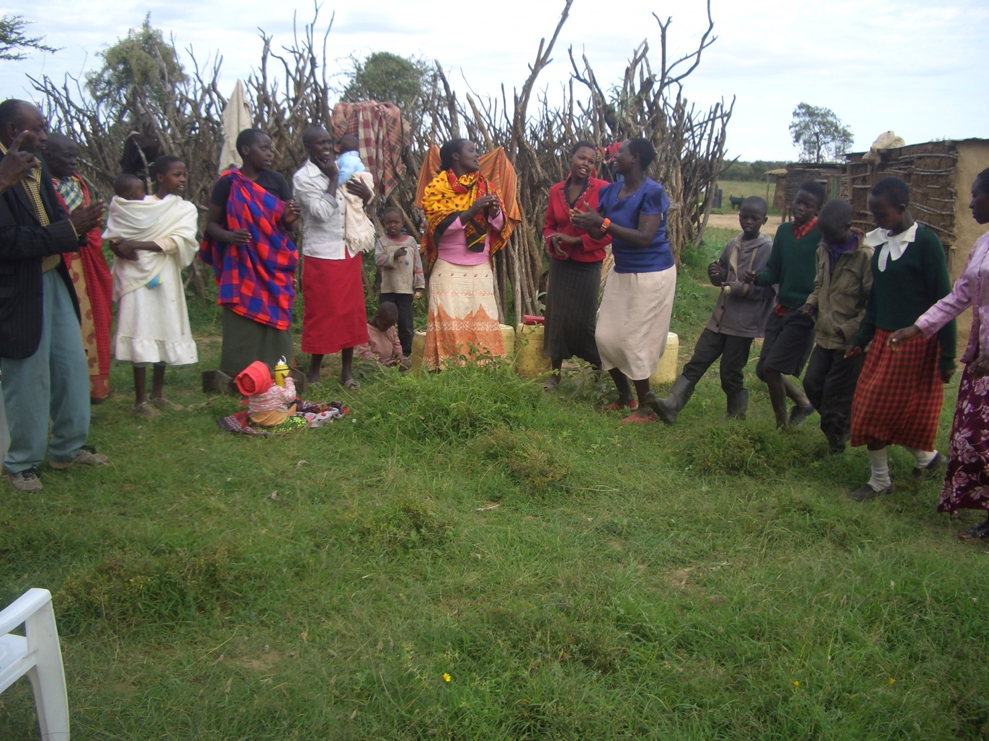
PHOTO ABOVE: WORSHIP SERVICE IN THE MAASAI VILLAGE. IT IS A WONDERFUL EXPRESSION OF THE LOVE OF GOD IN THESE REMOTE VILLAGES.

SPECIAL THANKS TO ALL OF YOU FOR YOUR PRAYERS, SUPPORT AND ACTUAL PERSONAL PARTICIPATION IN THE WORK THAT WE DO. YOU HAVE ENABLED US TO MEET EDUCATION, MATERIAL, PLUS OTHER NEEDS OF MAASAI COMMUNITIES IN NAROK AND AROUND THE NATION OF KENYA. YOU HAVE ALSO ENABLED US TO PREACH THE TRUE GOSPEL AS WE MAKE DISCIPLES OF CHRIST IN KENYA AND IN OTHER NATIONS.

SOME OF THE YEAR 2015 P.F.J.M PLANS
>>> Missions/Outreach Council: Church plants in Kenya at Nyakach, and Ngong'.Church plant in Pakistan in October 2015. Church planting survey in Liberia, and Uganda. Church plant visits in Kenya in Nyamkebe, Nyakach, Eldoret/Kitale, Ongata Rongai, and Nairobi.
Mission trip and graduation of Bible class in PFJM Tanzania in August 2015. Gospel outreaches/evangelistic campaigns in Kenya. Tanzania Church visits Kenya in June 2015.
>>> Adult/Literacy education classes among the Maasai community of Narok Kenya.
>>> Supply computers and begin computer learning classes at the Kandaria secondary school in Kisumu region of Kenya in February 2015.
>>> Education sponsorship programmes. Support programmes for poor and needy people/communities.
>>> Youth, women, children, programmes. End year celebration, Big meal celebration, etc.
>>> Annual General meeting in PFJM Narok town Church on 21st November 2015.

WIDOWS AND THE POOR PEOPLE'S PROJECTS NEED YOUR SUPPORT
PFJM has established a self-help project called ''Cluster Dynamics'' which are designed to pull together groups of 5, 10 or 15 people from within a community group who are mutually in great need. The groups are tasked with developing a micro-project which will generate income for the group in order that they can support themselves and their families.
The groups mainly made up of destitute women, are poor for a number of reasons but mainly due to the tragedy of HIV/AIDS which affects each family in one way or another. Some suffer from the disease themselves, others as a result of losing their husband by HIV/AIDS. The result is that the remaining partner (usually wife and mother) is left to support a number of children. PFJM can help these groups get established by providing one time initial set up grant of £450, 900 and 1350 respectively, allowing them to get going with their project and bring in the much needed income that will grow the project and support the group and their dependants. PFJM will closely monitor the projects to ensure that they are profitable to the groups. You can invest in this worthy course that can profitably change lives of the poor widows and others for a life time. Currently, we have the groups of 5, 10 and 15 ready to move with any support that comes to them. PLEASE HELP THESE POOR PEOPLE TRANSFORM THEIR LIVES BY YOUR ONE TIME SUPPORT.

PRAYER/PRAISE ITEMS AND PLANS & HOW TO BE PART OF THIS WORK
The mission work we are involved in is too dynamic and enormous for us to do on our own. We surely appreciate your partnership by prayer, support, and personal involvement.

- Narok Town Headquarters Church Land Purchase and Church Building at a cost of United Kingdom Pounds £22,000 or US$35,000. We thank all who have thus far donated. We have identified a piece of land in Narok town which costs US$15,000. The land is not yet bought due to insufficient funds. We still need more funds.
- Monthly Pastor's Family Support of US$300 (rural areas) or US$480 (urban areas)
- Orphans and Destitute children monthly support £20 or US$35. This year we have many needy children in the programme awaiting support.
- Needy College/University Students support and High School Students support needed.
- New Church Planting Mission in Pakistan at Lahore . Pakistan pastor being trained by PFJM so that he takes over the work. Other Church plants in Africa e.g.. in Ngong' , Nairobi and Nyakach in Kenya, Uganda in Lira, etc.
- We need Church Sanctuary and Primary school buildings in Tanzania Church. School, orphanage, clinic and guest house Building proposals in Narok and in Kisumu areas in Kenya.
- Mission Emphasis Programmes and community development projects in Kenya going on throughout the year. Church seminars for women, youth and children in August 2015.
- PFJM Tanzania Church needs prayers: To be officially registered by the Tanzania government. Bible school graduation to be held in August 2015. That church needs to build a sanctuary.
- Thanks to God for the mission/outreachh work already done in Nyakach, Eldoret, Nairobi and Narok
- BAPTISM to be conducted in Narok Kenya on 25th July 2015. Seminar and revival meetings in Narok on 24th and 25th July 2015.

WE CONTINUE TO TRULY VALUE YOUR PARTNERSHIP (PHILIPPIANS 1:5). THANK YOU!!!

