PEOPLE FOR JESUS MINISTRY,
P.O. BOX 1008,
Narok, 20500, KENYA,
EAST AFRICA
TEL: 254-721-204447 OR 254-736-574413
E-mail: peopleforjesusintmin@gmail.com

YOUR REF: ________ OUR REF: NRK/UP.1/2016 DATE: 31ST MARCH 2016

Dear Saints, Friends, well-wishers, and Partners,

HAPPY NEW YEAR 2016!!!
Receive new year blessed greetings from us People For Jesus Ministry (PFJM) family. We are busy as always with preaching the gospel of the Kingdom of God in different places and in many diverse acts of demonstrating Christian love. The Church is already busy with activities such as regular Church daily, weekly and monthly programmes and projects. Some of the evangelistic activities are enlisted in the updates while many others are not. The Church continues to work in communities with many poor orphans, widows, pupils, students, and people at risk who need our support but we thank God that we are able to help some of them with your partnership in this work. We trust God that you have began well in the year 2016.

JANUARY 2016
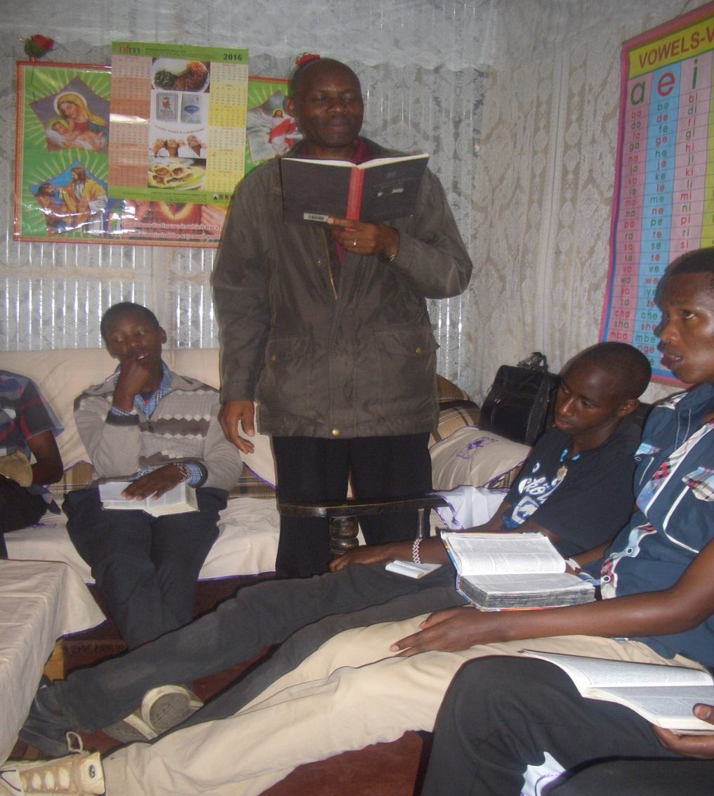
PHOTO ABOVE: PASTOR TOM CONDUCTING A CHURCH TRAINING AT THE BEGINNING OF THE YEAR 2016 AT NAROK KENYA TO EQUIP THE PFJM CHURCH FOR CHRISTIAN SERVICE IN 2016.
PFJM has been busy with leadership and prayer meetings for proper planning of Church programmes. Pastor Tom has been busy with the coordination of PFJM national and international Church activities apart from being the pastor of Narok town Church and Olooltoto Narok village Church on a full time basis. The year began with special trainings to equip the Church members and leaders (PFJM Church departments/ministries) for effective Christian services and work in the year 2016.

FEBRUARY 2016

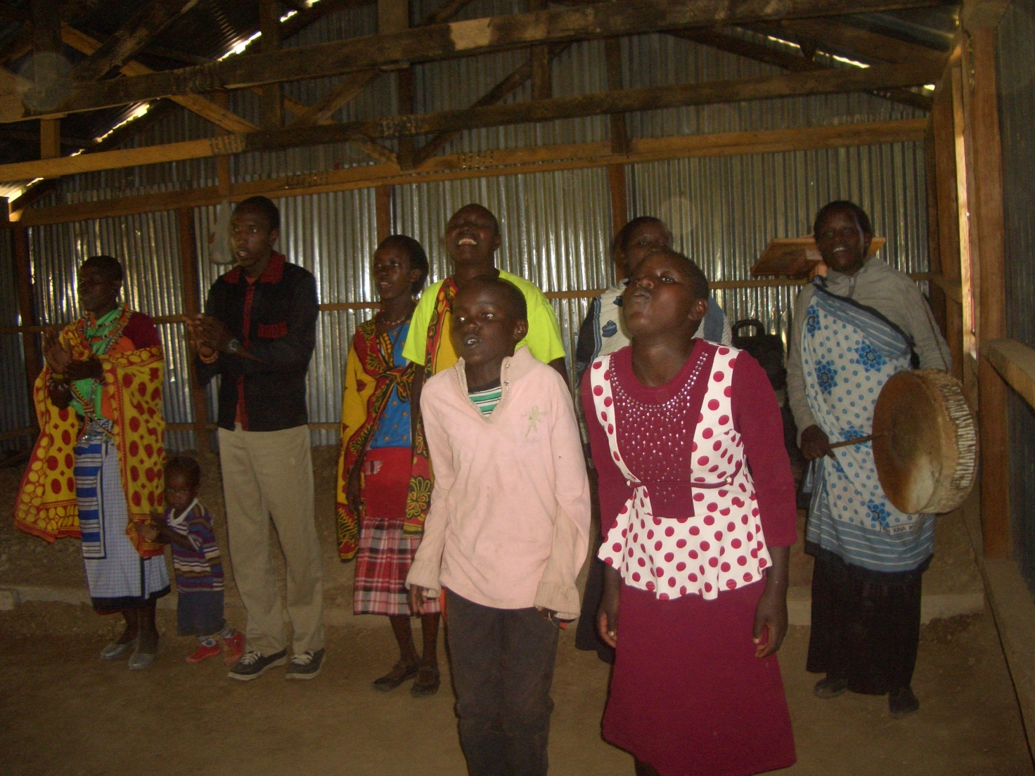
PHOTO ABOVE: PFJM OLOOLTOTO CHURCH CHOIR IN MAASAI VILLAGE OF NAROK KENYA SINGING IN ONE OF THE SUNDAY WORSHIP SERVICES IN FEBRUARY 2016.

KANDARIA SECONDARY SCHOOL UPDATES
Kandaria secondary school took the Kenya government national examinations for the first time in November 2015. The national examinations results were released in late February 2016. The school performed very well to the extent that all the students passed and half of them have qualified to join public and private universities while the rest qualified to join colleges. The school was in position 8 out of 45 secondary schools in Nyando district in Kisumu county.
The school does not have latrines/toilets at this time due to El-nino rains.
The school needs an extra classroom. Thanks to all who continue to support the school. Laboratory equipment such as microscopes, etc are needed.
NAROK TOWN CHURCH LAND AND SANCTUARY
NAROK TOWN CHURCH IS STILL SEEKING FOR SUPPORT FOR THE PURCHASE OF LAND AND THE CONSTRUCTION OF A CHURCH SANCTUARY. PLEASE KEEP US IN PRAYERS SO THAT WE RAISE US$35,000 FOR THE CHURCH BUILDING PROJECT. CHURCH MEMBERS HERE IN NAROK KENYA CONTINUE TO CONDUCT SOME FUNDSDRIVES. PLEASE JOIN US IN RAISING THE FUNDS.

PEOPLE FOR JESUS MINISTRY MISSION/OUTREACH TEAM COUNCIL
People For Jesus Ministry has a mission team or Mission Council that plans and implements local, regional and international missions programmes. That includes crusades, church planting, prayers and intercessory prayers, community evangelistic Outreach programmes and projects. The team also mobilizes, recruits, sends and support long-term and short-term missionaries and teams to different parts of the world. The Mission Team also hosts volunteer missionaries from every part of the world. The Mission Council meets every month to pray, plan and implement Church mission programmes. To those who are already preparing to come, you are welcome. Please contact us for details on how you can participate.

ORPHANS/VULNERABLE CHILDREN AND STUDENTS SUPPORT AND SPONSORSHIP:
The Church launched a serious 'school drop outs back to school' campaign programme in February 2014 as part of the Church sponsorship programme. The programme is targeting pupils/students who dropped out of school for various reasons especially among the Maasai communities in Narok county. We have thus far managed to support some pupils/students beneficiaries in the programme. Thanks to those who responded to our plea to help school drop outs plus those who have not been able to make it to school to go to school. We have not yet reached out target and many more children who need to go to school are increasing. YOU CAN GIVE AS LITTLE AS £15 PER MONTH OR £180 PER YEAR, US$25 PER MONTH OR US$300 PER YEAR TO ENABLE A STUDENT GO BACK TO GOVERNMENT DAY SECONDARY SCHOOL. About half of the funds is used for the purchase of school uniforms. You can also help a child go back to primary school by giving US$100 per year.

ADULT/LITERACY EDUCATION: THE MAASAI VILLAGE ADULT/LITERACY CLASS IS GOING ON. 85% OF THE CLASS ARE WOMEN AND GIRLS. THE PROBLEM OF EARLY MARRIAGES AMONG THE MAASAI GIRLS NECESSITATES THAT THEY DROP OUT OF SCHOOL OR NEVER MAKE IT TO SCHOOL SO THAT THEY GET MARRIED AND EARN THEIR FAMILY A WEALTH OF MANY COWS PAID AS DOWRY. THE CHURCH IS ADDRESSING THAT EDUCATION GAP BY CONDUCTING CLASSES FOR THOSE WHO HAVE EITHER DROPPED OUT OF SCHOOL OR THOSE WHO NEVER MADE IT TO ANY SCHOOL. THANKS TO THOSE WHO HAVE BEEN ABLE TO SUPPORT US. PLEASE JOIN US IN THIS ENDEAVOUR AT USD$60 PER MONTH PER CLASS.

MARCH 2016
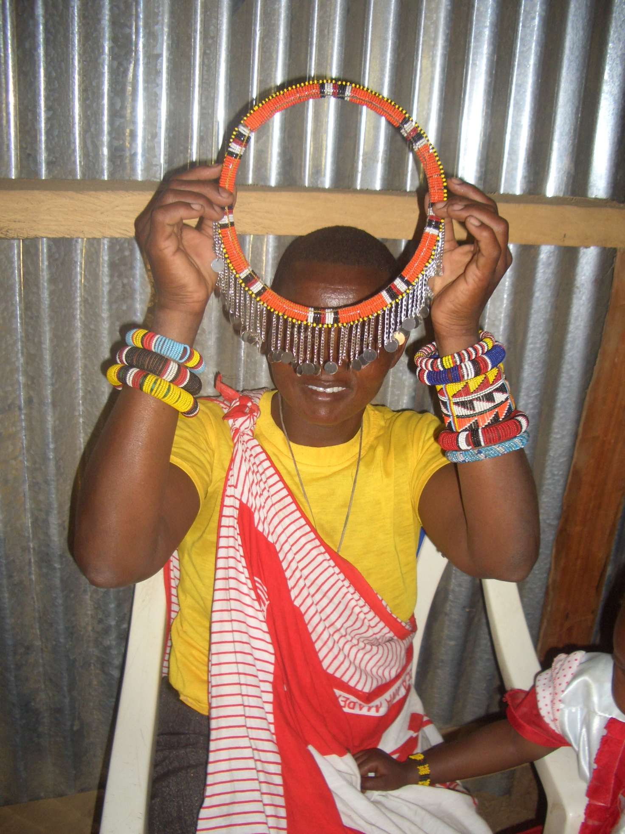

PHOTO ABOVE: A Church member from PFJM Olooltoto Maasai village Church displays unique Maasai tribe items during a planning meeting of how the Church will empower the poor Maasai women via group empowerment projects. The Church has a group of Maasai women that makes Maasai items and market is sought for the sale of the items in Kenya and in other countries/nations.

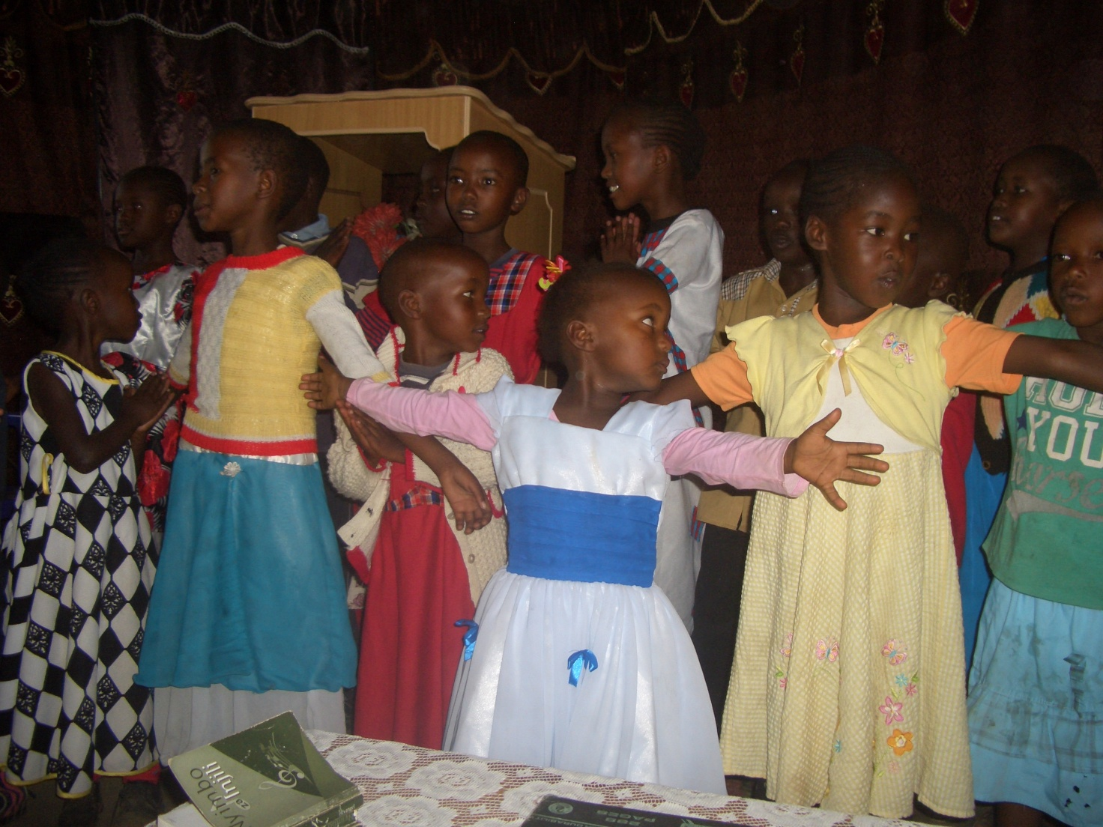
PHOTO ABOVE: People For Jesus Ministry Narok town Church Sunday school children sing Resurrection songs of Christ on Easter Sunday 2016.

19TH MARCH 2016: The Church Missions/Outreach council were trained on how to prepare the Church to be an effective missionaries sending Church. PFJM Church is keen in participating in the mission of God in the nations such as Pakistan, Tanzania, etc.

SOME OF THE YEAR 2016 P.F.J.M PLANS

>>> Missions/Outreach Council: Church plants in Kenya at Eldoret and Ngong' in Kenya. Church plant in Pakistan in October 2016. Church planting survey in Liberia, and Uganda. Church plant visits in Kenya in Nyamkebe, Nyakach, Eldoret, Ongata Rongai, and Nairobi.
Mission trip and graduation of Bible class in PFJM Tanzania in August 2016. Gospel outreaches/evangelistic campaigns in Kenya.
>>> Adult/Literacy education classes among the Maasai community of Narok Kenya.
>>>Funds-drives for the Narok town Church purchase of land and building of Church Sanctuary.
>>> Supply computers and begin computer learning classes at PFJM Narok town Church.
>>> Education sponsorship programmes. Support programmes for poor and needy people/communities.
>>>Visit and support mobilization for disabled/physically challenged children/people in Nairobi Kenya.
>>>Bible school establishment in Kenya and in Dar-Es- Salaam Tanzania
>>>Children Vocational Bible School camp.
>>>Youth camp on 6th to 10th December 2016 and quarterly youth rallies in April and August 2016.
>>> Other Youth, women, children, programmes. End year celebration, Big meal celebration, etc. >>> Annual General meeting in PFJM Narok town Church on 20th November 2016.
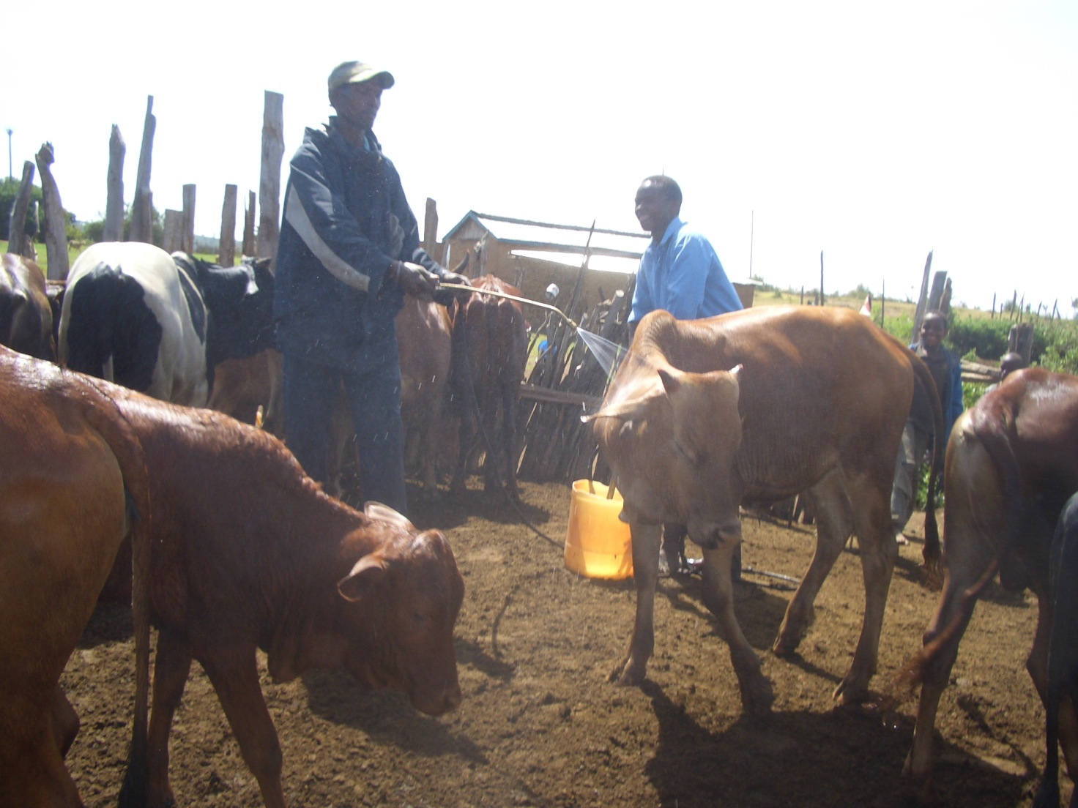
PHOTO ABOVE: PFJM Church members treat cows in the cows shed area on 28th March 2016 during the PFJM Annual Christian Service Day 2016 event. This event was conducted in all parts of Kenya where PFJM Church has a branch. In Narok Kenya, the Church treated livestock and shared the gospel. Other branch Churches did various other community services in aid of needy people.

WIDOWS AND THE POOR PEOPLE'S PROJECTS NEED YOUR SUPPORT
PFJM has established a self-help project called ''Cluster Dynamics'' which are designed to pull together groups of 5, 10 or 15 people from within a community group who are mutually in great need. The groups are tasked with developing a micro-project which will generate income for the group in order that they can support themselves and their families.
The groups mainly made up of destitute women, are poor for a number of reasons but mainly due to the tragedy of HIV/AIDS which affects each family in one way or another. Some suffer from the disease themselves, others as a result of losing their husband by HIV/AIDS. The result is that the remaining partner (usually wife and mother) is left to support a number of children. PFJM can help these groups get established by providing one time initial set up grant of £450, 900 and 1350 respectively, allowing them to get going with their project and bring in the much needed income that will grow the project and support the group and their dependants. PFJM will closely monitor the projects to ensure that they are profitable to the groups. You can invest in this worthy course that can profitably change lives of the poor widows and others for a life time. Currently, we have the groups of 5, 10 and 15 ready to move with any support that comes to them. ON 2ND JANUARY 2016, THE FIRST ACTIVE CLUSTER GROUP WILL BE SHARING AN ANNUAL PROFITS. PLEASE HELP THESE POOR PEOPLE TRANSFORM THEIR LIVES BY YOUR ONE TIME SUPPORT.

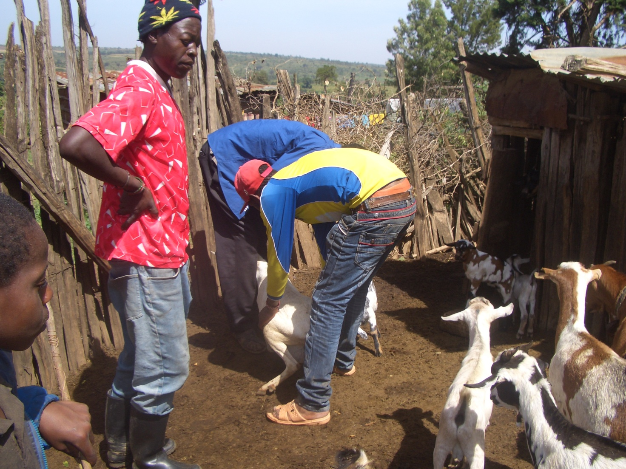

PHOTO ABOVE: PFJM CHURCH CHRISTIAN SERVICE DAY IN NAROK KENYA AT MOTONYI MAASAI VILLAGE IN THE GOATS/SHEEP SHED AREA. THAT EVENT TOOK PLACE ON 28TH MARCH 2016.

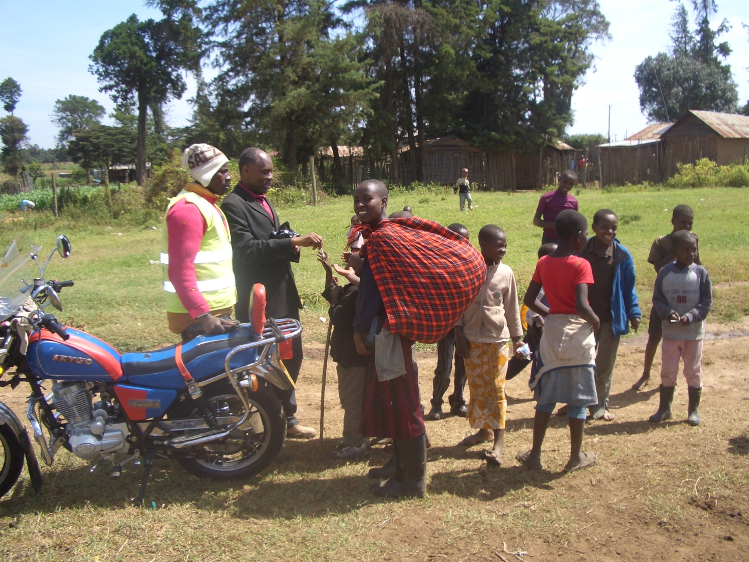
PHOTO ABOVE: PASTOR TOM IN BLACK COAT ISSUES SWEETS TO CHILDREN DURING THE CHRISTIAN SERVICE DAY IN MAASAI VILLAGE IN NAROK KENYA.

PRAYER/PRAISE ITEMS AND PLANS & HOW TO BE PART OF THIS WORK
The mission work we are involved in is too dynamic and enormous for us to do on our own. We surely appreciate your partnership by prayer, support, and personal involvement.

- Narok Town Headquarters Church Land Purchase and Church Building at a cost of United Kingdom Pounds £22,000 or US$35,000. We thank all who have thus far donated. We have identified a piece of land in Narok town which costs US$15,000. The land is not yet bought due to insufficient funds. We still need more funds.
- Monthly Pastor's Family Support of US$300 (rural areas) or US$480 (urban areas)
- Orphans and Destitute children monthly support £20 or US$35. This year we have many needy children in the programme awaiting support.
- Needy College/University Students support and High School Students support needed.
- New Church Planting Mission in Pakistan at Lahore . Pakistan pastor being trained by PFJM so that he takes over the work. Other Church plants in Africa e.g.. in Ngong', Kitale and Katolo in Kenya, Uganda in Lira,Dar-Es-Saalam and Zanzibar in Tanzania etc.
- We need Church Sanctuary and Primary school buildings in Tanzania Church. School, orphanage, clinic and guest house Building proposals in Narok and in Kisumu areas in Kenya.
- Mission Emphasis Programmes and community development projects in Kenya going on throughout the year.
- PFJM Tanzania Church needs prayers: To be officially registered by the Tanzania government. Bible school graduation to be held in August 2016. That church needs to build a main sanctuary in Dar-Es-Saalam.
- Pray for the upcoming Crusades, Revival meetings in different parts of Kenya in May, June and August 2016.
- Pray for Church Annual General Meeting to be held on 20th November 2016.
- Pray for the Big Meal 2016 events for the needy children feeding and awards programme on Christmas Day. Also pray for the End of Year seminar and end year prayer vigil.

SPECIAL THANKS TO ALL OF YOU FOR YOUR PRAYERS, SUPPORT AND ACTUAL PERSONAL PARTICIPATION IN THE WORK THAT WE DO. YOU HAVE ENABLED US TO MEET EDUCATION, MATERIAL, PLUS OTHER NEEDS OF MAASAI COMMUNITIES IN NAROK AND AROUND THE NATION OF KENYA. YOU HAVE ALSO ENABLED US TO PREACH THE TRUE GOSPEL AS WE MAKE DISCIPLES OF CHRIST IN KENYA AND IN OTHER NATIONS.
BECAUSE OF YOUR PRAYERS AND SUPPORT, WE WERE ABLE TO DO WHAT WE DO. WE ASK YOU TO KEEP ON STANDING WITH US FOR THE SAKE OF THE WORK OF GOD'S KINGDOM AND FOR MINISTERING TO POOR/NEEDY COMMUNITIES.

HAPPY NEW YEAR 2016. THE YEAR OF TRIUMPH IN THE POWER OF JESUS CHRIST.
2 CORINTHIANS 2:14

WE CONTINUE TO TRULY VALUE YOUR PARTNERSHIP (PHILIPPIANS 1:5). THANK YOU!!!

