PEOPLE FOR JESUS MINISTRY,
P.O. BOX 1008,
Narok, 20500, KENYA,
EAST AFRICA
TEL: 254-721-204447 OR 254-736-574413
E-mail: peopleforjesusintmin@gmail.com

YOUR REF: ________ OUR REF: NRK/UP.3/2015 DATE: 30TH SEPTEMBER 2015

Dear Saints, Friends, well-wishers, and Partners,

Receive blessed greetings from us People For Jesus Ministry (PFJM) family. We are busy with preaching of the gospel of the Kingdom of God in different places and in many diverse acts of Christian love. Many activities have been going on for regular Church daily, weekly and monthly programmes and projects. Some of the evangelistic activities are enlisted in the updates while many others are not. The Church continues to work in communities with many poor orphans, widows, pupils, students, and people at risk who need our support but we thank God that we are able to help some of them with your partnership.

JULY 2015

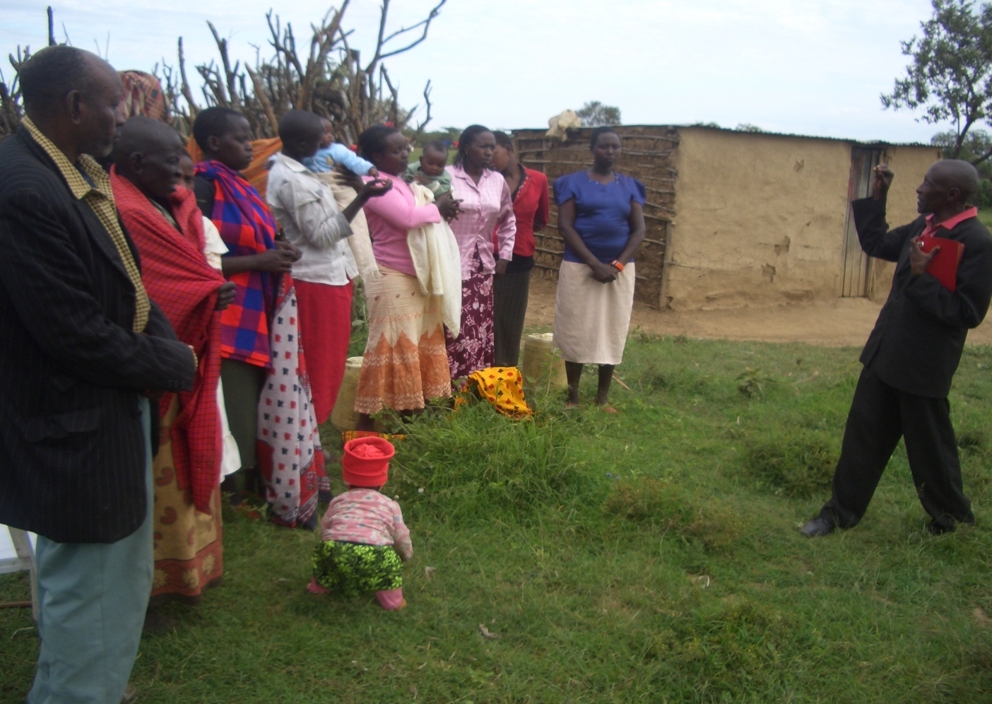
PHOTO ABOVE:Narok Olooltoto Maasai village Church weekly mid-week fellowship.
The Maasai village Church has spiritually reviving mid-week fellowships every week in which the Word of God is taught, many people give their lives to Christ and the saints help one another in fellowship.

23RD – 27TH JULY 2015. (Water Baptism: 25th July 2015. Seminar and revival meetings in Narok on 24th and 25th July 2015). Those were special days of great spiritual revival in the Narok PFJM Church. We conducted water baptism for 17 new converts at a Ewaso Ngiro river in Narok near the Olooltoto village Church. Men, women, and youth were immersed into much water amid melodious Maasai gospel songs accompanied with special jumps. We also conducted visits to the needy children being helped by the Church. The Church was able to hold revival meetings and some teaching sessions.
During the month of July 2015, the Church also embarked on making an underground water tank that will hold about 20,000 to 25,000 litres of clean drinking water at the Olooltoto Church. The Church will harvest rain water during rainy season or fill up the tank using the Narok town service water during dry season. The work on the underground tank is almost complete. It is an area prone to drought. Remember we have two plastic tanks each holding 10,000 litres of water. The Church will now have a 40,000 to 45,000 litres of water capacity tanks. Thanks to those who have supported that noble course. WE CAN NOW GET CLEAN DRINKING WATER.

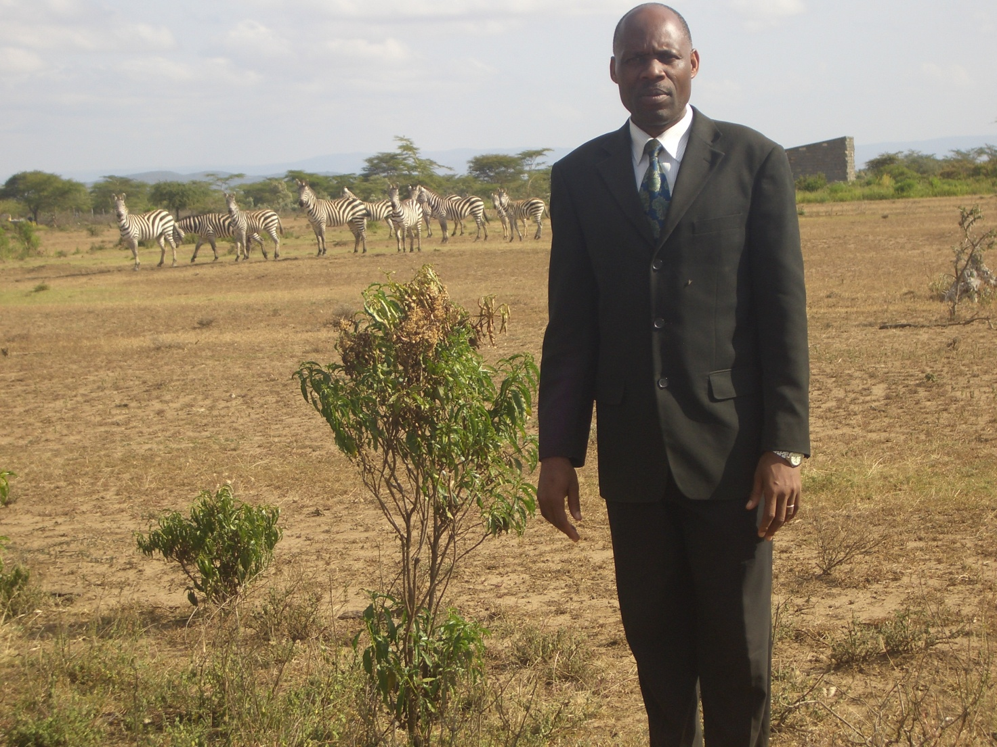
PHOTO ABOVE: Pastor Tom walking to the Olooltoto Maasai village Church and he met the group of Zebras on the way to the Church.
He walks long distances in wildlife prone areas and he surely needs a car for effective evangelistic work. Keep that in prayers for God's provision.

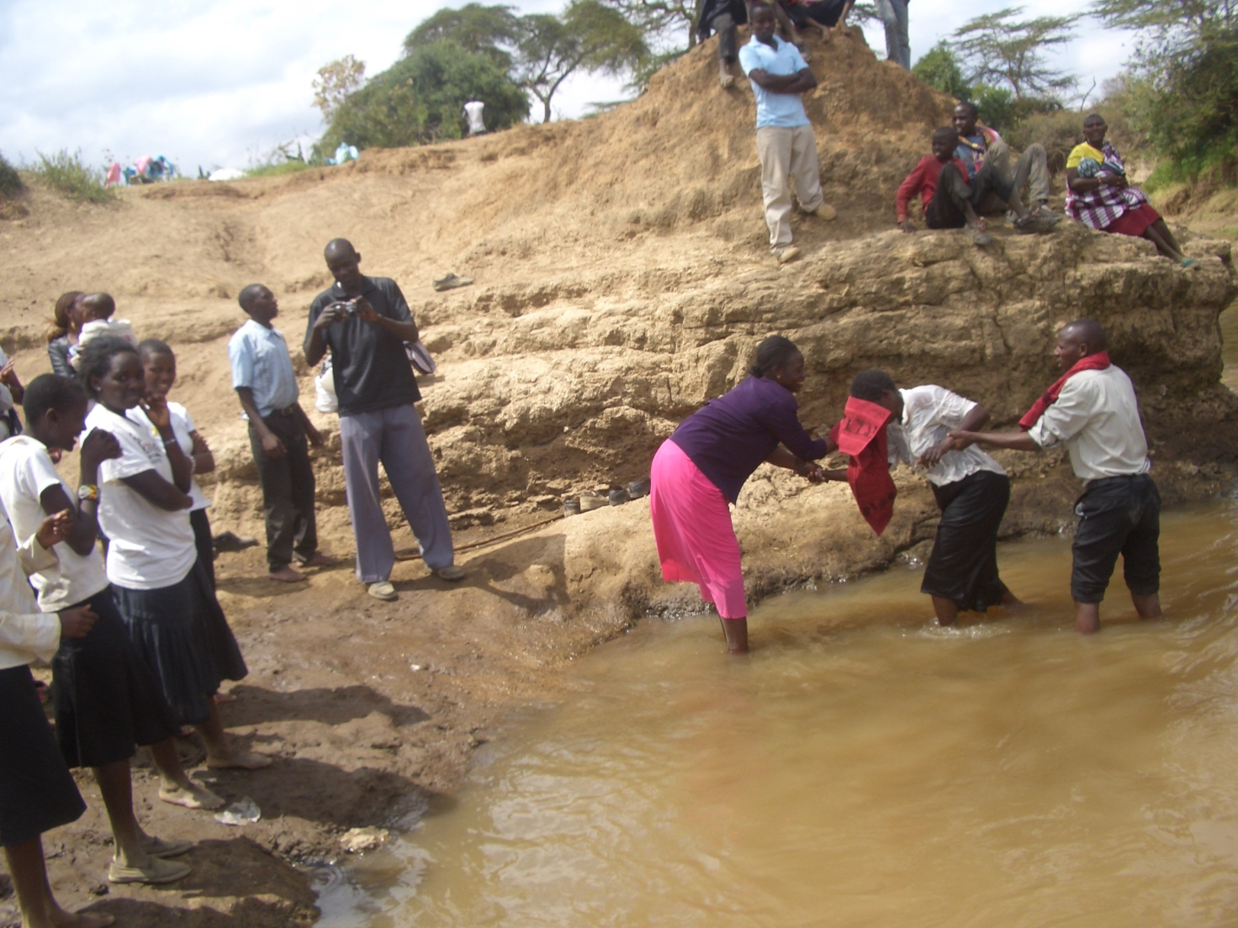
PHOTO ABOVE: Baptism session on 25th July 2015 at Narok Ewaso Ngiro river. 17 new Christians were baptised and that was followed by a big ceremony to celebrate the new believers. The Olooltoto Maasai village Church membership has more than tripled in the last three months. Glory to God for He makes the increase!!.

AUGUST 2015

KANDARIA MIXED SECONDARY SCHOOL UPDATES
Kandaria secondary school now has temporary teacher's residential houses. The temporary houses have been built using iron sheets and timber. The school needs permanent teachers residential houses. The school now has science laboratory. In August 2015, Kandaria secondary school took another test with 40 secondary schools and Kandaria secondary school was in position nine. More classrooms/laptops and laboratory equipment needed at the school. Secondary school candidates now stay at the school. They sleep inside classrooms. They need a dormitory. The school also needs volunteer teachers. WE APPRECIATE OUR PARTNERS WHO HAVE BEEN SUPPORTING THE SCHOOL.
18TH –23RD AUGUST 2015: That was a week of women and youth seminars, and special leadership meetings in all the PFJM Churches in Kenya and Tanzania. It was a great time for learning family matters, business skills, Christian service in Church and in the community plus lots of teachings concerned with youth, women and Church leaders.
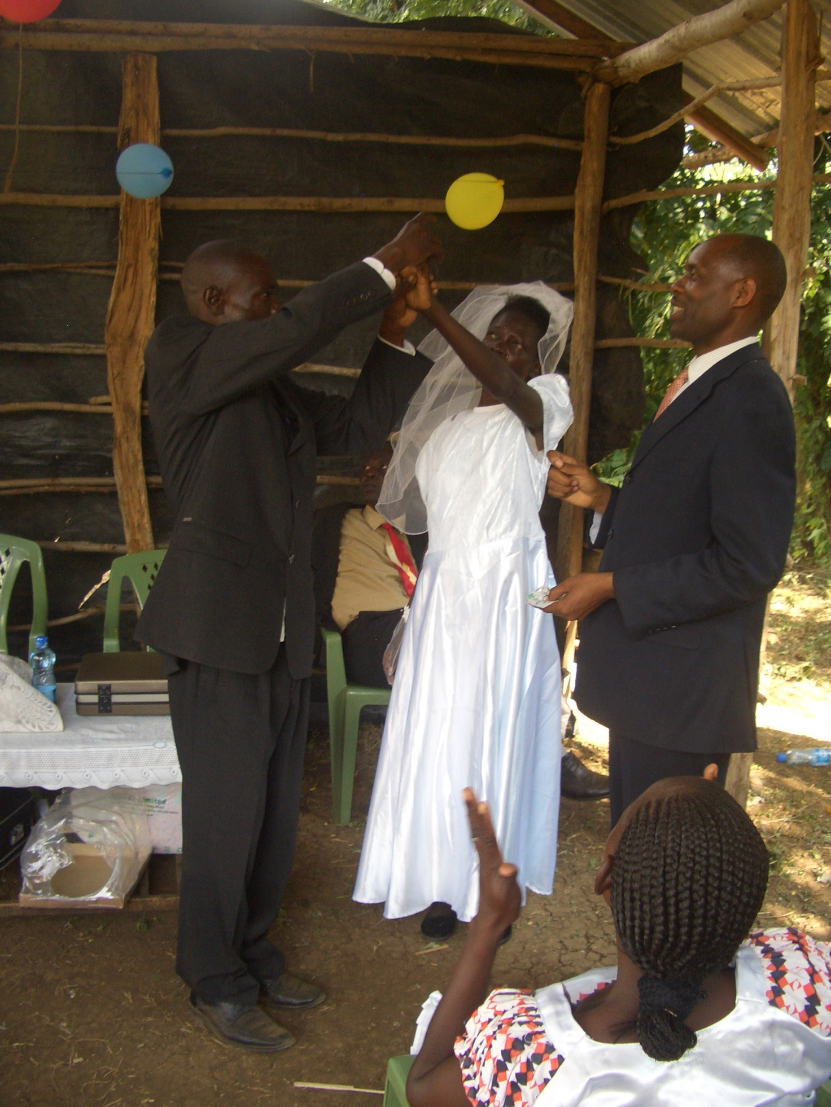
PHOTO ABOVE: Pastor Tom presides over the wedding between Pastor Alex and wife Eunice on 15th August 2015 at PFJM Nyamkebe Kisumu Church in Kenya.

NAROK TOWN CHURCH LAND AND SANCTUARY
NAROK TOWN CHURCH IS STILL SEEKING FOR SUPPORT FOR THE PURCHASE OF LAND AND THE CONSTRUCTION OF A CHURCH SANCTUARY. PLEASE KEEP US IN PRAYERS SO THAT WE RAISE US$35,000 FOR THE CHURCH BUILDING PROJECT. CHURCH MEMBERS HERE IN NAROK KENYA CONTINUE TO CONDUCT SOME FUNDSDRIVES. PLEASE JOIN US IN RAISING THE FUNDS.

PEOPLE FOR JESUS MINISTRY MISSION/OUTREACH TEAM COUNCIL
People For Jesus Ministry has a mission team or Mission Council that plans and implements local, regional and international missions programmes. That includes crusades, church planting, prayers and intercessory prayers, community evangelistic Outreach programmes and projects. The team also mobilizes, recruits, sends and support long-term and short-term missionaries and teams to different parts of the world. The Mission Team also hosts volunteer missionaries from every part of the world. The Mission Council meets every month to pray, plan and implement Church mission programmes. Please contact us for details on how you can participate.
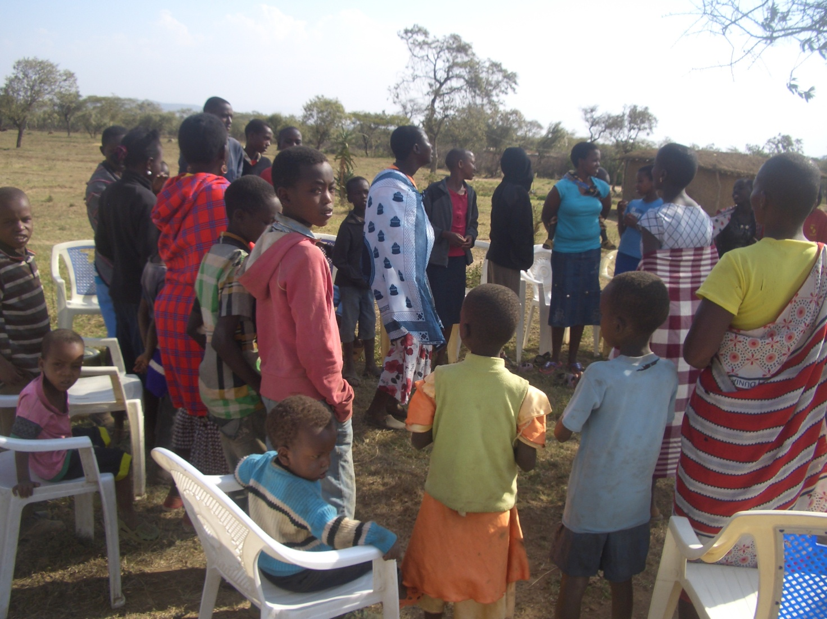
PHOTO ABOVE: An outreach fellowship in Narok Kenya.

ORPHANS/VULNERABLE CHILDREN AND STUDENTS SUPPORT AND SPONSORSHIP:
The Church launched a serious 'school drop outs back to school' campaign programme in February 2014 as part of the Church sponsorship programme. The programme is targeting pupils/students who dropped out of school for various reasons especially among the Maasai communities in Narok county. We have thus far managed to support some pupils/students beneficiaries in the programme. Thanks to those who responded to our plea to help school drop outs plus those who have not been able to make it to school to go to school. We have not yet reached out target and many more children who need to go to school are increasing. YOU CAN GIVE AS LITTLE AS £15 PER MONTH OR £180 PER YEAR, US$25 PER MONTH OR US$300 PER YEAR TO ENABLE A STUDENT GO BACK TO GOVERNMENT DAY SECONDARY SCHOOL. About half of the funds is used for the purchase of school uniforms. You can also help a child go back to primary school by giving US$100 per year.

ADULT/LITERACY EDUCATION: THE MAASAI VILLAGE ADULT/LITERACY CLASS IS GOING ON. 95% OF THE CLASS ARE WOMEN AND GIRLS. THE PROBLEM OF EARLY MARRIAGES AMONG THE MAASAI GIRLS NECESSITATES THAT THEY DROP OUT OF SCHOOL OR NEVER MAKE IT TO SCHOOL SO THAT THEY GET MARRIED AND EARN THEIR FAMILY A WEALTH OF MANY COWS PAID AS DOWRY. THE CHURCH IS ADDRESSING THAT EDUCATION GAP BY CONDUCTING CLASSES FOR THOSE WHO HAVE EITHER DROPPED OUT OF SCHOOL OR THOSE WHO NEVER MADE IT TO ANY SCHOOL. PLEASE JOIN US IN THIS ENDEAVOUR.

SEPTEMBER 2015
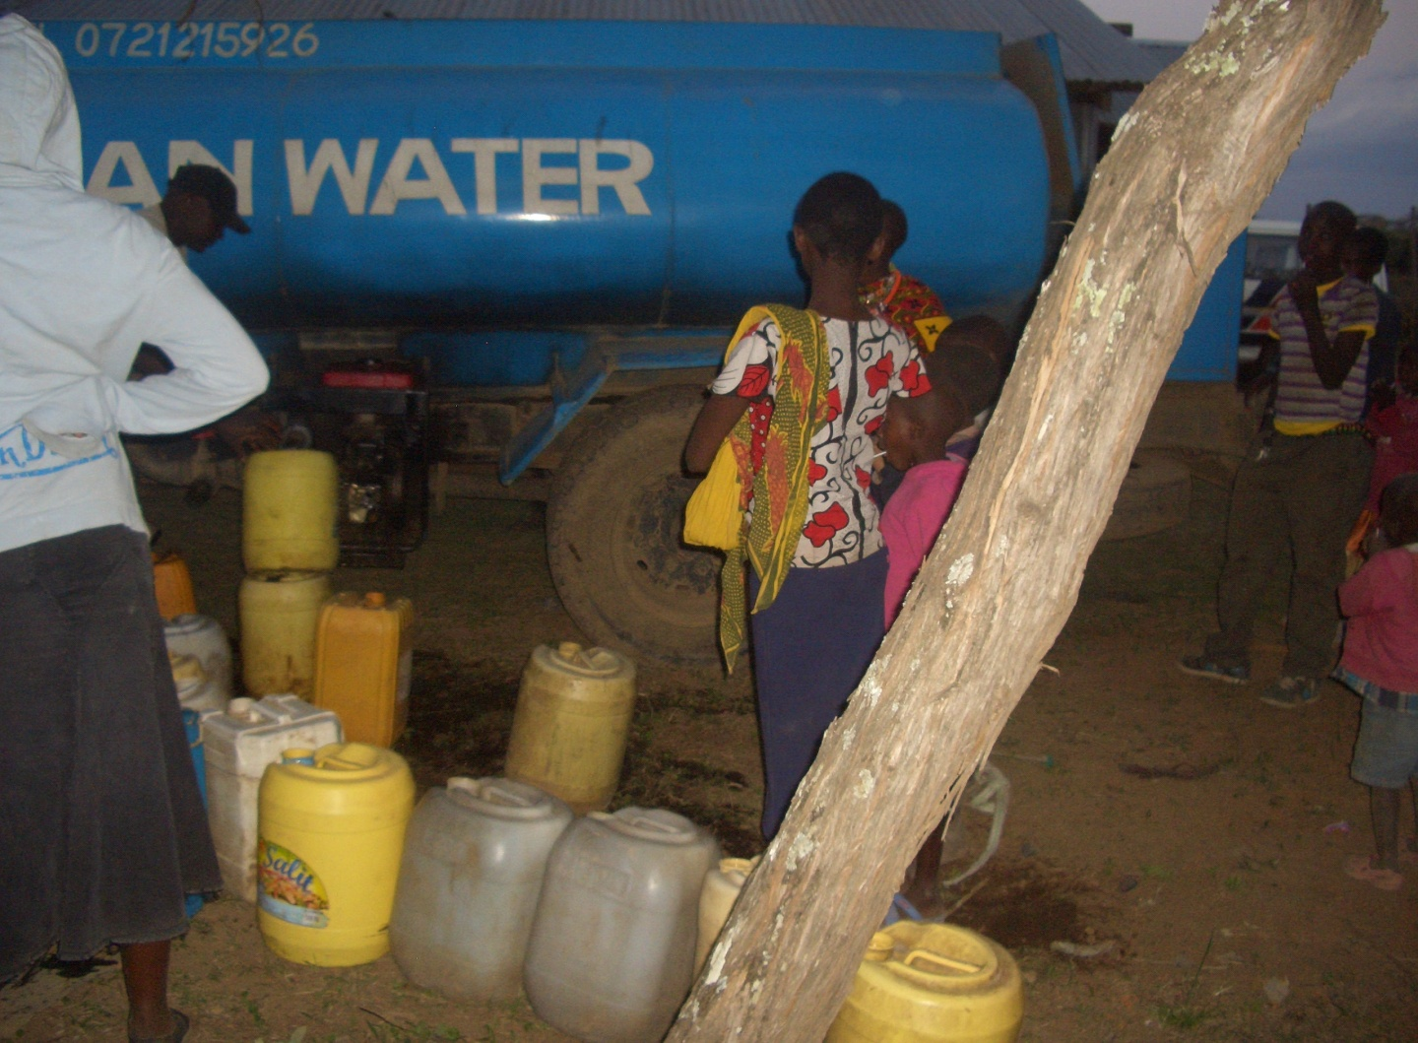
PHOTO ABOVE: Narok town clean drinking water service supplies water to Maasai villagers at the Church.
PHOTO BELOW: Maasai Bridegroom (left) and Bride(right) at a recent early marriage incident in Narok. The boy is 17 years old and the girl is 13 years old. The Church is doing their best to address this matter.
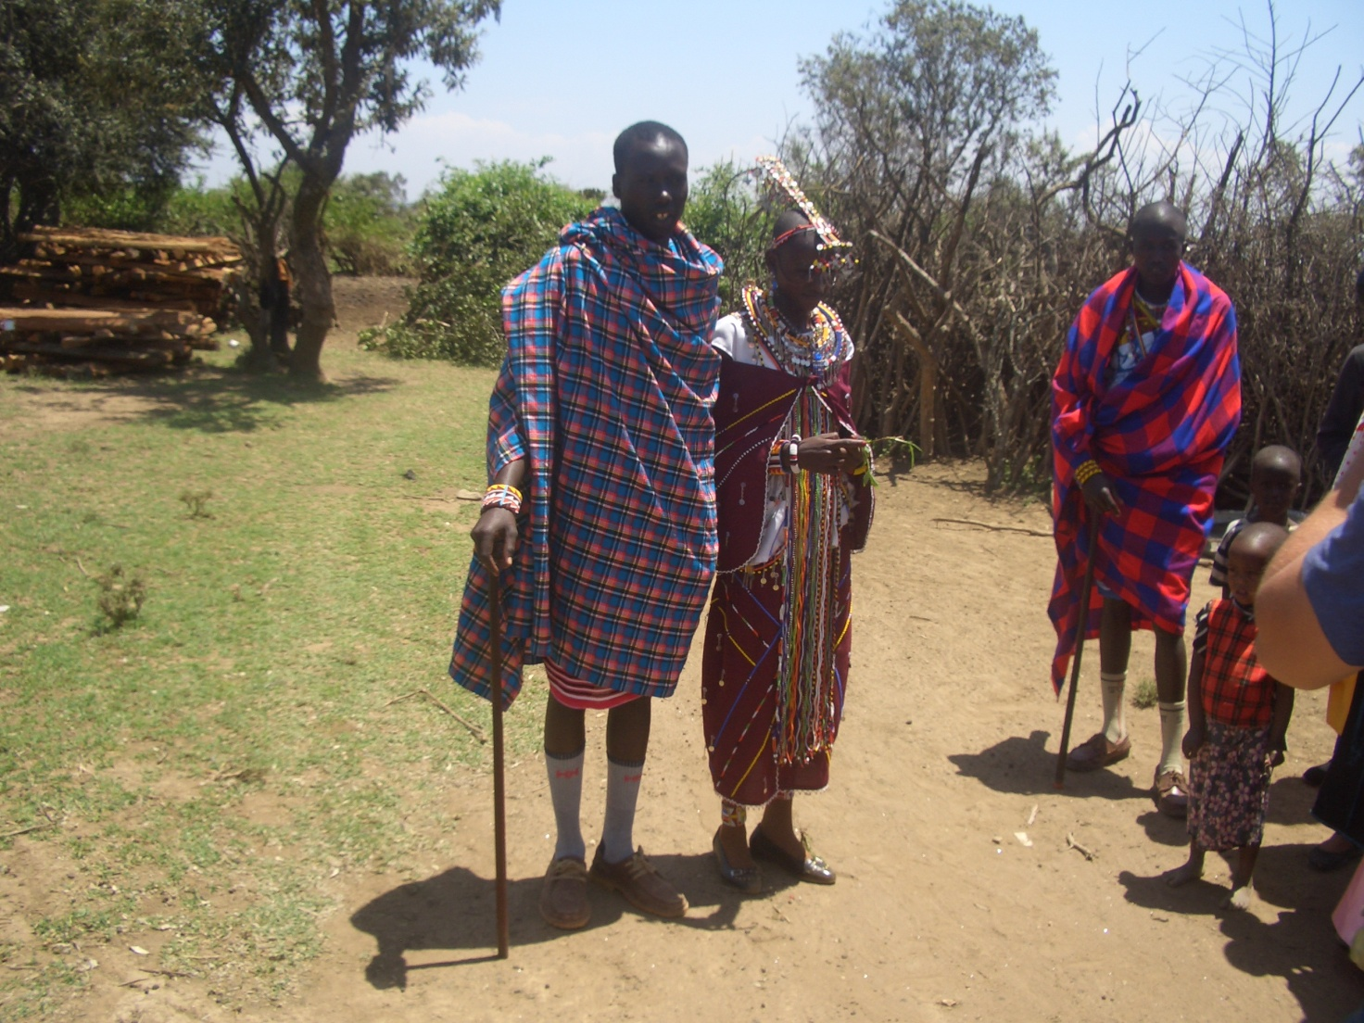

BIG MEAL 2015: REMEMBER OUR ANNUAL BIG MEAL EVENT IS AROUND THE CORNER. WE FEED NEEDY/POOR/ORPHAN CHILDREN ON DELICIOUS MEALS ON 25TH DECEMBER ANNUALLY. THIS YEAR, WE TARGET ABOUT 800 CHILDREN IN KENYA AND IN TANZANIA. WE NEED YOUR SUPPORT AGAIN THIS YEAR.

SOME OF THE YEAR 2015 P.F.J.M PLANS

>>> Missions/Outreach Council: Church plants in Kenya at Nyakach, and Ngong'. Church plant in Pakistan in October 2015. Church planting survey in Liberia, and Uganda. Church plant visits in Kenya in Nyamkebe, Nyakach, Eldoret/Kitale, Ongata Rongai, and Nairobi.
Mission trip and graduation of Bible class in PFJM Tanzania in August 2015. Gospel outreaches/evangelistic campaigns in Kenya. Tanzania Church visits Kenya in June 2015.
>>> Adult/Literacy education classes among the Maasai community of Narok Kenya.
>>> Supply computers and begin computer learning classes at the Kandaria secondary school in Kisumu region of Kenya in February 2015.
>>> Education sponsorship programmes. Support programmes for poor and needy people/communities.
>>> Youth, women, children, programmes. End year celebration, Big meal celebration, etc.
>>> Annual General meeting in PFJM Narok town Church on 21st November 2015. National Leadership Empowerment Conference on 18th-- 22nd November 2015 at Narok Town Church.

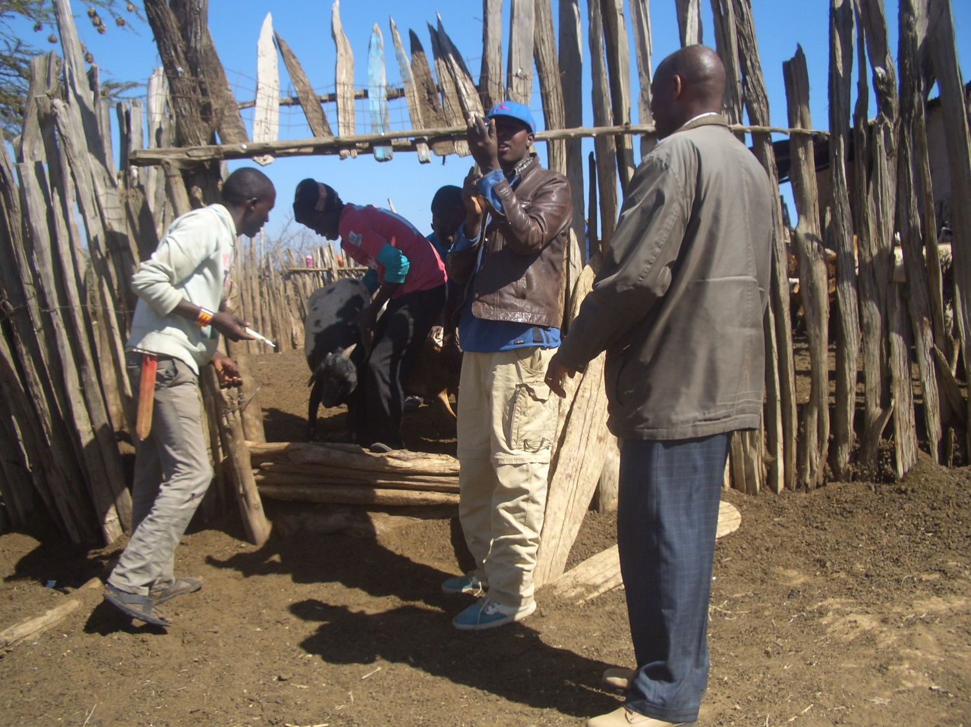
PHOTO ABOVE: PFJM Veterinary evangelistic outreach in September 2015. About 2,000 livestock were treated in Narok Kenya.

WIDOWS AND THE POOR PEOPLE'S PROJECTS NEED YOUR SUPPORT
PFJM has established a self-help project called ''Cluster Dynamics'' which are designed to pull together groups of 5, 10 or 15 people from within a community group who are mutually in great need. The groups are tasked with developing a micro-project which will generate income for the group in order that they can support themselves and their families.
The groups mainly made up of destitute women, are poor for a number of reasons but mainly due to the tragedy of HIV/AIDS which affects each family in one way or another. Some suffer from the disease themselves, others as a result of losing their husband by HIV/AIDS. The result is that the remaining partner (usually wife and mother) is left to support a number of children. PFJM can help these groups get established by providing one time initial set up grant of £450, 900 and 1350 respectively, allowing them to get going with their project and bring in the much needed income that will grow the project and support the group and their dependants. PFJM will closely monitor the projects to ensure that they are profitable to the groups. You can invest in this worthy course that can profitably change lives of the poor widows and others for a life time. Currently, we have the groups of 5, 10 and 15 ready to move with any support that comes to them. PLEASE HELP THESE POOR PEOPLE TRANSFORM THEIR LIVES BY YOUR ONE TIME SUPPORT.

PRAYER/PRAISE ITEMS AND PLANS & HOW TO BE PART OF THIS WORK
The mission work we are involved in is too dynamic and enormous for us to do on our own. We surely appreciate your partnership by prayer, support, and personal involvement.

- Narok Town Headquarters Church Land Purchase and Church Building at a cost of United Kingdom Pounds £22,000 or US$35,000. We thank all who have thus far donated. We have identified a piece of land in Narok town which costs US$15,000. The land is not yet bought due to insufficient funds. We still need more funds.
- Monthly Pastor's Family Support of US$300 (rural areas) or US$480 (urban areas)
- Orphans and Destitute children monthly support £20 or US$35. This year we have many needy children in the programme awaiting support.
- Needy College/University Students support and High School Students support needed.
- New Church Planting Mission in Pakistan at Lahore . Pakistan pastor being trained by PFJM so that he takes over the work. Other Church plants in Africa e.g.. in Ngong' , Nairobi and Nyakach in Kenya, Uganda in Lira, etc.
- We need Church Sanctuary and Primary school buildings in Tanzania Church. School, orphanage, clinic and guest house Building proposals in Narok and in Kisumu areas in Kenya.
- Mission Emphasis Programmes and community development projects in Kenya going on throughout the year. Thanks to God for the success of those that have already been done.
- PFJM Tanzania Church needs prayers: To be officially registered by the Tanzania government. Bible school graduation to be held in August 2016. That church needs to build a sanctuary.
- Pray for the upcoming Crusade and Revival meeting in Narok Town Church on 24th and 25th October 2015.
- Pray for the upcoming International Church Leadership Empowerment Conference on 18th through to 22nd November 2015 at the PFJM Narok Town Church in Kenya.
- Thanks to God for the mission/outreach work already done in Nyakach, Eldoret, Nairobi and Narok
- Pray for the Big Meal 2015 events for the needy children feeding and awards programme on Christmas Day. Also pray for the End of Year seminar and end year prayer vigil.
- BAPTISM was conducted in Narok Kenya on 25th July 2015. Seminar and revival meetings were conducted in Narok on 24th and 25th July 2015. Thanks to God.

SPECIAL THANKS TO ALL OF YOU FOR YOUR PRAYERS, SUPPORT AND ACTUAL PERSONAL PARTICIPATION IN THE WORK THAT WE DO. YOU HAVE ENABLED US TO MEET EDUCATION, MATERIAL, PLUS OTHER NEEDS OF MAASAI COMMUNITIES IN NAROK AND AROUND THE NATION OF KENYA. YOU HAVE ALSO ENABLED US TO PREACH THE TRUE GOSPEL AS WE MAKE DISCIPLES OF CHRIST IN KENYA AND IN OTHER NATIONS.

WE CONTINUE TO TRULY VALUE YOUR PARTNERSHIP (PHILIPPIANS 1:5). THANK YOU!!!

