PEOPLE FOR JESUS MINISTRY,
P.O. BOX 1008,
Narok, 20500, KENYA,
EAST AFRICA
TEL: 254-721-204447 OR 254-736-574413
E-mail: peopleforjesusintmin@gmail.com

YOUR REF: ________ OUR REF: NRK/UP.4/2015 DATE: 31ST DECEMBER 2015

Dear Saints, Friends, well-wishers, and Partners,

HAPPY NEW YEAR 2016!!!
Receive new year blessed greetings from us People For Jesus Ministry (PFJM) family. We are busy as always with preaching of the gospel of the Kingdom of God in different places and in many diverse acts of demonstrating Christian love. Many activities have been going on for the whole of the year 2015 such as regular Church daily, weekly and monthly programmes and projects. Some of the evangelistic activities are enlisted in the updates while many others are not. The Church continues to work in communities with many poor orphans, widows, pupils, students, and people at risk who need our support but we thank God that we are able to help some of them with your partnership in this work. We trust God that you have began well in the year 2016.

OCTOBER 2015
New Church plant in Nairobi at Lucky Summer area was done. The Church was busy with discipleship programmes and community development projects at Olooltoto Maasai village Church.
PHOTO BELOW: Pastor Tom at Born This Way Foundation disabled centre in Nairobi
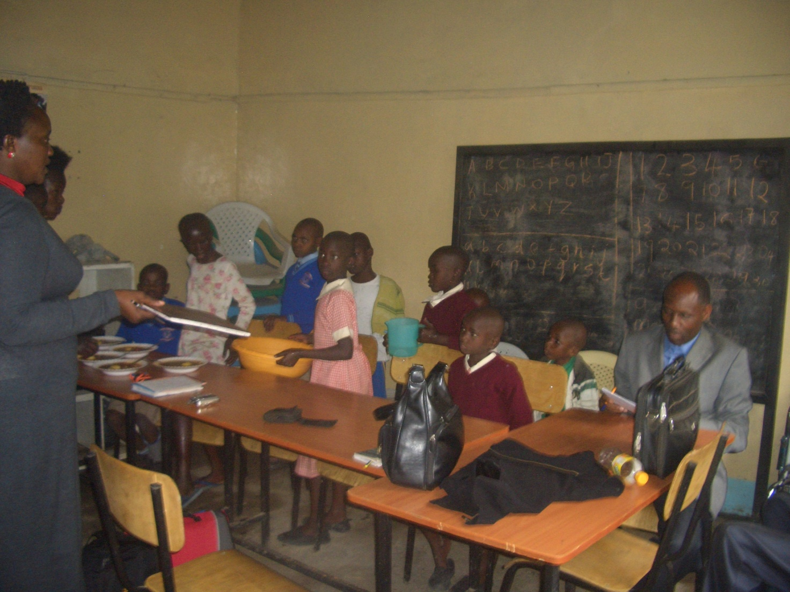
The Church supports two disabled centres in Nairobi. The PFJM Church and their partners support the disabled centres by giving wheel chairs, food, etc. One is located within the PFJM Kayole Nairobi Church compound and the other one is Born This Way Foundation.

PHOTO BELOW:Narok Olooltoto Maasai village Church and the completed water gutters
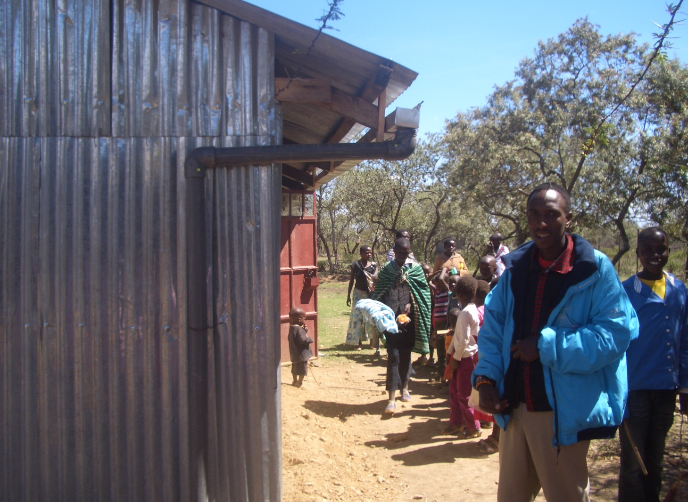
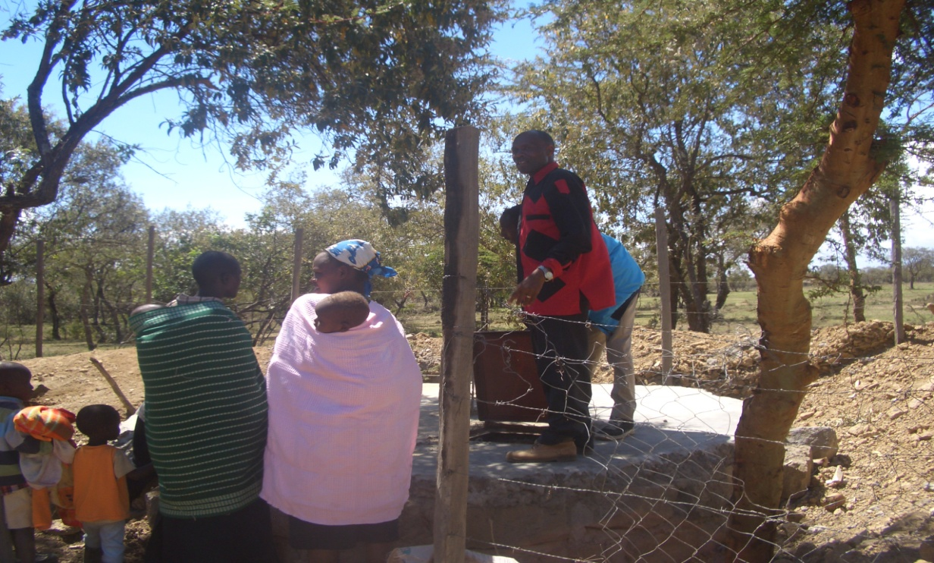
PHOTO ABOVE: PASTOR TOM INSPECTS COMPLETED UNDERGROUND WATER TANK AT OLOOLTOTO MAASAI VILLAGE CHURCH IN NAROK KENYA.
NOVEMBER 2015
PHOTO BELOW: PFJM NATIONAL CHURCH LEADERS EMPOWERMENT CONFERENCE IN NAROK KENYA IN NOVEMBER 2015

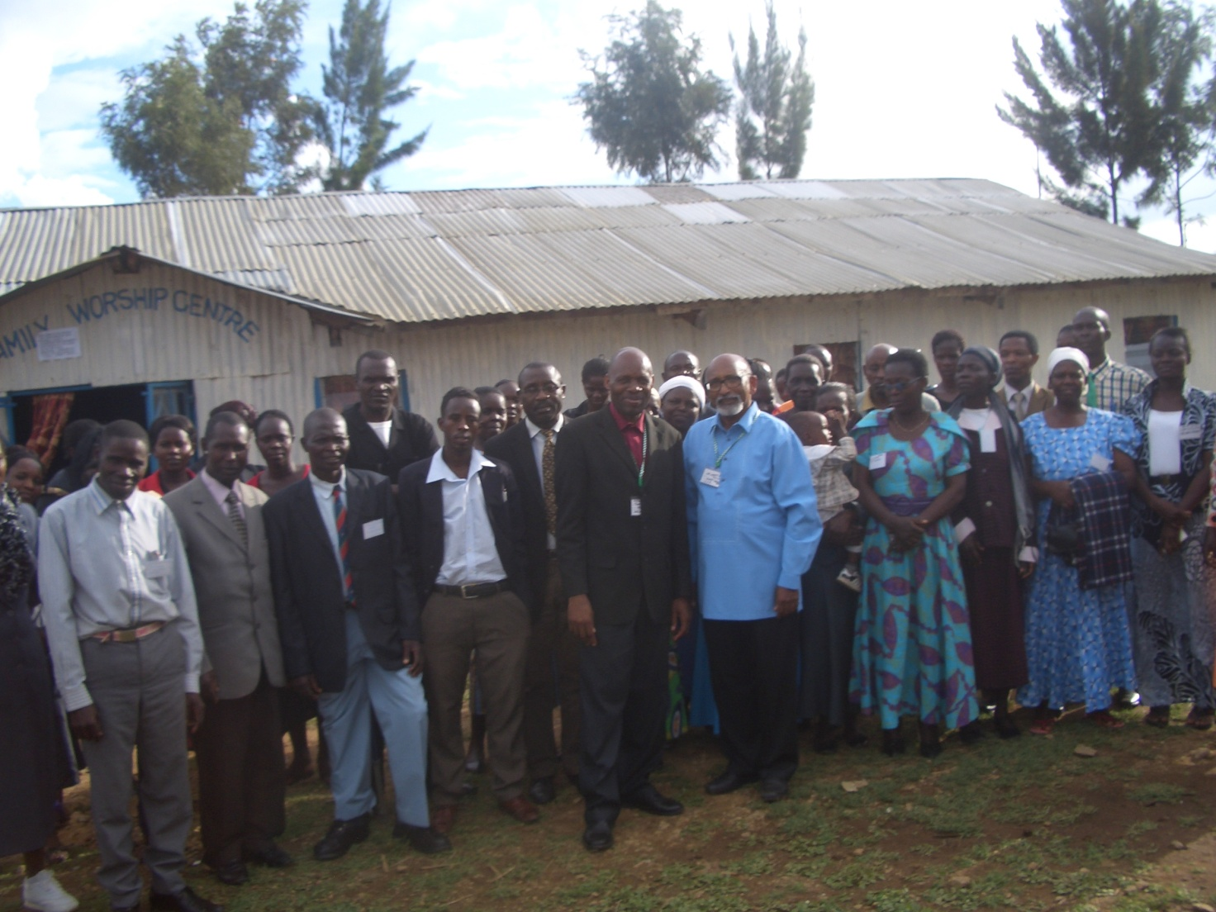

The Church national and regional leaders conference was conducted in Narok town Church from 18th --20th November 2015. Sixty seven leaders attended the meeting and we were surely well taught many aspects of church leadership in the 21st century. Several Church leadership departments were also launched such as Pastors Wives Fellowship, International Secretariat of PFJM, ETC. Leaders from Kenya, USA, Nigeria and Tanzania were in attendance. We thank all of you who prayed with us, those who participated in person, and those who supported that worthy conference. It is likely to be come an annual event.

KANDARIA SECONDARY SCHOOL UPDATES
Kandaria secondary school is doing well. They did national secondary schools final exams in November 2015.
We hope for good results in February 2016. The school does not have latrines/toilets at this time due to El-nino rains.
The school needs an extra classroom. Thanks to all who have been supporting the school.
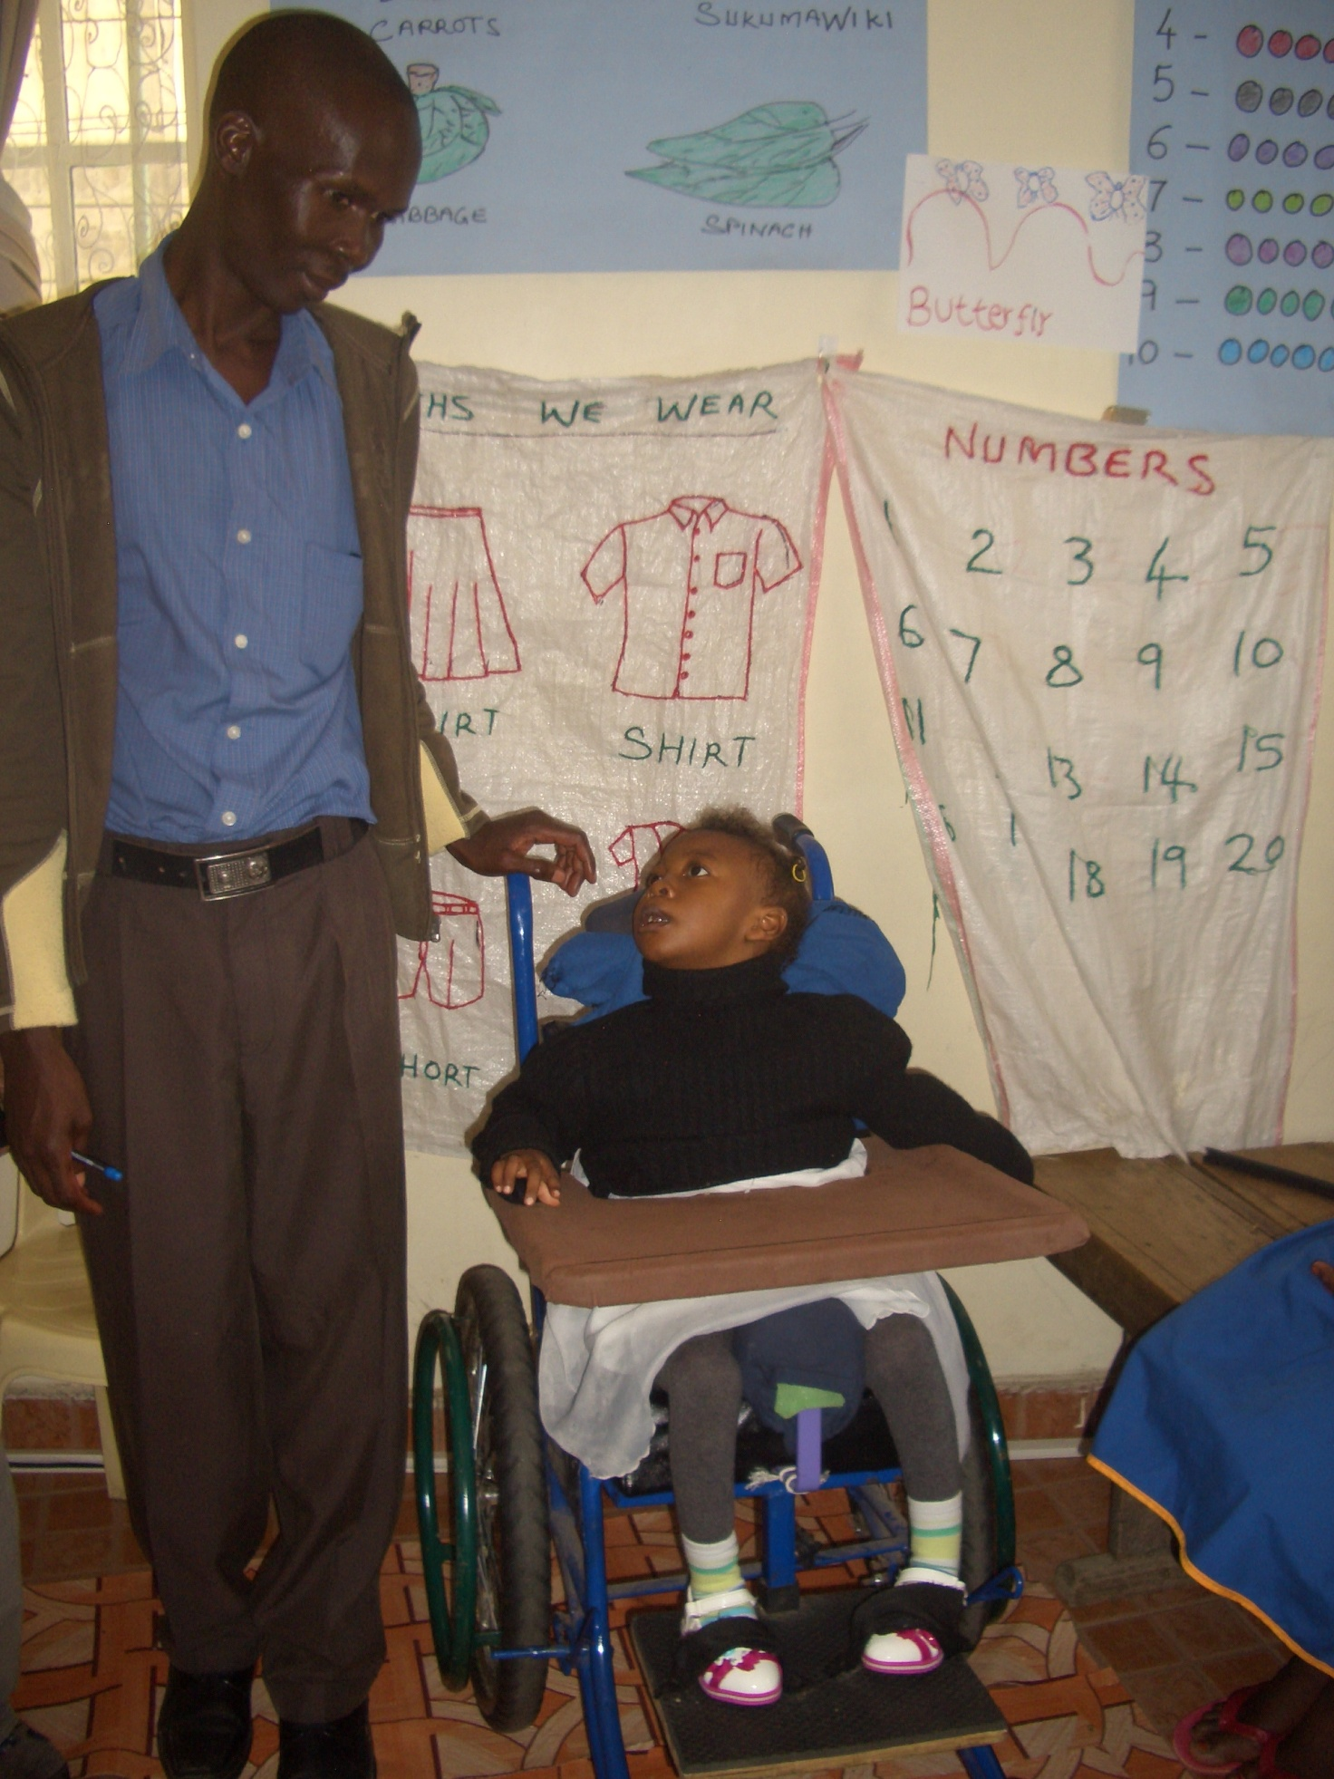
PHOTO ABOVE: PASTOR JOHNSON OF PFJM NAIROBI KAYOLE BRANCH CHURCH PLAYING WITH ONE OF THE DISABLED CHILDREN AT THE CHURCH COMPOUND IN NOVEMBER 2015
1ST NOVEMBER 2015: Pastor Tom visited the Kayole branch Church and had time with the disabled centre children at the Church. The children were given good food plus other items on that day. Please pray for that centre at the Church.
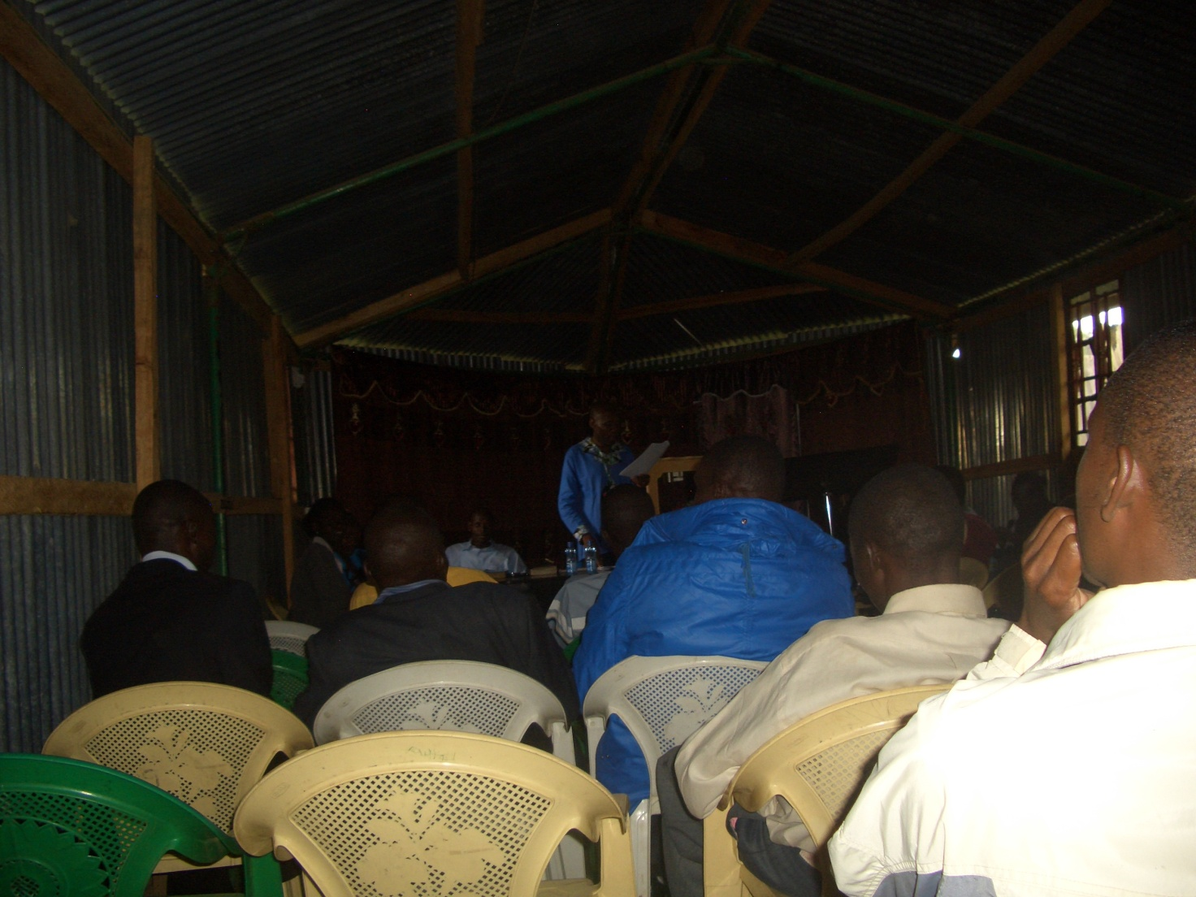
PHOTO ABOVE: Pastor Tom conducting PFJM Annual General Meeting of all PFJM Church leaders at Narok town Church headquarters on 21st November 2015

NAROK TOWN CHURCH LAND AND SANCTUARY
NAROK TOWN CHURCH IS STILL SEEKING FOR SUPPORT FOR THE PURCHASE OF LAND AND THE CONSTRUCTION OF A CHURCH SANCTUARY. PLEASE KEEP US IN PRAYERS SO THAT WE RAISE US$35,000 FOR THE CHURCH BUILDING PROJECT. CHURCH MEMBERS HERE IN NAROK KENYA CONTINUE TO CONDUCT SOME FUNDSDRIVES. PLEASE JOIN US IN RAISING THE FUNDS.

PEOPLE FOR JESUS MINISTRY MISSION/OUTREACH TEAM COUNCIL
People For Jesus Ministry has a mission team or Mission Council that plans and implements local, regional and international missions programmes. That includes crusades, church planting, prayers and intercessory prayers, community evangelistic Outreach programmes and projects. The team also mobilizes, recruits, sends and support long-term and short-term missionaries and teams to different parts of the world. The Mission Team also hosts volunteer missionaries from every part of the world. The Mission Council meets every month to pray, plan and implement Church mission programmes. Please contact us for details on how you can participate.

ORPHANS/VULNERABLE CHILDREN AND STUDENTS SUPPORT AND SPONSORSHIP:
The Church launched a serious 'school drop outs back to school' campaign programme in February 2014 as part of the Church sponsorship programme. The programme is targeting pupils/students who dropped out of school for various reasons especially among the Maasai communities in Narok county. We have thus far managed to support some pupils/students beneficiaries in the programme. Thanks to those who responded to our plea to help school drop outs plus those who have not been able to make it to school to go to school. We have not yet reached out target and many more children who need to go to school are increasing. YOU CAN GIVE AS LITTLE AS £15 PER MONTH OR £180 PER YEAR, US$25 PER MONTH OR US$300 PER YEAR TO ENABLE A STUDENT GO BACK TO GOVERNMENT DAY SECONDARY SCHOOL. About half of the funds is used for the purchase of school uniforms. You can also help a child go back to primary school by giving US$100 per year.
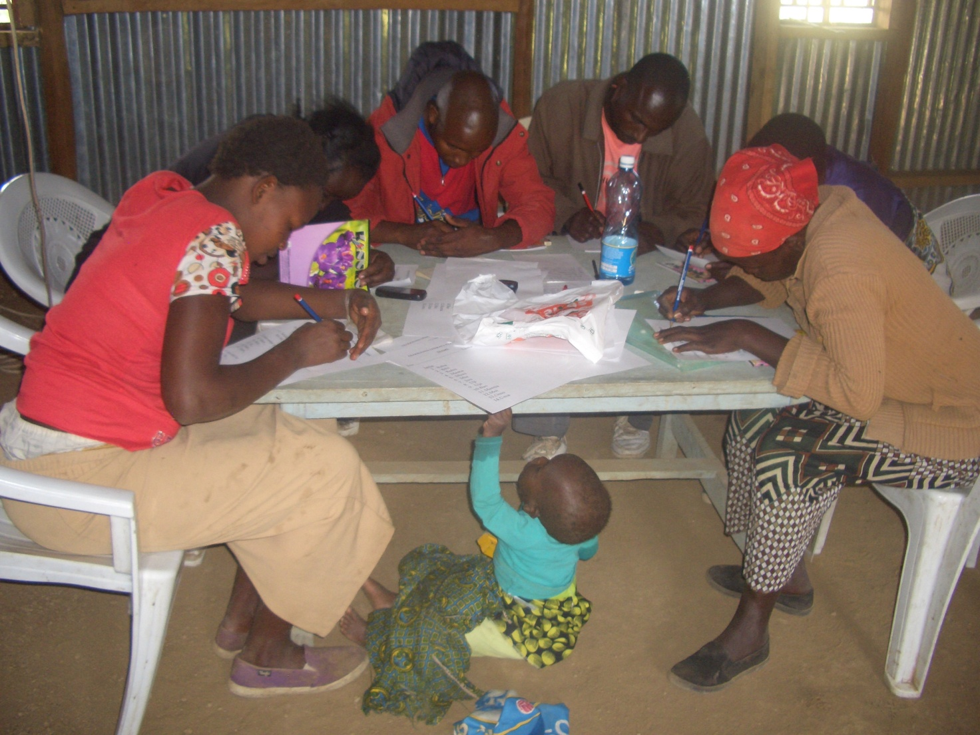
PHOTO ABOVE: CHURCH LITERACY/ADULT EDUCATION CLASS IN SESSION
ADULT/LITERACY EDUCATION: THE MAASAI VILLAGE ADULT/LITERACY CLASS IS GOING ON. 85% OF THE CLASS ARE WOMEN AND GIRLS. THE PROBLEM OF EARLY MARRIAGES AMONG THE MAASAI GIRLS NECESSITATES THAT THEY DROP OUT OF SCHOOL OR NEVER MAKE IT TO SCHOOL SO THAT THEY GET MARRIED AND EARN THEIR FAMILY A WEALTH OF MANY COWS PAID AS DOWRY. THE CHURCH IS ADDRESSING THAT EDUCATION GAP BY CONDUCTING CLASSES FOR THOSE WHO HAVE EITHER DROPPED OUT OF SCHOOL OR THOSE WHO NEVER MADE IT TO ANY SCHOOL. THANKS TO THOSE WHO HAVE BEEN ABLE TO SUPPORT US. PLEASE JOIN US IN THIS ENDEAVOUR AT USD$70 PER MONTH PER CLASS.

DECEMBER 2015

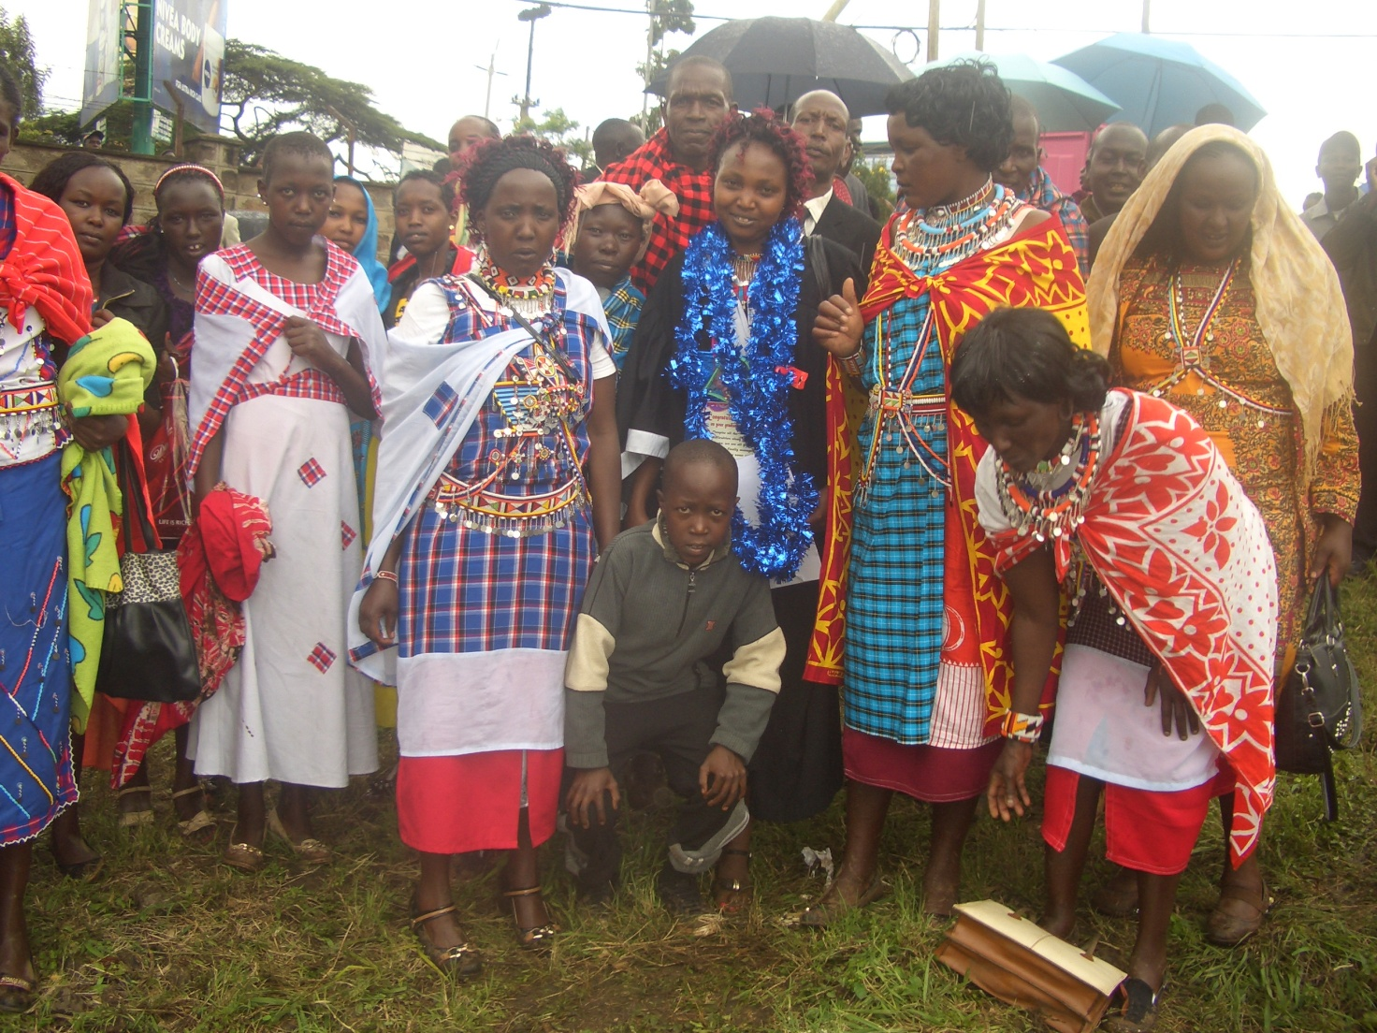
PHOTO ABOVE: Narok town Church members join the family of a Maasai girl sponsored by the Church at a graduation ceremony in Nairobi at Kenya Medical Training college. The girl is Eunice Naserian who graduated with Diploma in Community Health Nursing on 3rd December 2015.

SOME OF THE YEAR 2016 P.F.J.M PLANS

>>> Missions/Outreach Council: Church plants in Kenya at Eldoret and Ngong' in Kenya. Church plant in Pakistan in October 2016. Church planting survey in Liberia, and Uganda. Church plant visits in Kenya in Nyamkebe, Nyakach, Eldoret, Ongata Rongai, and Nairobi.
Mission trip and graduation of Bible class in PFJM Tanzania in August 2016. Gospel outreaches/evangelistic campaigns in Kenya.
>>> Adult/Literacy education classes among the Maasai community of Narok Kenya.
>>>Funds-drives for the Narok town Church purchase of land and building of Church Sanctuary.
>>> Supply computers and begin computer learning classes at PFJM Narok town Church.
>>> Education sponsorship programmes. Support programmes for poor and needy people/communities.
>>>Visit and support mobilization for disabled centres in Nairobi Kenya.
>>>Bible school establishment in Kenya.
>>>Children Vocational Bible School camp.
>>>Youth camp and quarterly youth rallies.
>>> Other Youth, women, children, programmes. End year celebration, Big meal celebration, etc. >>> Annual General meeting in PFJM Narok town Church on 20th November 2016.
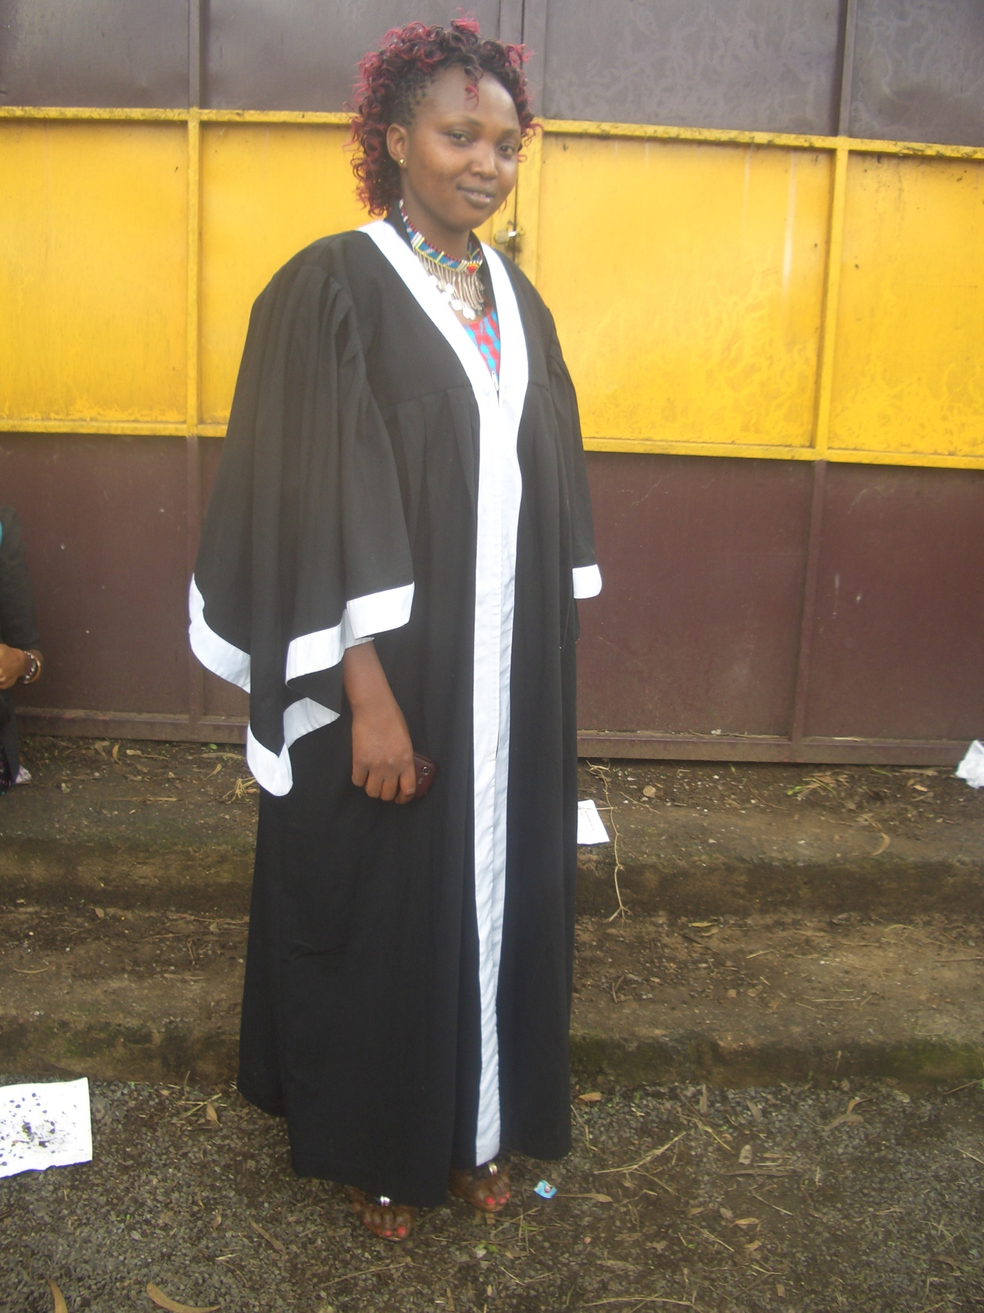
PHOTO ABOVE: A MAASAI GIRL KNOWN AS EUNICE NASERIAN ON HER GRADUATION DAY IN NAIROBI KENYA MEDICAL TRAINING COLLEGE.

NOTE: The Church also had another student graduate at Moi University in Kenya in September 2015 under the Church sponsorship programme for poor/orphan children.

8TH THROUGH TO 12TH DECEMBER 2015: The Church conducted a powerful and spiritually life-transforming youth camp at the Olooltoto Maasai village Church which involved many youth coming to learn wholistic aspects of well-rounded youth, coupled with life skills. There were plenary and small groups sessions. Topics were diverse and interesting such as youth sexuality, youth and integrity, youth and career choice, youth and salvation and Christian service.

PHOTO BELOW: A SMALL GROUP YOUTH BIBLE STUDY SESSION DURING THE CHURCH YOUTH CAMP IN NAROK KENYA IN DECEMBER 2015

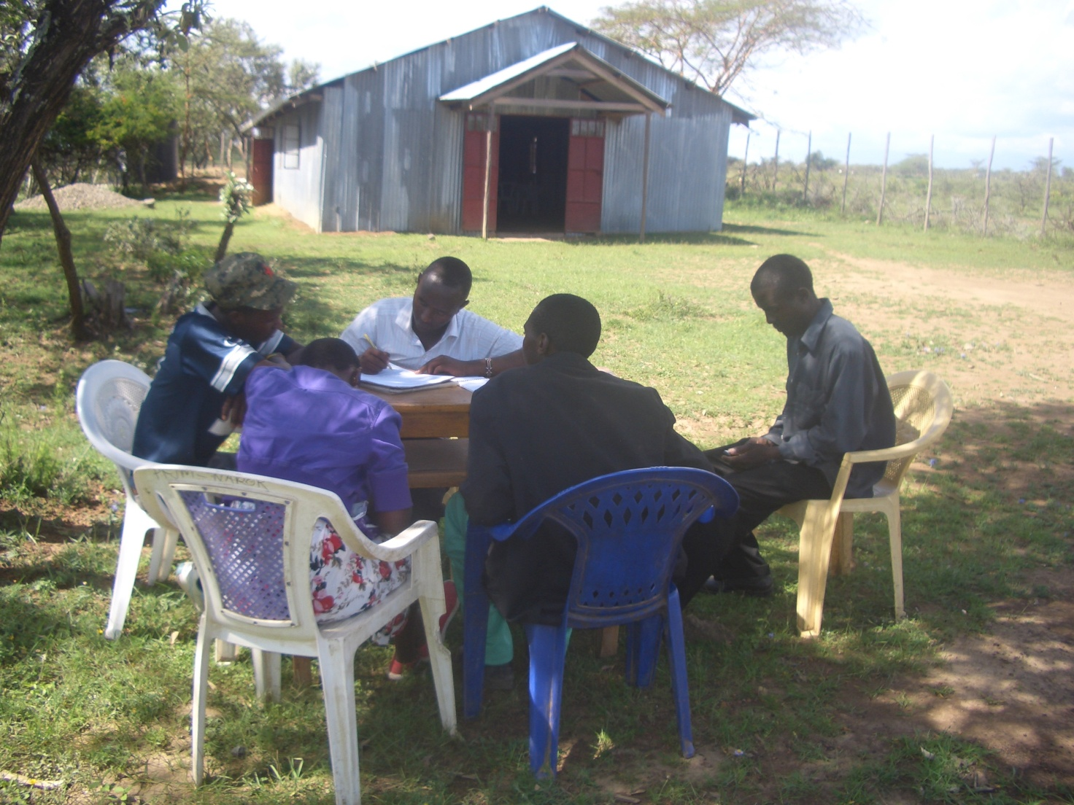

BIG MEAL 2015: WE WERE ABLE TO FEED NEEDY/POOR/ORPHAN CHILDREN ON DELICIOUS MEALS ON 25TH DECEMBER 2015 IN OUR ANNUAL EVENT DUBBED BIG MEAL. THIS YEAR 2015, WE HAD 500 CHILDREN FROM NAROK COUNTY, 60 CHILDREN IN NAROBI COUNTY, 90 CHILDREN FROM KISUMU COUNTY (40 CHILDREN IN NYAKACH KENYA, 50 CHILDREN IN NYAMKEBE KENYA), AND 250 CHILDREN IN OUR TANZANIA CHURCHES OF MOROGORO AND DARESALAAM. WE TOOK CARE OF ABOUT 840 CHILDREN IN TOTAL IN BIG MEAL 2015. IT WAS A WONDERFUL TIME OF SINGING, POEMS, GOSPEL SHARING, AWARD GIVING FOR ALL KINDS OF CHILDREN IN DIFFERENT AREAS OF PARTICIPATION. WE CROWNED IT ALL WITH EATING DELICOIUS MEALS THAT THE CHILDREN COULD NOT FINISH. THEY ATE TO THE FULL AND STILL LEFT SOME FOOD. SOME OF THE CHILDREN CAME WITH THEIR PARENTS WHO ALSO ENJOYED BEING WITH THEIR CHILDREN.
I TRULY THANK THOSE WHO SUPPORTED THE BIG MEAL 2015.
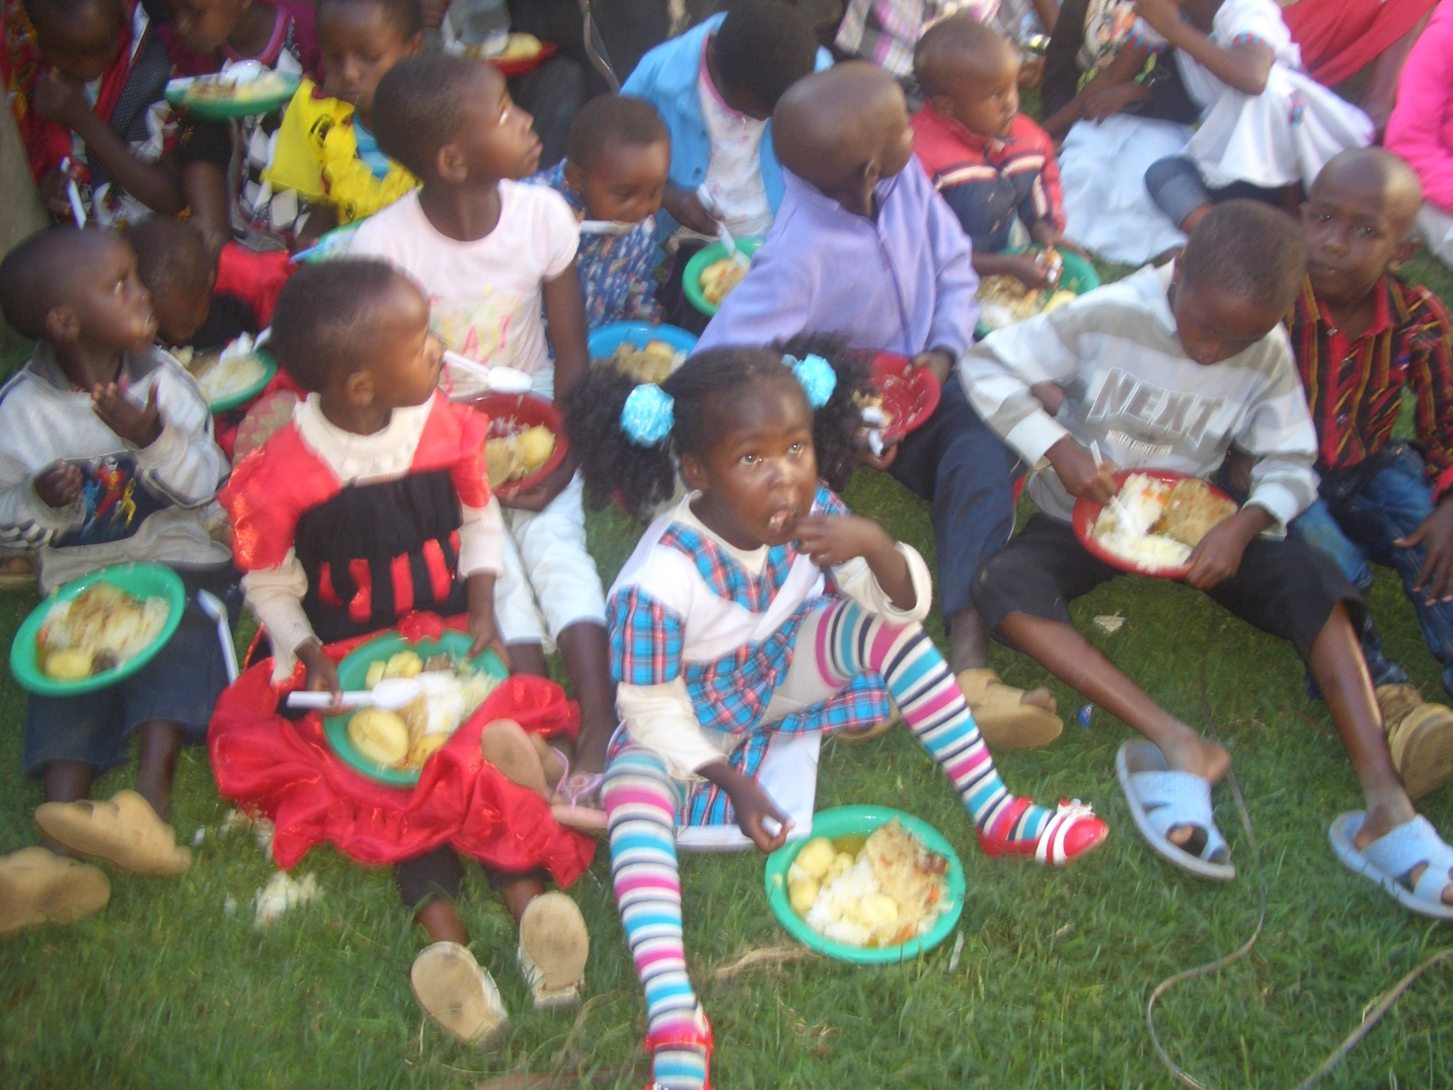
PHOTO ABOVE: PFJM BIG MEAL 2015 AT THE NAROK TOWN CHURCH ON 25TH DECEMBER 2015

WIDOWS AND THE POOR PEOPLE'S PROJECTS NEED YOUR SUPPORT
PFJM has established a self-help project called ''Cluster Dynamics'' which are designed to pull together groups of 5, 10 or 15 people from within a community group who are mutually in great need. The groups are tasked with developing a micro-project which will generate income for the group in order that they can support themselves and their families.
The groups mainly made up of destitute women, are poor for a number of reasons but mainly due to the tragedy of HIV/AIDS which affects each family in one way or another. Some suffer from the disease themselves, others as a result of losing their husband by HIV/AIDS. The result is that the remaining partner (usually wife and mother) is left to support a number of children. PFJM can help these groups get established by providing one time initial set up grant of £450, 900 and 1350 respectively, allowing them to get going with their project and bring in the much needed income that will grow the project and support the group and their dependants. PFJM will closely monitor the projects to ensure that they are profitable to the groups. You can invest in this worthy course that can profitably change lives of the poor widows and others for a life time. Currently, we have the groups of 5, 10 and 15 ready to move with any support that comes to them. ON 2ND JANUARY 2016, THE FIRST ACTIVE CLUSTER GROUP WILL BE SHARING AN ANNUAL PROFITS. PLEASE HELP THESE POOR PEOPLE TRANSFORM THEIR LIVES BY YOUR ONE TIME SUPPORT.

PRAYER/PRAISE ITEMS AND PLANS & HOW TO BE PART OF THIS WORK
The mission work we are involved in is too dynamic and enormous for us to do on our own. We surely appreciate your partnership by prayer, support, and personal involvement.

- Narok Town Headquarters Church Land Purchase and Church Building at a cost of United Kingdom Pounds £22,000 or US$35,000. We thank all who have thus far donated. We have identified a piece of land in Narok town which costs US$15,000. The land is not yet bought due to insufficient funds. We still need more funds.
- Monthly Pastor's Family Support of US$300 (rural areas) or US$480 (urban areas)
- Orphans and Destitute children monthly support £20 or US$35. This year we have many needy children in the programme awaiting support.
- Needy College/University Students support and High School Students support needed.
- New Church Planting Mission in Pakistan at Lahore . Pakistan pastor being trained by PFJM so that he takes over the work. Other Church plants in Africa e.g.. in Ngong', Kitale and Katolo in Kenya, Uganda in Lira, etc.
- We need Church Sanctuary and Primary school buildings in Tanzania Church. School, orphanage, clinic and guest house Building proposals in Narok and in Kisumu areas in Kenya.
- Mission Emphasis Programmes and community development projects in Kenya going on throughout the year.
- PFJM Tanzania Church needs prayers: To be officially registered by the Tanzania government. Bible school graduation to be held in August 2016. That church needs to build a sanctuary.
- Pray for the upcoming Crusade and Revival meeting in Narok Town Church on 26th, 27th and 28th March 2016.
- Pray for Church Annual General Meeting to be held on 20th November 2016.
- Thanks to God for the mission/outreach work that was done in Nyakach, Eldoret, Nairobi and Narok
- Pray for the Big Meal 2016 events for the needy children feeding and awards programme on Christmas Day. Also pray for the End of Year seminar and end year prayer vigil.

SPECIAL THANKS TO ALL OF YOU FOR YOUR PRAYERS, SUPPORT AND ACTUAL PERSONAL PARTICIPATION IN THE WORK THAT WE DO. YOU HAVE ENABLED US TO MEET EDUCATION, MATERIAL, PLUS OTHER NEEDS OF MAASAI COMMUNITIES IN NAROK AND AROUND THE NATION OF KENYA. YOU HAVE ALSO ENABLED US TO PREACH THE TRUE GOSPEL AS WE MAKE DISCIPLES OF CHRIST IN KENYA AND IN OTHER NATIONS.
BECAUSE OF YOUR PRAYERS AND SUPPORT, WE WERE ABLE TO SUCCEED IN THE YEAR 2015. WE ASK YOU TO KEEP ON STANDING WITH US FOR THE SAKE OF THE WORK OF GOD'S KINGDOM AND FOR MINISTERING TO POOR/NEEDY COMMUNITIES.

HAPPY NEW YEAR 2016. THE YEAR OF TRIUMPH IN THE POWER OF JESUS CHRIST.
2 CORINTHIANS 2:14

WE CONTINUE TO TRULY VALUE YOUR PARTNERSHIP (PHILIPPIANS 1:5). THANK YOU!!!

