PEOPLE FOR JESUS MINISTRY,
P.O. BOX 1008,
Narok, 20500, KENYA,
EAST AFRICA
TEL: 254-721-204447 OR 254-736-574413
E-mail: peopleforjesusintmin@gmail.com

YOUR REF: ________ OUR REF: NRK/UP.2/2017 DATE: 30TH JUNE 2017

Dear Saints, Friends, well-wishers, and Partners,

GLORY TO THE LORD JESUS CHRIST!!!
We send warm greetings from the People For Jesus Ministry (PFJM) family. We are blessed to be busy preaching the gospel of the Kingdom of God in different places and in many diverse acts of demonstrating Christian love. Activities such as regular Church daily, weekly and monthly programmes and projects are going on. Since the whole Church is engaged in many aspects of ministries and services locally and globally, we have just given a summary of what we have done in the last quarter which is not exhaustive. The Church continues to work in communities with many poor orphans, the disabled, widows, pupils, prisons, students, and people at risk who need our support but we thank God that we are able to help some of them with your partnership in this work. It is our hope and earnest prayers that you are doing your very best in all your endeavours, especially in your service in the Kingdom of God and in different communities around the world.

APRIL 2017
PHOTO BELOW: SOME OF THE MAASAI COMMUNITY CHURCH LEADERS AT NAROK RECEIVE TRAINING VIA COMPUTERS IN OUR ON-GOING LEADERSHIP COMPUTER-COMPLIANCE COURSES AT NAROK TOWN.
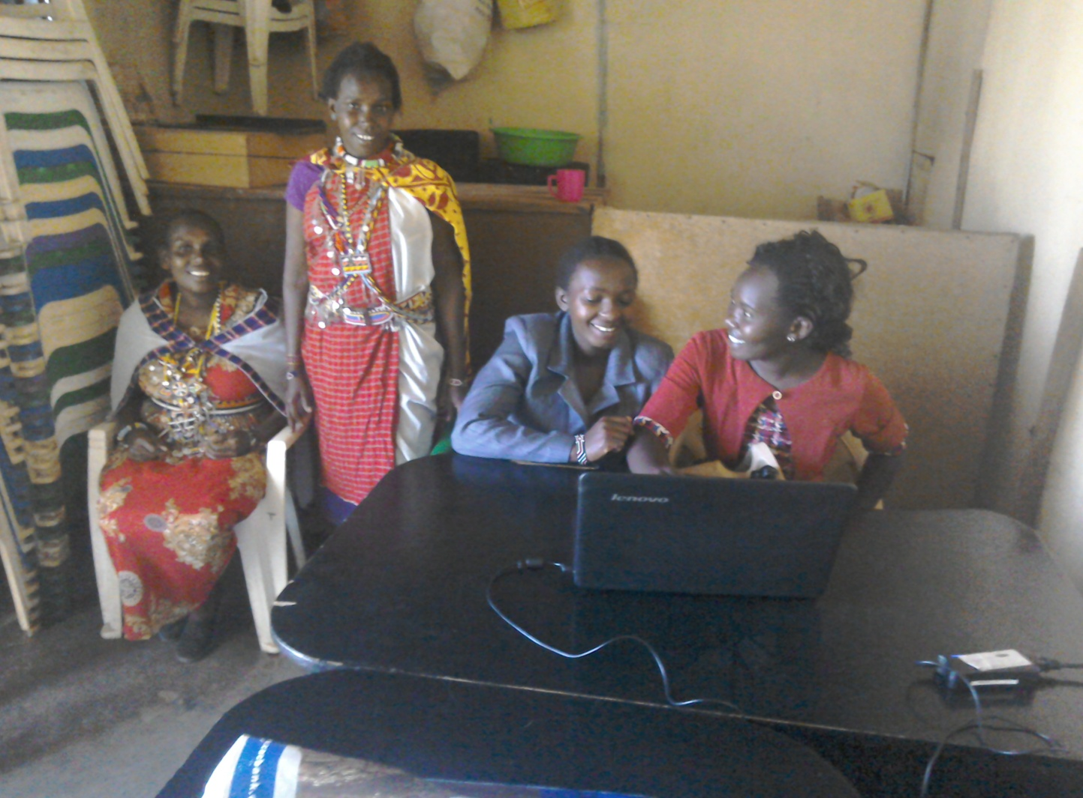

PEOPLE FOR JESUS MINISTRY MISSION/OUTREACH TEAM COUNCIL
People For Jesus Ministry has a mission team or Mission Council that plans and implements local, regional and international missions programmes. That includes crusades, church planting, prayers and intercessory prayers, community evangelistic Outreach programmes and projects. The team also mobilizes, recruits, sends and support long-term and short-term missionaries and teams to different parts of the world. The Mission Team also hosts volunteer missionaries from every part of the world. The Mission Council meets every month to pray, plan and implement Church mission programmes. Please contact us for details on how you can participate.

PHOTO BELOW: Pastor Tom's graduation day at Pan Africa Christian University in Nairobi Kenya on 28th October 2016. He is pursuing further undergraduate theological studies but currently he unable to be in school session because he does not have the requisite university fees. Keep him in prayers.

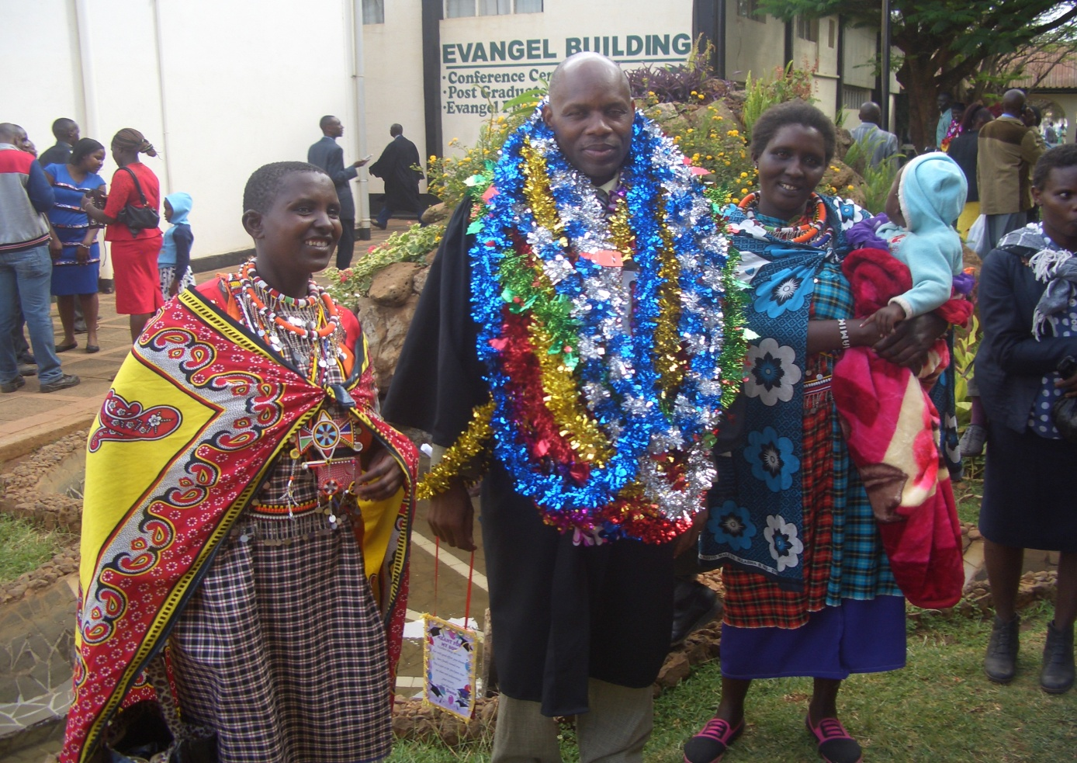

CHURCH DISABLE SUPPORT PROGRAMME
The Church has a disabled centre in Nairobi at Kayole known as Hekalu Disabled Support Centre. The PFJM Church and their partners support the disabled centre by giving wheel chairs, food, furniture, physiotherapy equipment, etc. The disabled centre is currently located within the PFJM Kayole Nairobi Church compound. The children are many. Brailes are needed for special reading and writing. Physiotherapy equipment and financial support is needed for the many needs of the disable children. The number of disabled children applicants who need help are increasing each day, but we cannot take in more since we do not have enough space and sufficient facilities for more than the number we currently assist.

PHOTO ABOVE: WOMEN SEMINAR AT NAROK TOWN CHURCH IN KENYA IN APRIL 2017
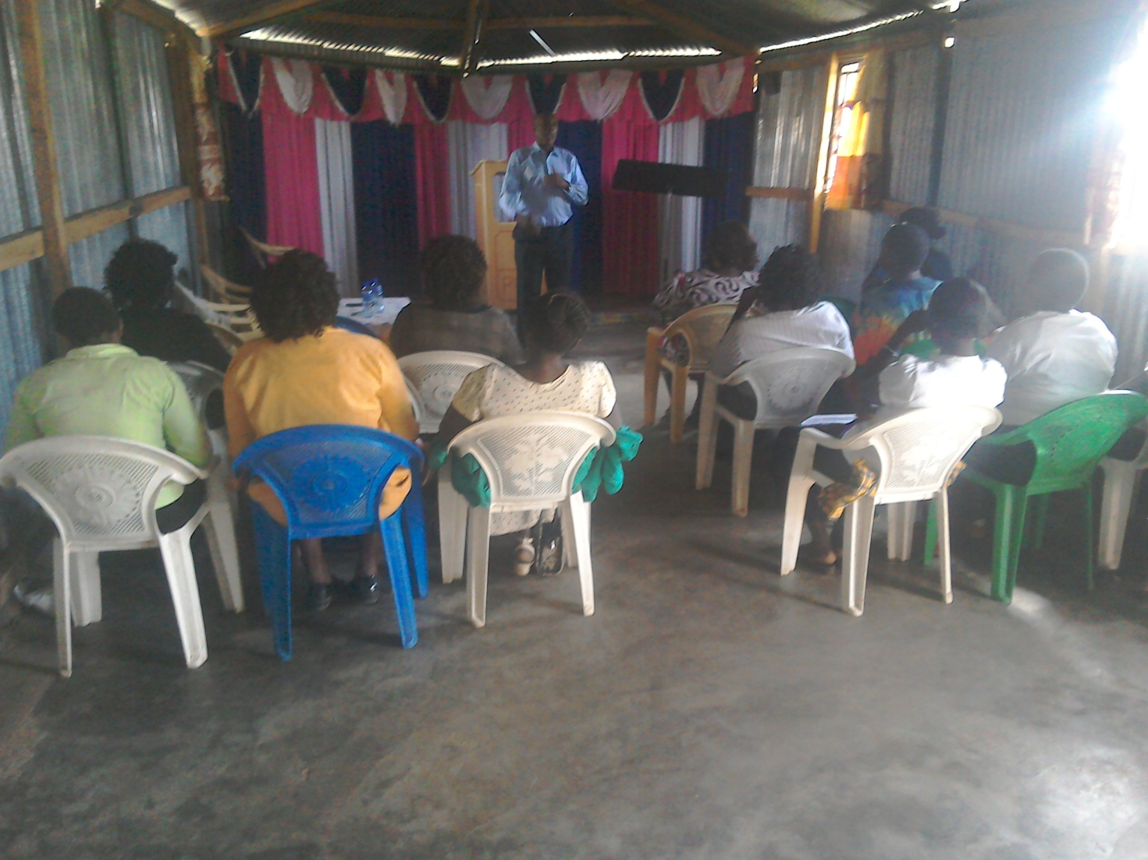
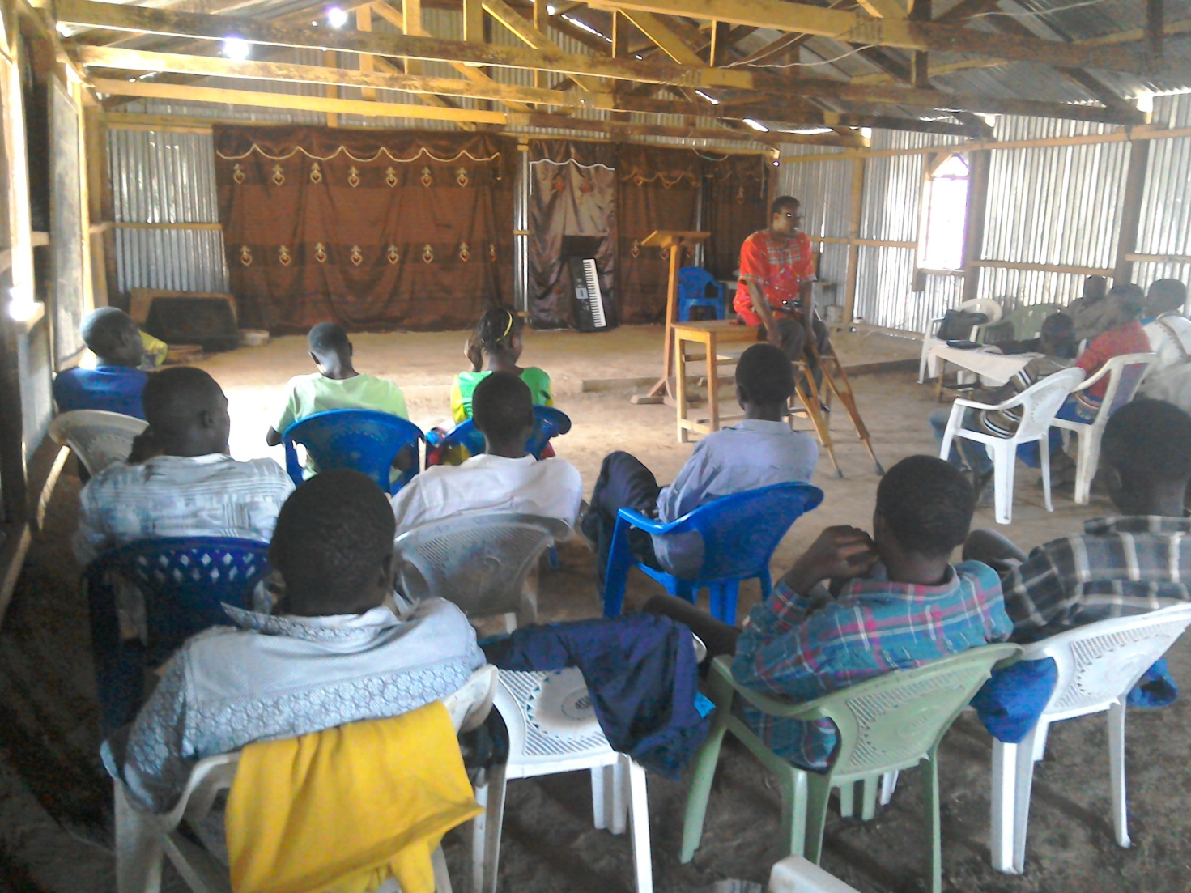
PHOTO ABOVE: A PASTOR TEACHING AT OUR NAROK COUNTY YOUTH RALLY HELD AT OLOOLTOTO MAASAI VILLAGE CHURCH SANCTUARY ON 14TH APRIL 2017. ON THE SAME DAY AT NIGHT, THE YOUTH HELD AN OVERNIGHT REVIVAL PRAYER VIGIL. MANY YOUTH WERE IN ATTENDANCE. WE CONDUCTED YOUTH RALLIES IN DIFFERENT REGIONS OF KENYA ON THE SAME DAY.

NAROK TOWN CHURCH LAND AND SANCTUARY
NAROK TOWN CHURCH IS STILL SEEKING FOR SUPPORT FOR THE PURCHASE OF LAND AND THE CONSTRUCTION OF A CHURCH SANCTUARY. PLEASE KEEP US IN PRAYERS SO THAT WE RAISE US$35,000 FOR THE CHURCH BUILDING PROJECT. CHURCH MEMBERS HERE IN NAROK KENYA CONTINUE TO CONDUCT SOME FUNDSDRIVES. THE VALUE OF LAND KEEPS RISING UP SO THE SOONER WE PURCHASE LAND THE BETTER. PLEASE JOIN US IN RAISING THE FUNDS.

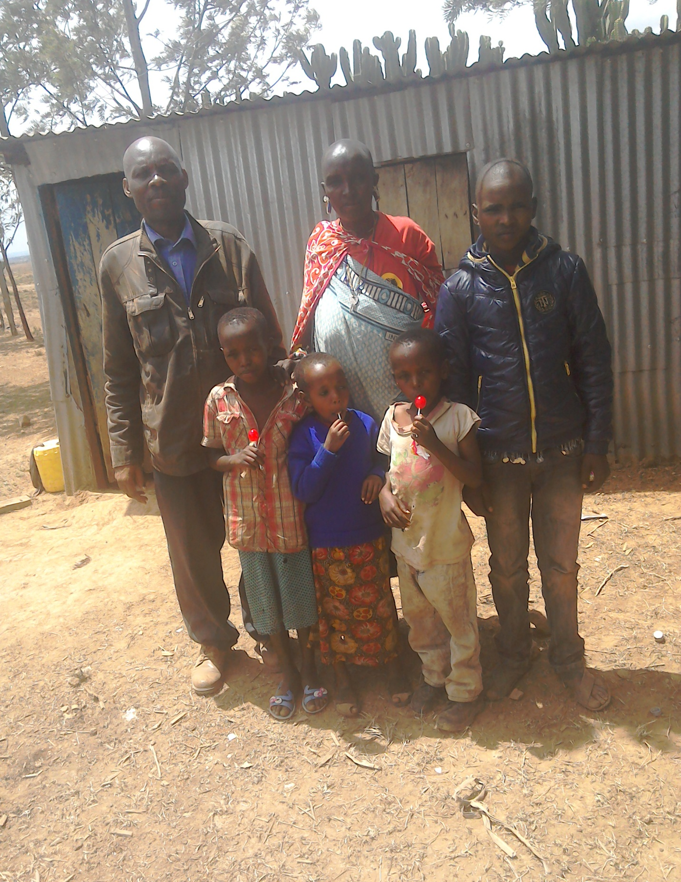
PHOTO ABOVE: PASTOR TOM VISITING ORPHANS IN NAROK VILLAGES ON 17TH APRIL 2017 DURING THE CHURCH 2017 ANNUAL CHRISTIAN SERVICE DAY. THIS YEAR WE WERE MINISTERING TO THE POOR AND THE SICK. THE CHILDREN ARE TOTAL ORPHANS. THE BOY ON THE RIGHT HAND SIDE IS THE ELDEST IN THE FAMILY AND WE HAVE TAKEN HIM TO SCHOOL, PRIMARY STANDARD ONE IN APRIL 2017.
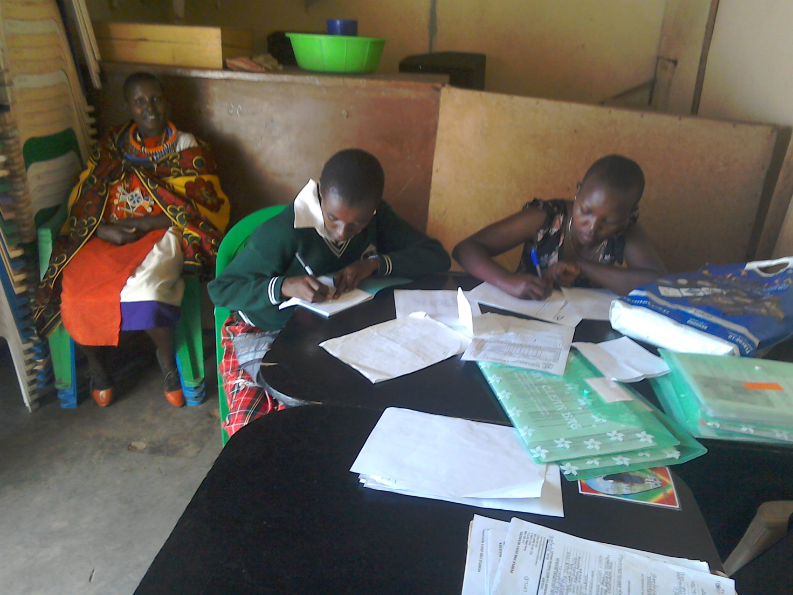
PHOTO ABOVE: MAASAI GIRLS STUDENTS SPONSORED BY THE CHURCH WRITING TERMLY REPORTS IN ARPIL 2017

MAY 2017

FAMILY ISSUES: THE YOUNGEST SON TO PASTOR TOM, JOSHUA HUGH, WHO IS TWO AND HALF YEARS OLD, HAS HAD SERIOUS PNEUMONIA AND MALARIA IN MAY AND JUNE. HE IS RECOVERING NOW. REMEMBER THAT THIS SEASON, JUNE TO EARLY AUGUST, IS OUR WINTER PERIOD. MY HOUSE IN THE UPCOUNTRY VILLAGE IS NOT YET COMPLETE. WE NEED $20,000 TO COMPLETE THE CONSTRUCTION OF THE HOUSE. HELP IS SURELY NEEDED IN THAT ENDEAVOUR. PETER AND DEBORAH ARE IN SCHOOL AND THEY ARE DOING WELL. EUNICE AND PASTOR TOM ARE BUSY AS USUAL WITH MISSIONS AND OUTREACH PROGRAMMES IN SERVICE TO THE LORD. THANKS FOR YOUR PRAYERS.

ORPHANS/VULNERABLE CHILDREN AND STUDENTS SUPPORT AND SPONSORSHIP:
The Church launched a serious 'school drop outs back to school' campaign programme in February 2014 as part of the Church sponsorship programme. The programme is targeting pupils/students who dropped out of school for various reasons especially among the Maasai communities in Narok county. We have thus far managed to support some pupils/students beneficiaries in the programme. Thanks to those who responded to our plea to help school drop outs plus those who have not been able to make it to school to go to school. We have not yet reached our target and many more children who need to go to school are increasing. YOU CAN GIVE AS LITTLE AS £15 PER MONTH OR £180 PER YEAR, US$25 PER MONTH OR US$300 PER YEAR TO ENABLE A STUDENT GO BACK TO GOVERNMENT DAY SECONDARY SCHOOL. About half of the funds is used for the purchase of school uniforms. You can also help a child go back to primary school by giving US$100 per year. THE CHILDREN/STUDENTS BEING SPONSORED ARE FINE AND DOING THEIR VERY BEST IN SCHOOL. WE THANK ALL SPONSORS HELPING THE ORPHANS AND VULNERABLE CHILDREN/STUDENTS.

PHOTO BELOW: CHURCH LEADERS CONFERENCE HELD AT NAROK TOWN BY PEOPLE FOR JESUS MINISTRY ON 2ND AND 3RD MAY 2017
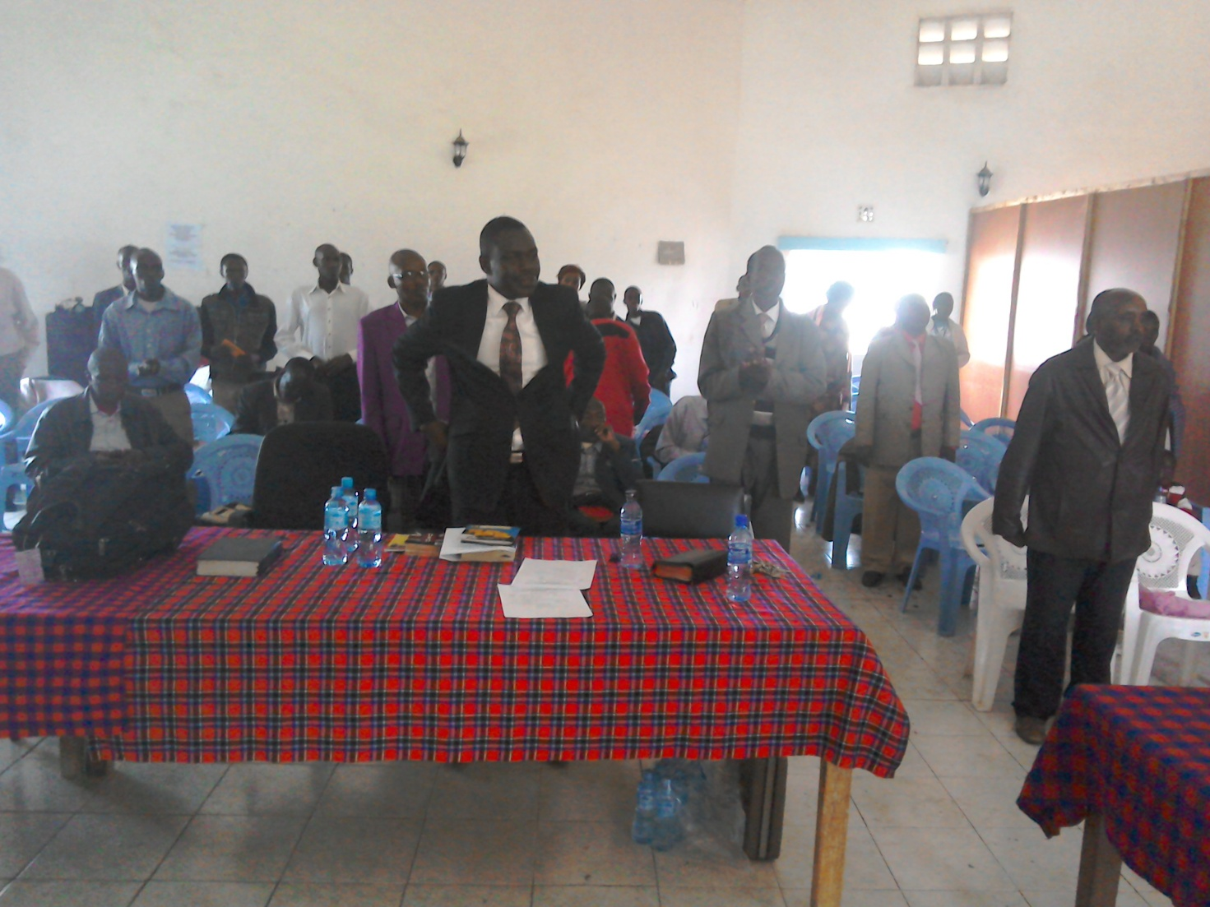

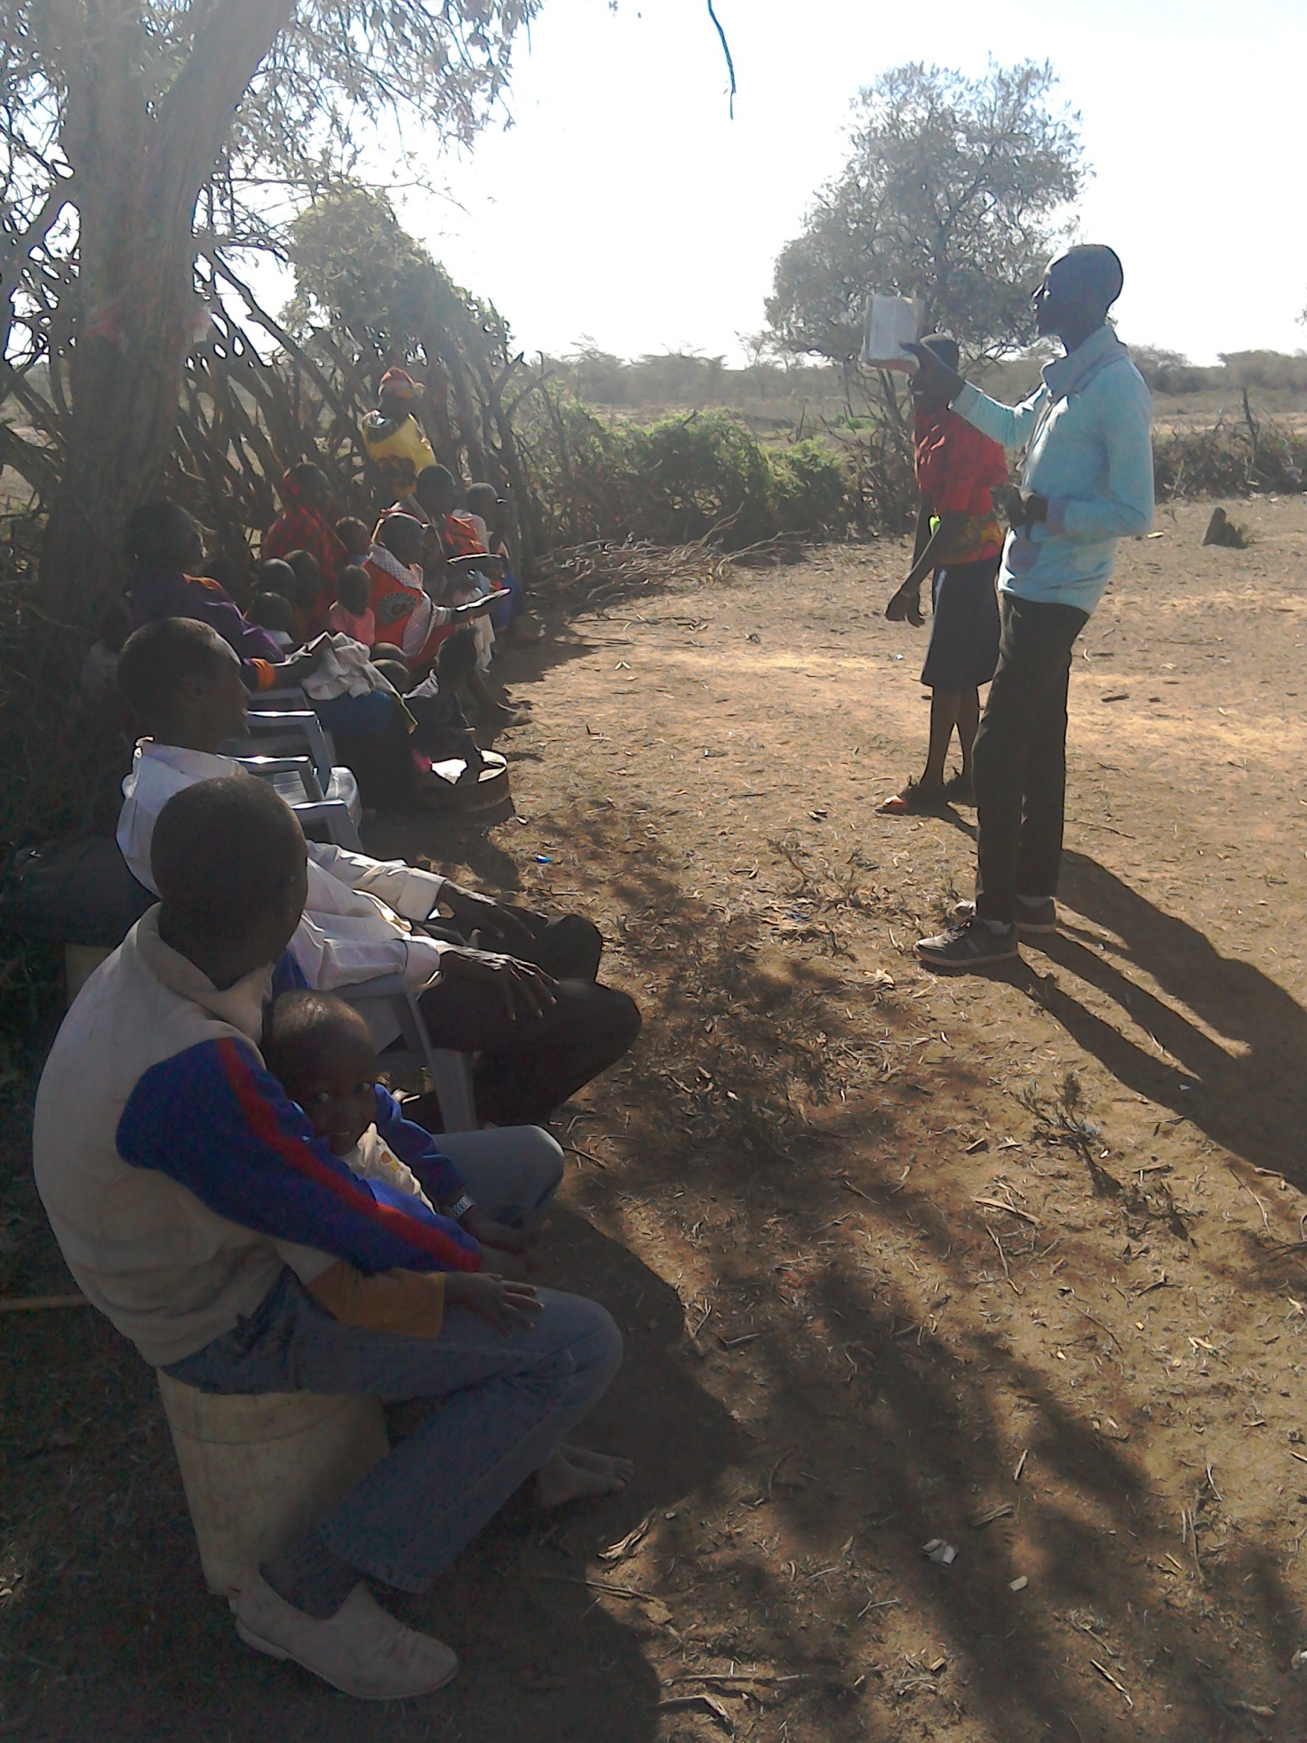
PHOTO ABOVE: MIDWEEK FELLOWSHIP AT OLOOLTOTO NAROK CHURCH IN MAY 2017. THE LORD HAS BLESSED THE CHURCH DESPITE SERIOUS DROUGHT.

ADULT/LITERACY EDUCATION:
THE MAASAI VILLAGE ADULT/LITERACY CLASS IS GOING ON. 85% OF THE CLASS ARE WOMEN AND GIRLS. THE PROBLEM OF EARLY MARRIAGES AMONG THE MAASAI GIRLS NECESSITATES THAT THEY DROP OUT OF SCHOOL OR NEVER MAKE IT TO SCHOOL SO THAT THEY GET MARRIED AND EARN THEIR FAMILY A WEALTH OF MANY COWS PAID AS DOWRY. THE CHURCH IS ADDRESSING THAT EDUCATION GAP BY CONDUCTING CLASSES FOR THOSE WHO HAVE EITHER DROPPED OUT OF SCHOOL OR THOSE WHO NEVER MADE IT TO ANY SCHOOL. THANKS TO THOSE WHO HAVE BEEN ABLE TO SUPPORT US. PLEASE JOIN US IN THIS ENDEAVOUR AT USD$70 PER MONTH PER CLASS. CURRENTLY, DROUGHT HAS BEEN DISRUPTING OUR CLASSES SINCE THE MAASAI COMMUNITY ARE BASICALLY PASTORALISTS AND THEY HAVE TO LOOK FOR PASTURE AND WATER FOR THEIR LIVESTOCK. THE CLASSES WILL SOON RESUME. WE HAVE INTERGRATED CLASSES WITH INCOME GENERATING ACTIVITY TO ENABLE ADULTS EARN A LIVING AS THEY LEARN. WE CALL IT 'FEED BOTH THE MIND AND THE BODY'.

KANDARIA SECONDARY SCHOOL UPDATES

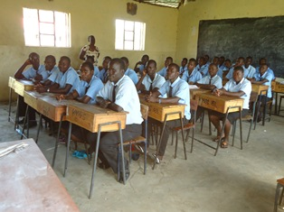
PHOTO ABOVE: Kandaria Secondary School located in Kandaria village in Kisumu County in Kenya. The school currently needs a kitchen, £4000, and an extra classroom, £10,000. The Church and their partners are doing what they can to ensure that Kandaria community have access to secondary school education despite the remoteness of the village next to Lake Victoria in Kenya.
JUNE 2017
TANZANIA CHURCH UPDATES
The Church in Dar Esalaam is doing well and there is a new leader. Our Tanzania Overseer, Pastor Samuel Mbanga, has now relocated to Morogoro to lead the whole Tanzania Church from there and to run the Church School of Ministry. He has already had a New Church plant in Morogoro in May 2017. We have four local Churches in Morogoro and one local Church at Dar Esalaam. The Church runs a nursery school in Morogoro and in Dar Esalaam.
Keep us in prayers as Kenya missions/outreach team plans to travel there on 21st to the 28th of August 2017. We need to build the Church sanctuaries and to build the School of Ministry and the nursery/primary schools in Dar Esalaam and Morogoro.

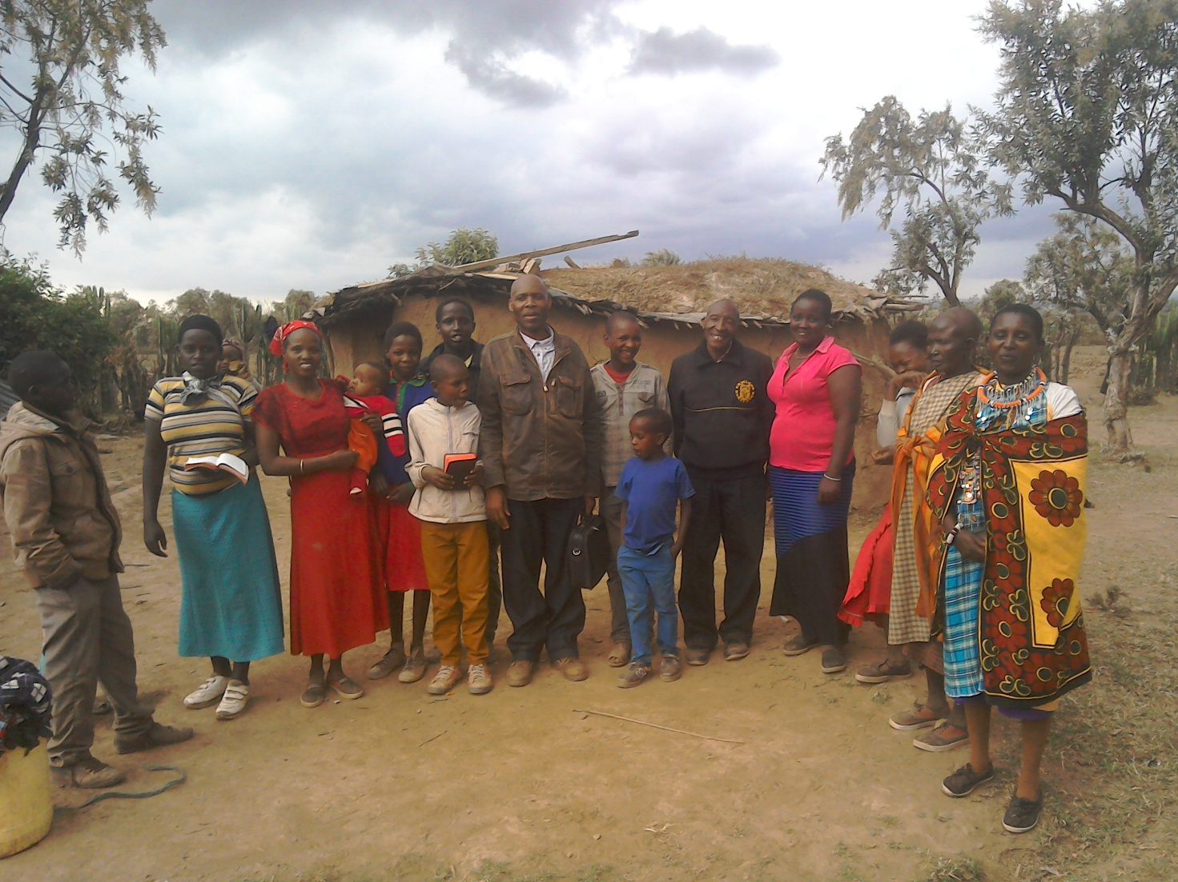
PHOTO ABOVE: OLOOLTOTO CHURCH MIDWEEK FELLOWSHIP IN JUNE 2017

SOME OF THE YEAR 2017 P.F.J.M PLANS

>>> Missions/Outreach Council: Church plants in Kenya at Eldoret and Ngong' in Kenya. Church plant in Pakistan in October 2017. Church planting survey in Liberia, and Uganda. Church plant visits in Kenya in Nyamkebe, Nyakach, Eldoret, Ongata Rongai, and Nairobi.
Mission trip and graduation of Bible class in PFJM Tanzania in August 2017. Gospel outreaches/evangelistic campaigns in Kenya.
>>> Adult/Literacy education classes among the Maasai community of Narok Kenya.
>>>Funds-drives for the Narok town Church purchase of land and building of Church Sanctuary.
>>> Supply computers and begin computer learning classes at PFJM Narok town Church.
>>> Education sponsorship programmes. Support programmes for poor and needy people/communities.
>>>Visit and support mobilization for disabled centres in Nairobi Kenya.
>>>Bible school establishment in Kenya.
>>>Children Vocational Bible School camp.
>>>Youth camp and quarterly youth rallies.
>>> Other Youth, women, children, programmes. End year celebration, Big meal celebration, etc.
>>> Annual PFJM National leadership conference on 20th to 24th November 2017 at Narok.
>>>>> Annual General meeting in PFJM Narok town Church on 25th November 2017.

PHOTO BELOW: DROUGHT SITUATION IN NAROK, ESPECIALLY IN OLOOLTOTO AREA, NECESSITATED THE NEED FOR CLEAN DRINKING WATER. THE CHURCH DOING THEIR BEST TO SUPPLY WATER TO THE COMMUNITY THROUGH PARTNERS. WE NOW HAVE CLEAN DRINKING WATER AVAILABLE AT THE CHURCH AT ALL TIMES. ALL THE CONCRETE UNDERGROUND TANKS AND THE BIG PLASTIC TANKS ARE IN GOOD WORKING CONDITIONS.
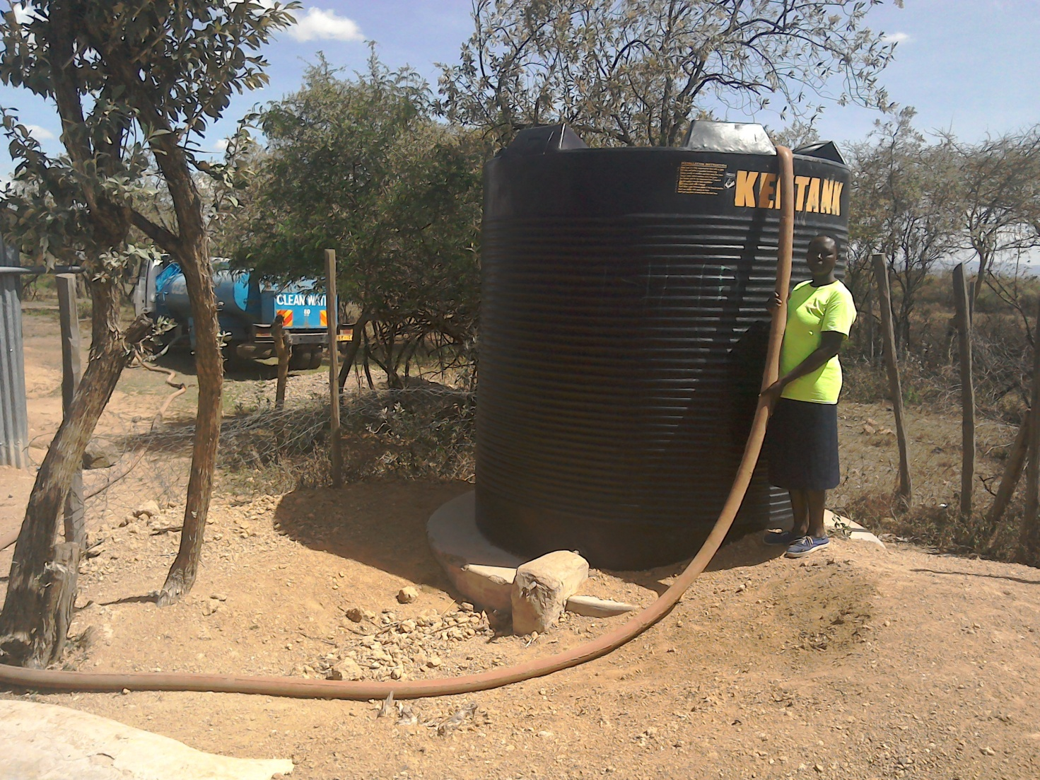

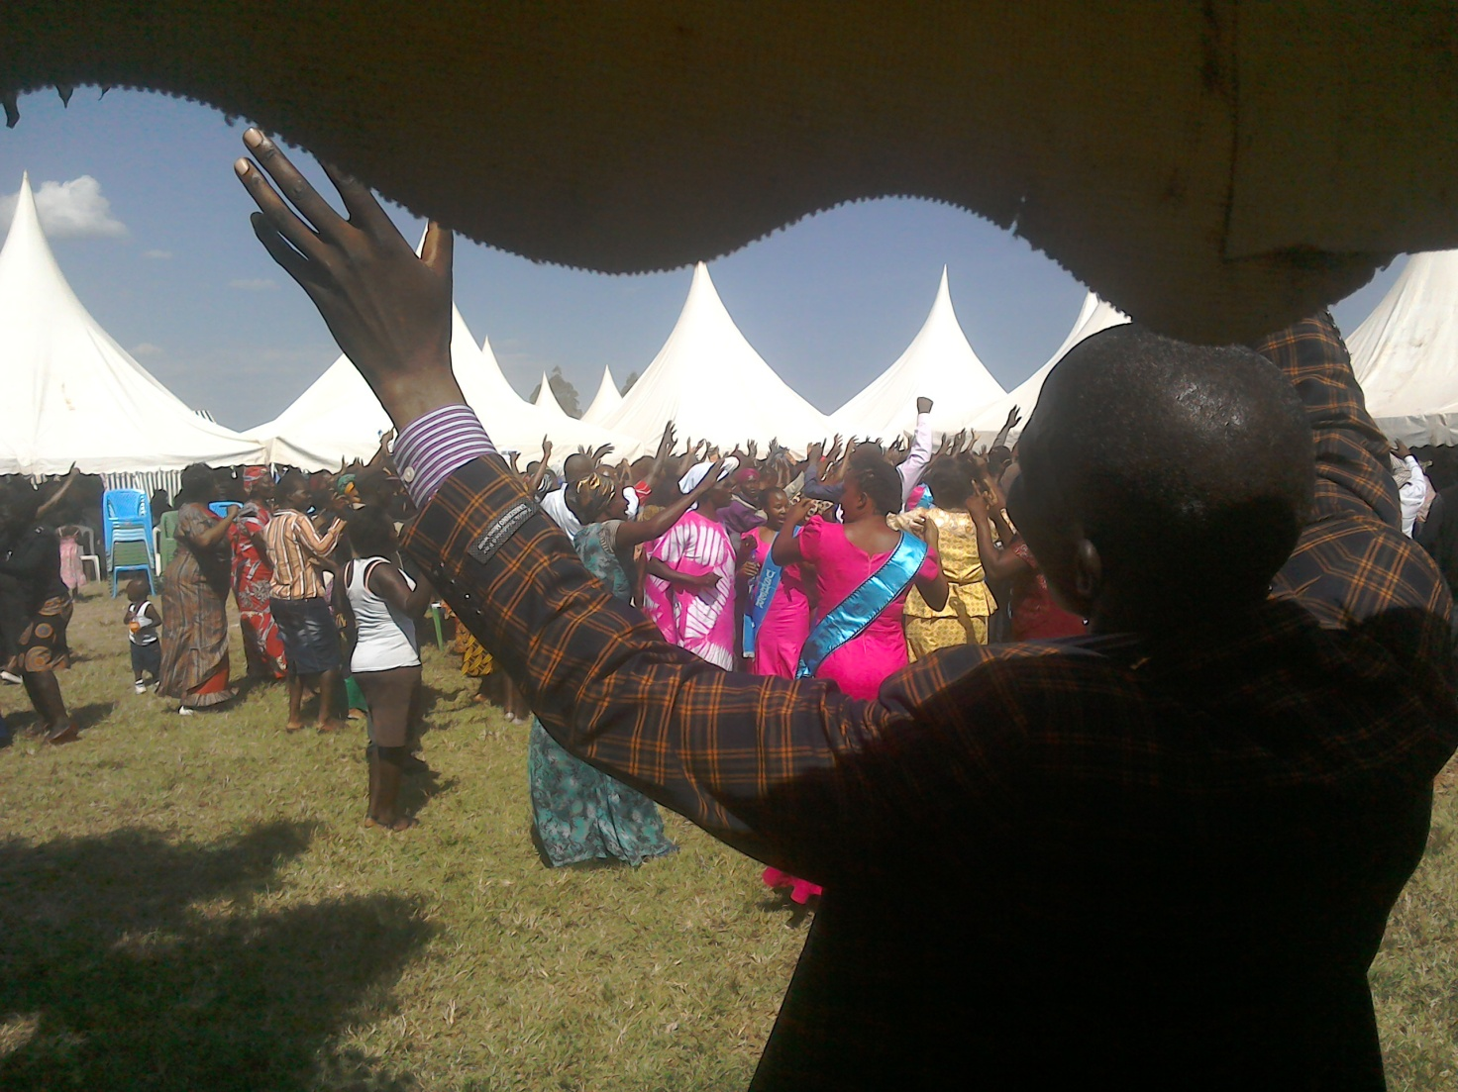
PHOTO ABOVE: PREACHING AT A KISUMU FUNERAL EVENT TURNED INTO A BIG CHRIST'S CRUSADE IN WHICH LEADERS OF PEOPLE FOR JESUS MINISTRY PARTICIPATED ON 24TH JUNE 2017

WIDOWS AND THE POOR PEOPLE'S PROJECTS NEED YOUR SUPPORT
PFJM has established a self-help project called ''Cluster Dynamics'' which are designed to pull together groups of 5, 10 or 15 people from within a community group who are mutually in great need. The groups are tasked with developing a micro-project which will generate income for the group in order that they can support themselves and their families.
The groups mainly made up of destitute women, are poor for a number of reasons but mainly due to the tragedy of HIV/AIDS which affects each family in one way or another. Some suffer from the disease themselves, others as a result of losing their husband by HIV/AIDS. The result is that the remaining partner (usually wife and mother) is left to support a number of children. PFJM can help these groups get established by providing one time initial set up grant of £500, 1000 and 1500 respectively, allowing them to get going with their project and bring in the much needed income that will grow the project and support the group and their dependants. PFJM will closely monitor the projects to ensure that they are profitable to the groups. You can invest in this worthy course that can profitably change lives of the poor widows and others for a life time. Currently, we have the groups of 5, 10 and 15 ready to move with any support that comes to them. ON 2ND JANUARY 2017, THE SECOND CLUSTER GROUP SHARED THEIR ANNUAL PROFITS. PLEASE HELP THESE POOR PEOPLE TRANSFORM THEIR LIVES BY YOUR ONE TIME SUPPORT.

PRAYER/PRAISE ITEMS AND PLANS & HOW TO BE PART OF THIS WORK
The mission work we are involved in is too dynamic and enormous for us to do on our own. We surely appreciate your partnership by prayer, support, and personal involvement.

- Narok Town Headquarters Church Land Purchase and Church Building at a cost of United Kingdom Pounds £22,000 or US$35,000. We thank all who have thus far donated. We have identified a piece of land in Narok town which costs US$15,000. The land is not yet bought due to insufficient funds. We still need more funds.
- Monthly Pastor's Family Support of US$300 (rural areas) or US$480 (urban areas)
- Orphans and Destitute children monthly support £20 or US$35. This year we have many needy children in the programme awaiting support.
- Needy College/University Students support and High School Students support needed.
- New Church Planting Mission in Pakistan at Lahore . Pakistan pastor being trained by PFJM so that he takes over the work. Other Church plants in Africa e.g.. in Ngong', Kitale, Mumias and Katolo in Kenya, Liberia, Uganda in Lira, etc.
- We need Church Sanctuary and Primary school buildings in Tanzania Church. School, orphanage, clinic and guest house Building proposals in Narok and in Kisumu areas in Kenya.
- Mission Emphasis Programmes and community development projects in Kenya going on throughout the year. Thanks to Africa Pastors Fellowship who gave us a chance to partner with them in Church leadership empowerment programmes.
- PFJM Tanzania Church needs prayers: To be officially registered by the Tanzania government. Bible school graduation to be held in August 2017. That church needs to build a sanctuary in different places we have Church plants.
- Thank God for a successful leadership conference held in Narok town on 2nd and 3rd May 2017. Thanks to you and to God for the Youth Rally held in Kenya on 14th April 2017.
- Pray for missions/outreach work in early August 2017 in Eldoret, Church plant survey in Liberia in November 2017, Tanzania outreach in August 2017 at Dar Esalaam and Morogoro.
- Annual missions/outreach emphasis months in June through to September 2017.
- Thanks to God for many outreach activities that took place in Narok and other parts of Kenya in April 2017.
- Pray for Church Annual General Meeting to be held on 25th November 2017. Pray for Church Annual National Church Leaders conference for 20th to 24th November 2017.
- Pray for the Big Meal 2017 events for the needy children feeding and awards programme on Christmas Day. Also pray for the End of Year seminar and end year prayer vigil.

SPECIAL THANKS TO ALL OF YOU FOR YOUR PRAYERS, SUPPORT AND ACTUAL PERSONAL PARTICIPATION IN THE WORK THAT WE DO. BECAUSE OF YOUR PARTNERSHIP, WE ARE ABLE TO MEET EDUCATION AND MATERIAL NEEDS OF MAASAI COMMUNITIES IN NAROK AND AROUND THE NATION OF KENYA, BESIDES SERVING OTHER PEOPLE. YOU HAVE ALSO ENABLED US TO PREACH THE TRUE GOSPEL AS WE MAKE DISCIPLES OF CHRIST IN KENYA AND IN OTHER NATIONS.
WE ASK YOU TO KEEP ON STANDING WITH US FOR THE SAKE OF THE WORK OF GOD'S KINGDOM AND FOR MINISTERING TO POOR/NEEDY COMMUNITIES.

THE YEAR 2017: THE YEAR OF OVERCOMING OBSTACLES FOR DISTINGUISHED SERVICE.
GENESIS 50:15-21

YOUR PARTNERSHIP IS GREATLY VALUED (PHILIPPIANS 1:5). THANK YOU!!!

