PEOPLE FOR JESUS MINISTRY,
P.O. BOX 1008,
Narok, 20500, KENYA,
EAST AFRICA
TEL: 254-721-204447 OR 254-736-574413
E-mail: peopleforjesusintmin@gmail.com

YOUR REF: ________ OUR REF: NRK/UP.3/2017 DATE: 30TH SEPTEMBER 2017

Dear Saints, Friends, well-wishers, and Partners,

GLORY TO THE LORD JESUS CHRIST!!!
Receive warm greetings from the People For Jesus Ministry (PFJM) family. We are blessed to be busy preaching the gospel of the Kingdom of God in different places and in many diverse acts of demonstrating Christian love. Our activities such as regular Church daily, weekly and monthly programmes and projects are going on. Since the whole Church is engaged in many aspects of ministries and services locally and globally, we have just given a summary of what we have done in the last quarter which is not exhaustive. The Church continues to work in communities with many poor orphans, the disabled, widows, pupils, prisons, students, and people at risk who need our support. We thank God that we are able to help some of those vulnerable people with your partnership in the work that we do. It is our hope and earnest prayers that you are doing your very best in all your endeavours, especially in your service in the Kingdom of God and in different communities around the world.

JULY 2017
PHOTO BELOW: SOME OF THE SENIOR YOUTH MEMBERS OF NAROK TOWN CHURCH SINGING IN JULY 2017.
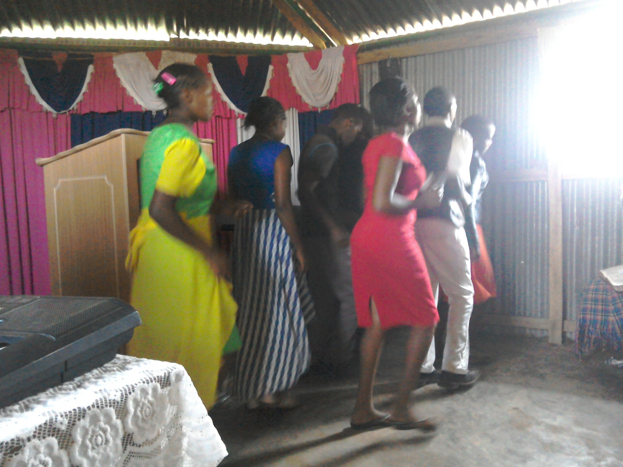

PEOPLE FOR JESUS MINISTRY MISSION/OUTREACH TEAM COUNCIL
People For Jesus Ministry has a mission team or Mission Council that plans and implements local, regional and international missions programmes. That includes crusades, church planting, prayers and intercessory prayers, community evangelistic Outreach programmes and projects. The team also mobilizes, recruits, sends and support long-term and short-term missionaries and teams to different parts of the world. The Mission Team also hosts volunteer missionaries from every part of the world. The Mission Council meets every month to pray, plan and implement Church mission programmes. Please contact us for details on how you can participate.

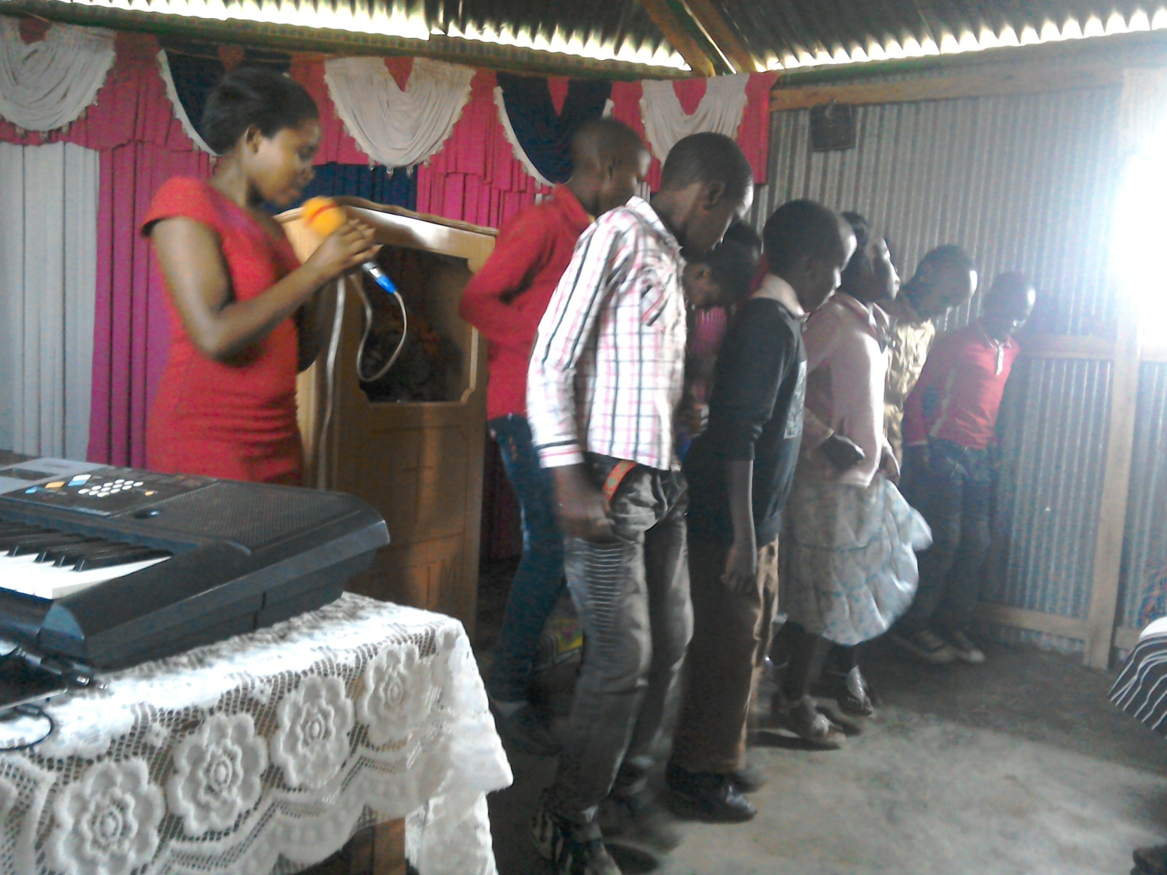
PHOTO ABOVE: CHILDREN OF PROPHECY AND VISION SINGING AT NAROK TOWN CHURCH IN JULY 2017 (IT IS PART OF CHURCH YOUTH OF AGES 9 THROUGH TO 17)

FAMILY ISSUES: THE YOUNGEST SON TO PASTOR TOM, JOSHUA HUGH, WHO IS THREE YEARS OLD, HAS HAD SERIOUS PNEUMONIA, MALARIA AND STOMACH PROBLEMS IN SEPTEMBER 2017. HE IS RECOVERING NOW AND STILL ON MEDICATION. MY HOUSE IN THE UPCOUNTRY VILLAGE IS NOT YET COMPLETE. WE NEED $20,000 TO COMPLETE THE CONSTRUCTION OF THE HOUSE. HELP IS SURELY NEEDED IN THAT ENDEAVOUR. PETER AND DEBORAH ARE IN SCHOOL AND THEY ARE DOING WELL. EUNICE AND PASTOR TOM ARE BUSY AS USUAL WITH MISSIONS AND OUTREACH PROGRAMMES IN SERVICE TO THE LORD. THANKS FOR YOUR PRAYERS.

PHOTO BELOW: PASTOR TOM'S FAMILY VISITING HIS MATERNAL GRANDFATHER (ALMOST 100 YEARS OLD) AND TWO GRANDMOTHERS IN JULY 2017 IN KISUMU
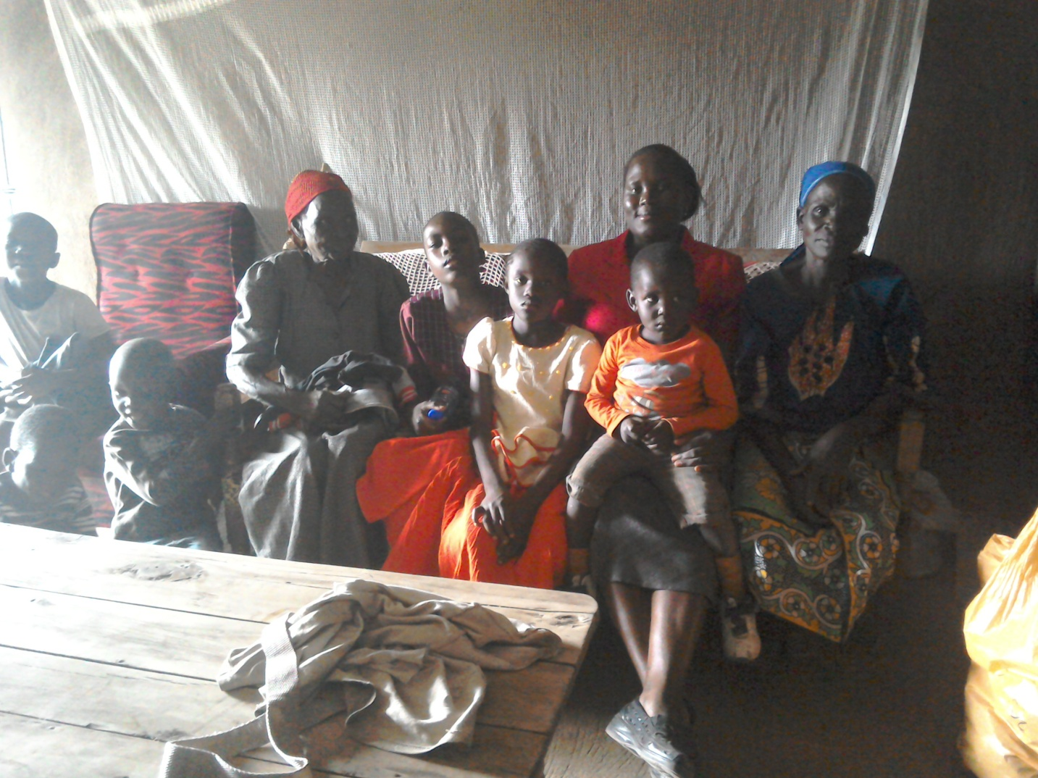

KENYA WILL HOLD REPEAT PRESIDENTIAL ELECTIONS ON 26TH OCTOBER 2017. KEEP US IN PRAYERS
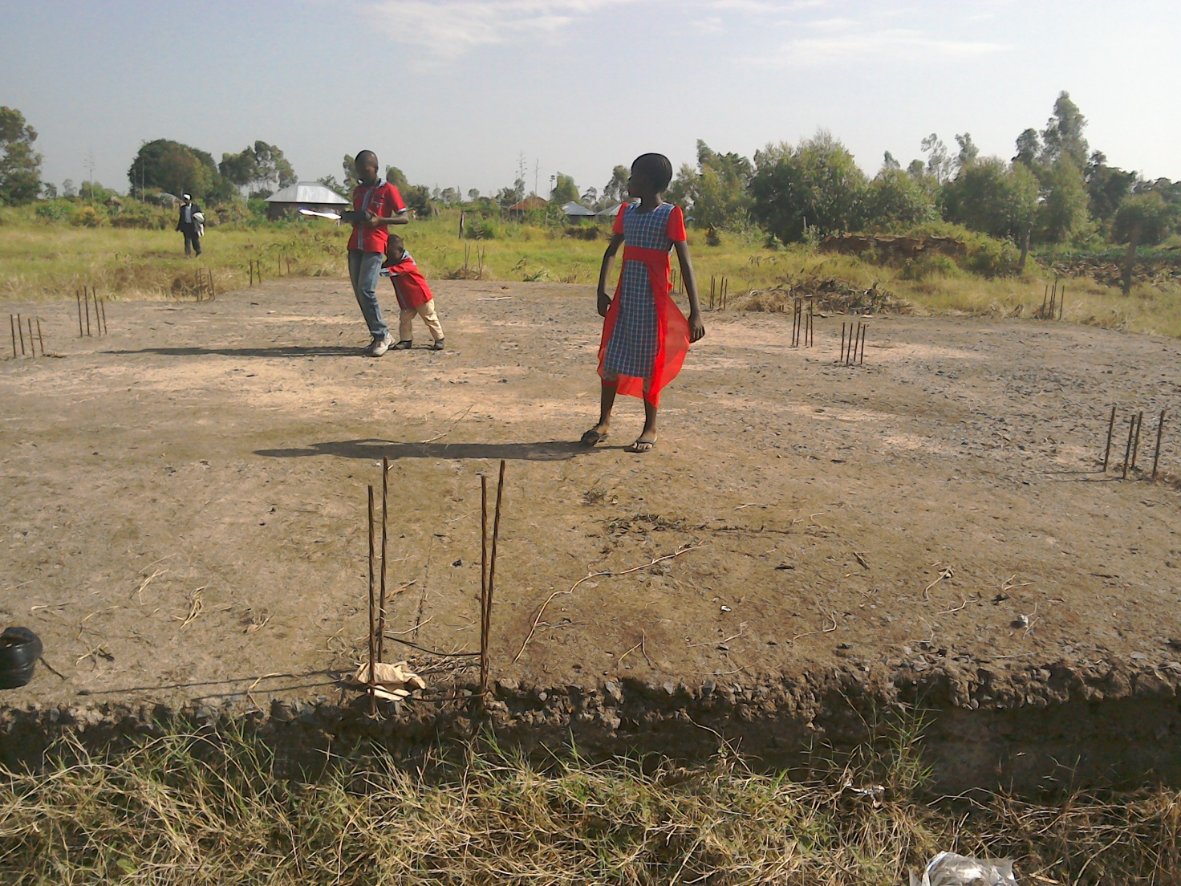
PHOTO ABOVE: Pastor Tom's children, Peter, Deborah and Joshua Hugh playing and praying on top of the foundation of their house, trusting God to provide UK£15,000 needed to complete the construction of the house so that they begin to live inside.
Pastor Tom graduated at the Pan Africa Christian University in Nairobi Kenya on 28th October 2016. He is pursuing further undergraduate theological studies but currently he is unable to be in school session because he does not have the requisite university fees. Keep him in prayers for God's provision of US$600 PER Semester for the next four semesters.

KANDARIA SECONDARY SCHOOL UPDATES
Kandaria Secondary School is located in Kandaria village in Kisumu County in Kenya. The school's new kitchen is currently under construction. Funds for the construction of two extra classrooms has already been received and their construction is beginning soon. The Church and their partners are doing whatever they can to ensure that Kandaria community have access to secondary school education despite the remoteness of the village next to Lake Victoria in Kenya.
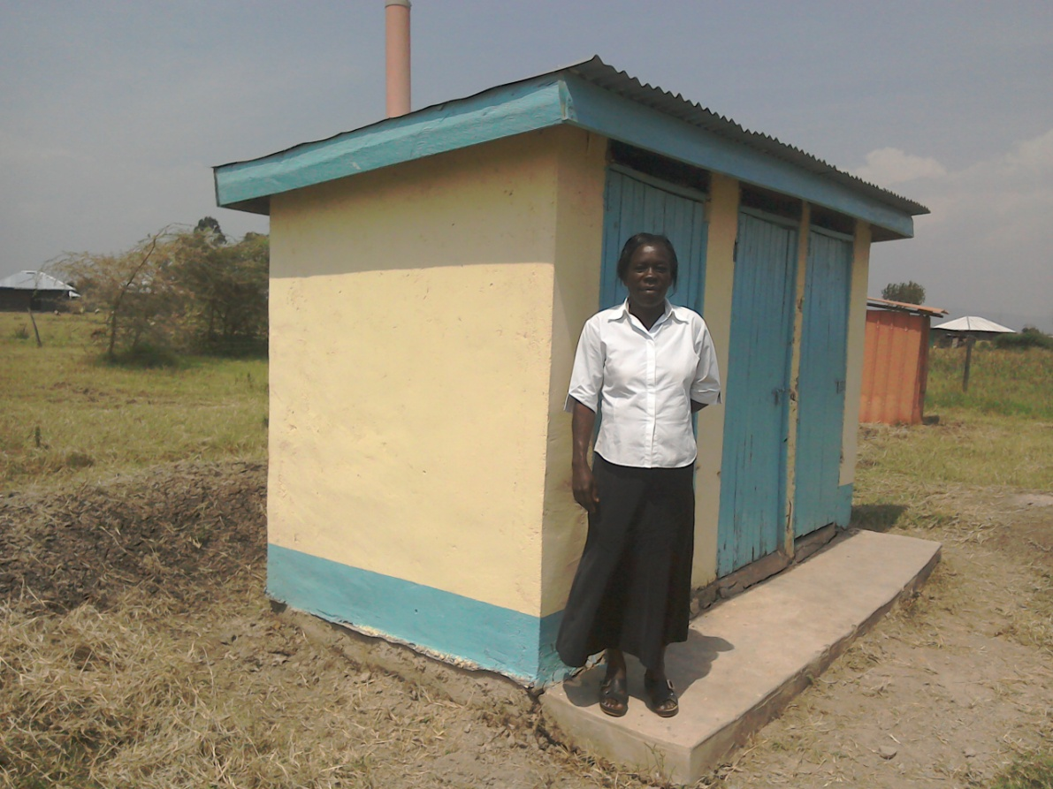

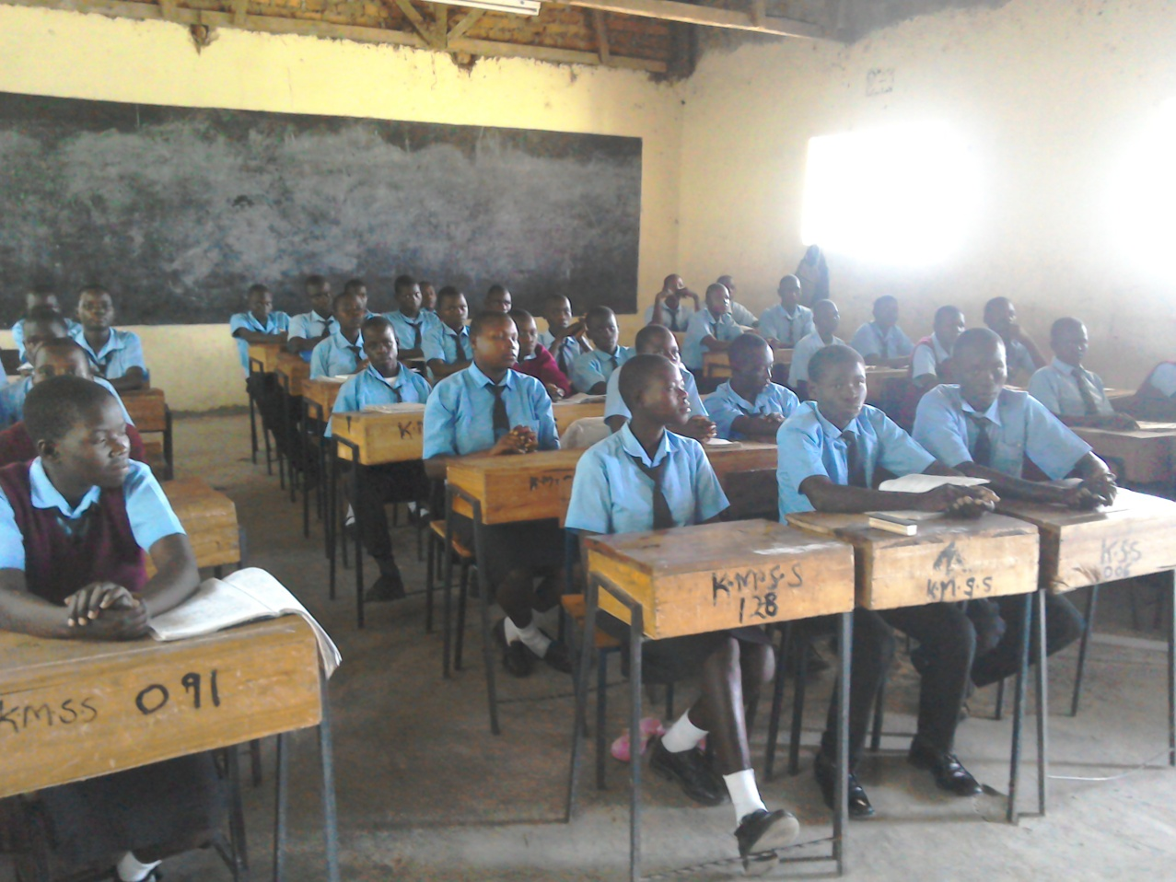

PHOTOS ABOVE: (TOP), the new Principal of Kandaria secondary school, madam Jane, standing at the latest latrines constructed at the school. (BOTTOM), Pastor Tom visiting students inside their classrooms in July 2017.
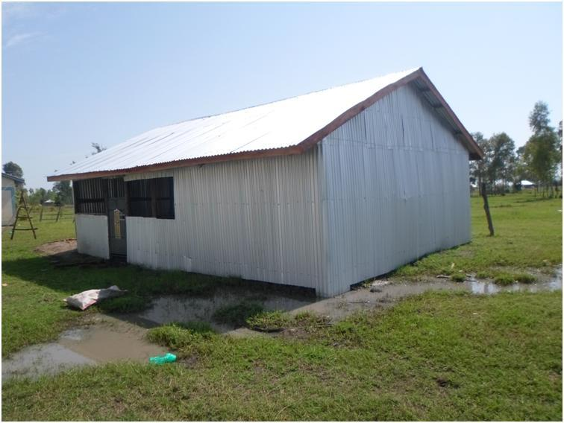

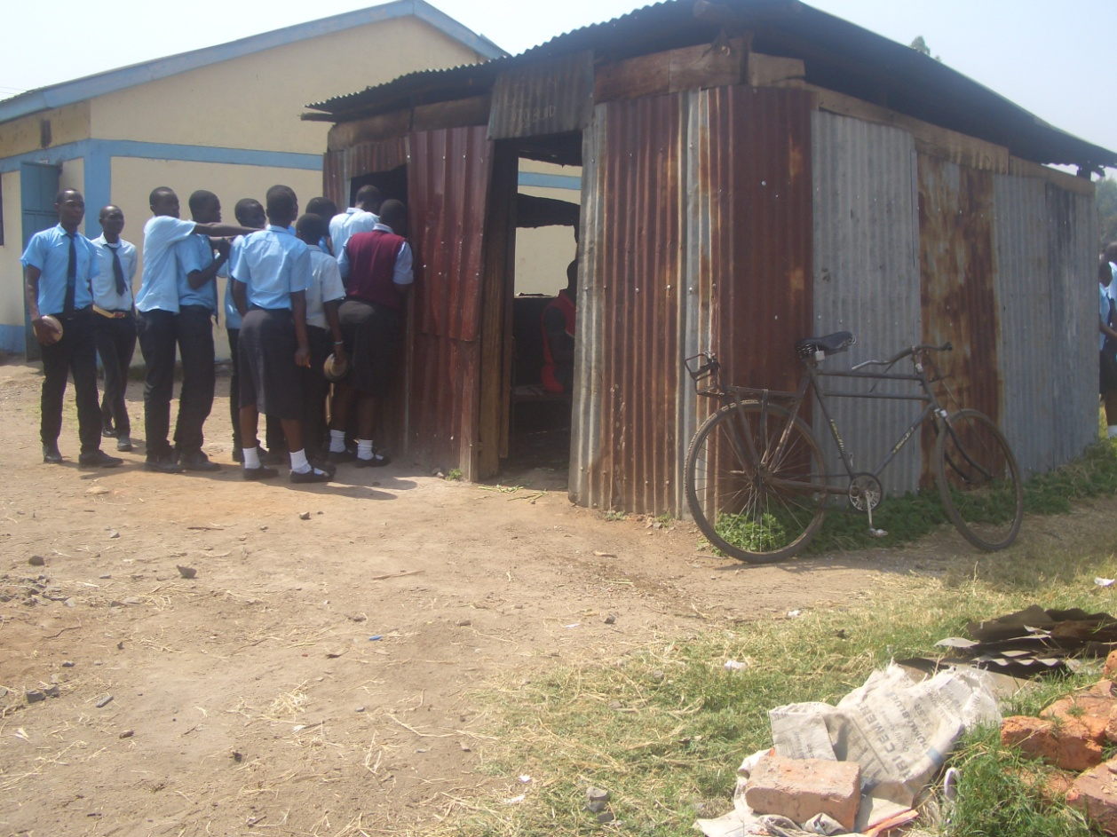

PHOTOS ABOVE: KANDARIA SECONDARY SCHOOL. (TOP), NEW KITCHEN UNDER CONSTRUCTION. (BOTTOM), OLD KITCHEN

AUGUST 2017
NAROK TOWN CHURCH LAND AND SANCTUARY
NAROK TOWN CHURCH IS STILL SEEKING FOR SUPPORT FOR THE PURCHASE OF LAND AND THE CONSTRUCTION OF A CHURCH SANCTUARY. PLEASE KEEP US IN PRAYERS SO THAT WE RAISE US$35,000 FOR THE CHURCH LAND PLUS BUILDING PROJECT. CHURCH MEMBERS HERE IN NAROK KENYA CONTINUE TO CONDUCT SOME FUNDSDRIVES. THE VALUE OF LAND KEEPS RISING UP SO THE SOONER WE PURCHASE LAND THE BETTER. PLEASE JOIN US IN RAISING THE FUNDS.
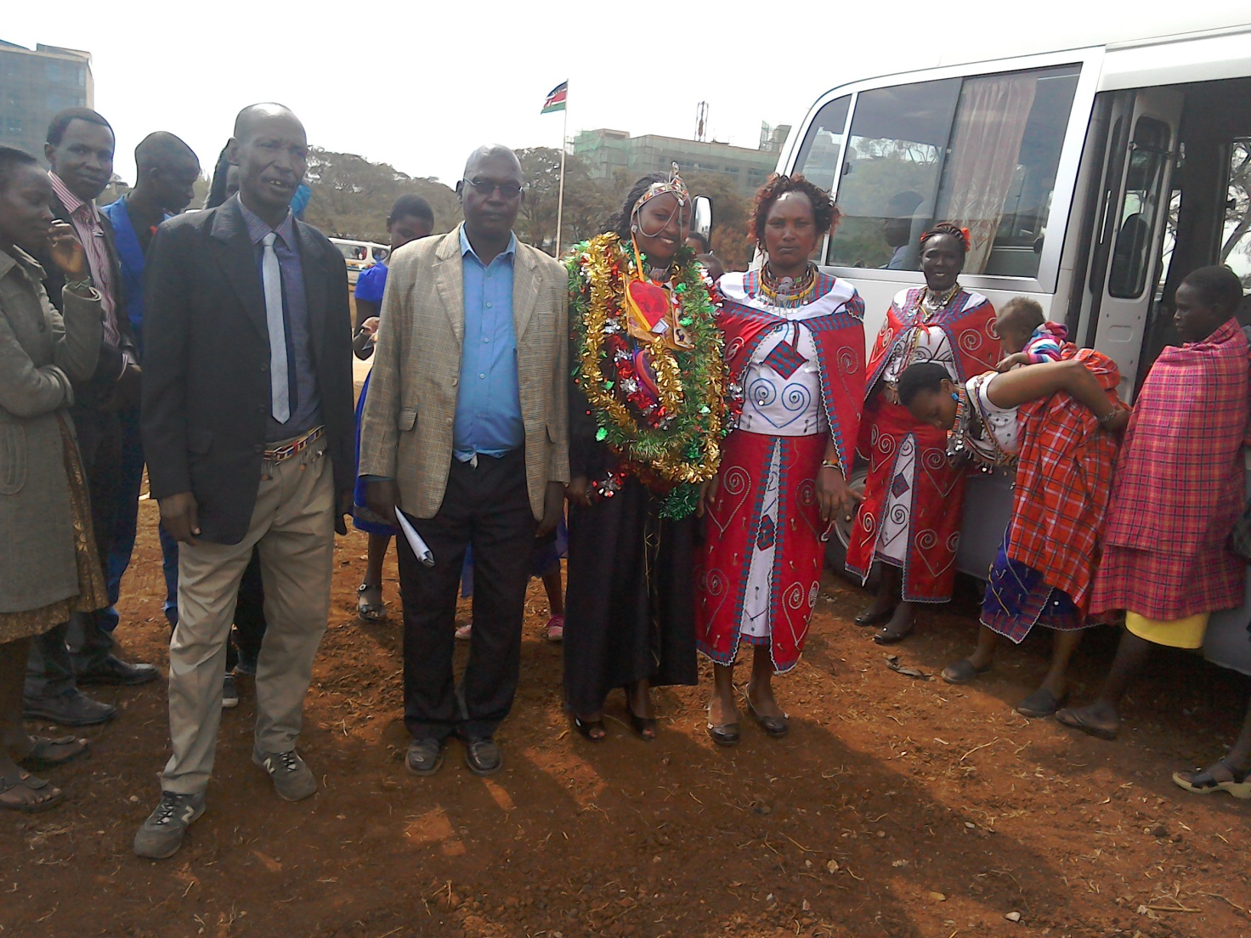
PHOTO ABOVE: A MAASAI GIRL AND YOUTH CHURCH MEMBER AT NAROK TOWN CHURCH GRADUATION AT A KENYA UNIVERSITY AT NAIROBI IN AUGUST 4TH,2017

ON 8TH AUGUST 2017, KENYA HELD A GENERAL ELECTION BUT THE PRESIDENTIAL RESULTS WERE NULLIFIED IN COURT.

ORPHANS/VULNERABLE CHILDREN AND STUDENTS SUPPORT AND SPONSORSHIP:
The Church launched a serious 'school drop outs back to school' campaign programme in February 2014 as part of the Church sponsorship programme. The programme is targeting pupils/students who dropped out of school for various reasons especially among the Maasai communities in Narok county. We have thus far managed to support some pupils/students beneficiaries in the programme. Thanks to those who responded to our plea to help school drop outs plus those who have not been able to make it to school to go to school. We have not yet reached our target and many more children who need to go to school are increasing. YOU CAN GIVE AS LITTLE AS £15 PER MONTH OR £180 PER YEAR, US$25 PER MONTH OR US$300 PER YEAR TO ENABLE A STUDENT GO BACK TO GOVERNMENT DAY SECONDARY SCHOOL. About half of the funds is used for the purchase of school uniforms. You can also help a child go back to primary school by giving US$100 per year. THE CHILDREN/STUDENTS BEING SPONSORED ARE FINE AND DOING THEIR VERY BEST IN SCHOOL. WE THANK ALL SPONSORS HELPING THE ORPHANS AND VULNERABLE CHILDREN/STUDENTS.
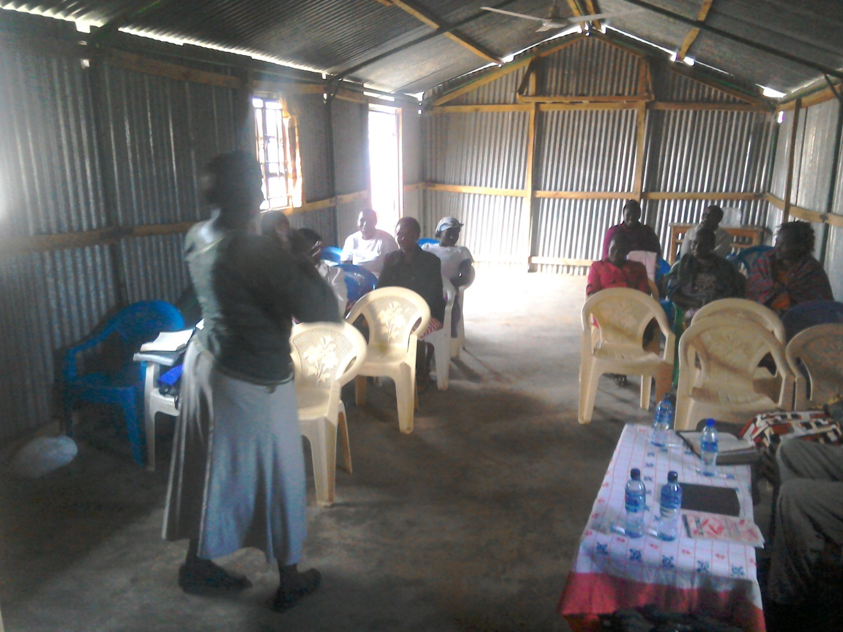

PHOTO ABOVE: WOMEN SEMINAR AT NAROK TOWN CHURCH IN KENYA ON AUGUST 15TH, 2017
ADULT/LITERACY EDUCATION:
THE MAASAI VILLAGE ADULT/LITERACY CLASS IS GOING ON. 85% OF THE CLASS ARE WOMEN AND GIRLS. THE PROBLEM OF EARLY MARRIAGES AMONG THE MAASAI GIRLS NECESSITATES THAT THEY DROP OUT OF SCHOOL OR NEVER MAKE IT TO SCHOOL SO THAT THEY GET MARRIED AND EARN THEIR FAMILY A WEALTH OF MANY COWS PAID AS DOWRY. THE CHURCH IS ADDRESSING THAT EDUCATION GAP BY CONDUCTING CLASSES FOR THOSE WHO HAVE EITHER DROPPED OUT OF SCHOOL OR THOSE WHO NEVER MADE IT TO ANY SCHOOL. THANKS TO THOSE WHO HAVE BEEN ABLE TO SUPPORT US. PLEASE JOIN US IN THIS ENDEAVOUR AT USD$70 PER MONTH PER CLASS. CURRENTLY, DROUGHT HAS BEEN DISRUPTING OUR CLASSES SINCE THE MAASAI COMMUNITY ARE BASICALLY PASTORALISTS AND THEY HAVE TO LOOK FOR PASTURE AND WATER FOR THEIR LIVESTOCK. THE CLASSES HAVE SINCE RESUMED. WE HAVE INTERGRATED CLASSES WITH INCOME GENERATING ACTIVITY TO ENABLE ADULTS EARN A LIVING AS THEY LEARN. WE CALL IT 'FEED BOTH THE MIND AND THE BODY'.
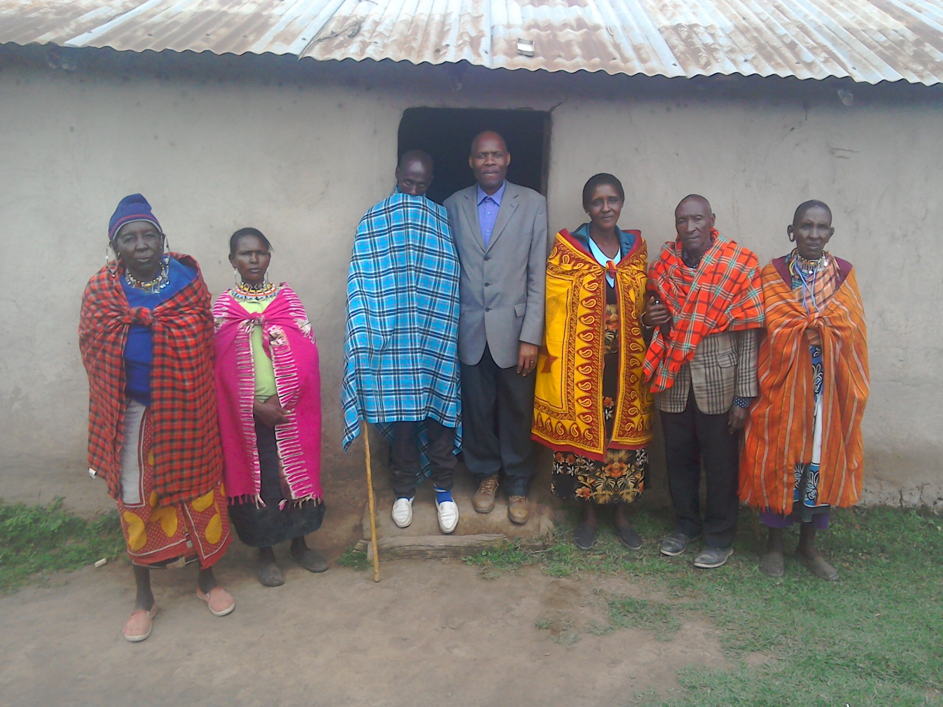
PHOTO ABOVE: PASTOR TOM IN A COAT AFTER LEADING A SPECIAL DELIVERANCE PRAYER MEETING IN A MAASAI VILLAGE IN NAROK IN AUGUST 2017.

CHURCH DISABLE SUPPORT PROGRAMME
The Church has a disabled centre in Nairobi at Kayole known as Hekalu Disable Support Programme. The PFJM Church and their partners support the disabled centre by giving wheel chairs, food, furniture, physiotherapy equipment, etc. The disabled centre is currently located within the PFJM Kayole Nairobi Church compound. The children are many. Brailes are needed for special reading and writing. Physiotherapy equipment and financial support is needed for the many needs of the disable children. The number of disabled children applicants who need help are increasing each day, but we cannot take in more since we do not have enough space and sufficient facilities for more than the number we currently assist.

TANZANIA CHURCH UPDATES
The Missions/outreach council of the Church sent a team of three members lead by pastor Tom for a nine days mission trip to Tanzania on 20th through to 29th August 2017. The three were pastor Tom, Leah and Eunice Naserian. Our Tanzania Overseer, Pastor Samuel Mbanga, who now lives with his family in Dar Es Salaam had to travel to Morogoro so that he could welcome the Kenya missions/outreach team. We have four local Churches in Morogoro and one local Church at Dar Esalaam. We held open air preaching crusades at Morogoro Bwawani main Church plus leadership seminars for four days. We also had a revival meeting at Mbigiri branch on 25th August. On 26th August we traveled to Dar Essalaam and held a Sunday worship service on 27th. We had important leadership strategic planning meetings during our trip. Several people gave their lives to Christ, some were healed and delivered from demon possesion. The Church in Tanzania needs leadership training Bible school, primary and secondary schools, clean water projects, pastors support, adult education programmes, sanctuary construction and community empowerment projects. Thanks to all who prayed with us and supported us in any way.

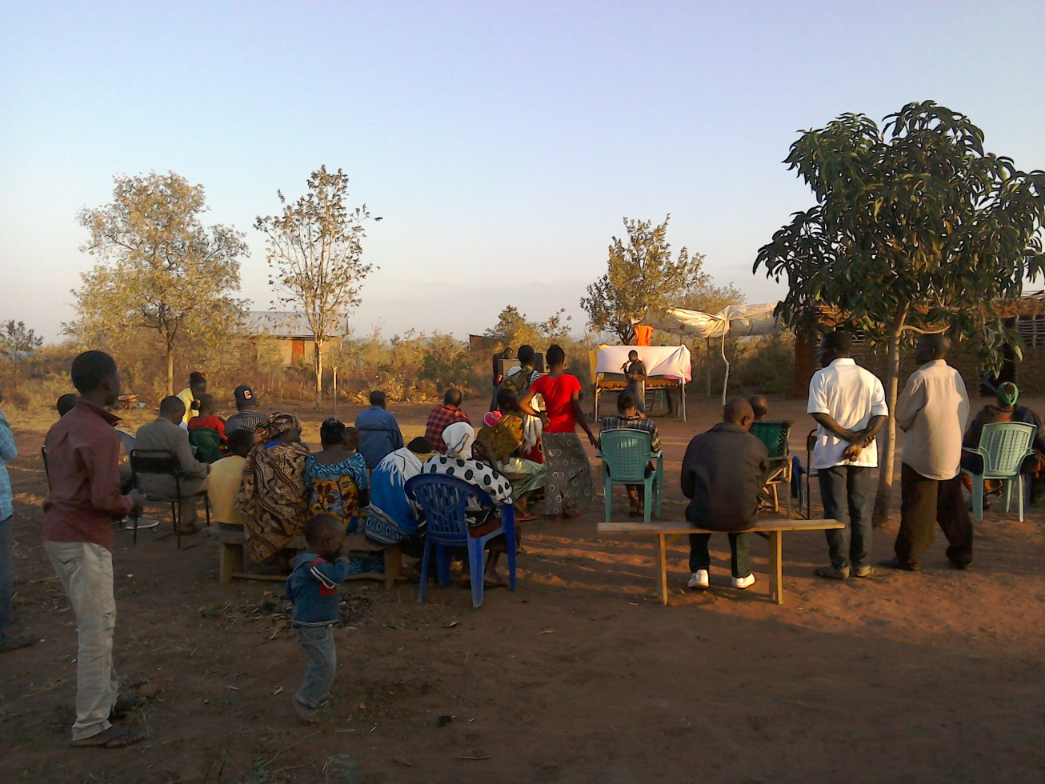

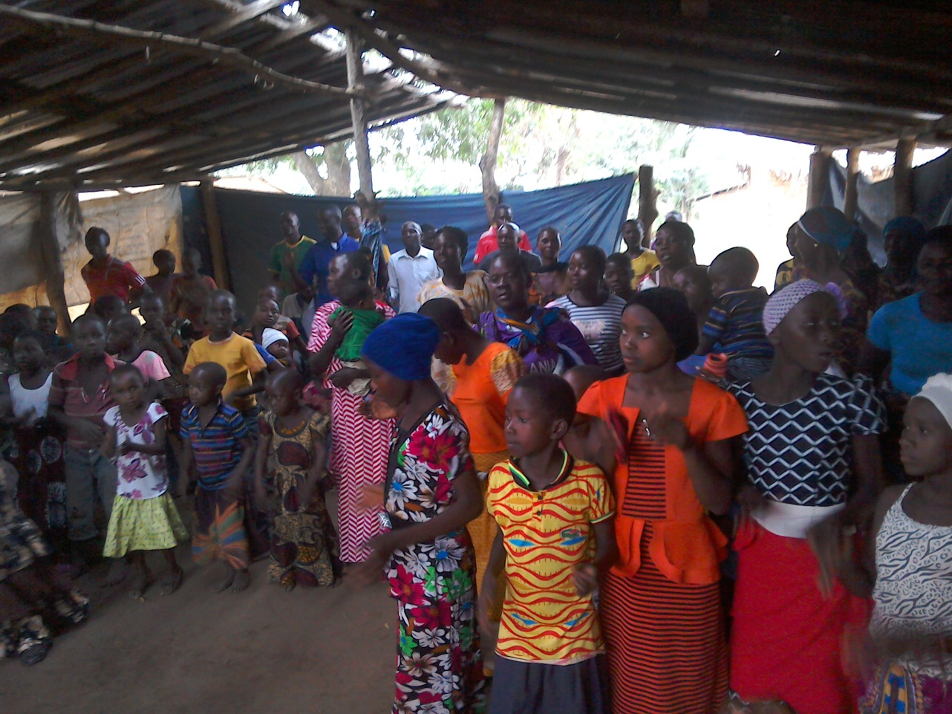

PHOTOS ABOVE:TANZANIA CHURCHES IN AUGUST 2017. (TOP) BWAWANI CHURCH CRUSADE MOROGORO . (BOTTOM) MBIGIRI CHURCH IN MOROGORO.

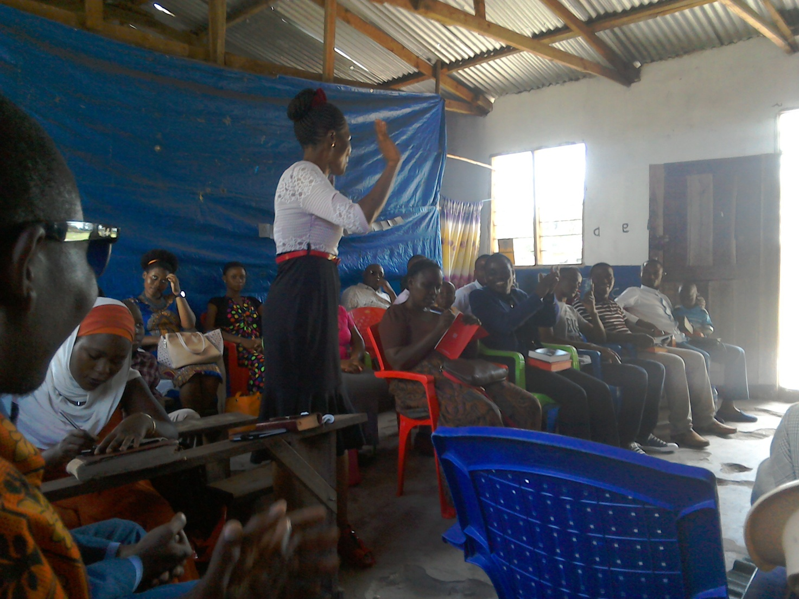
PHOTO ABOVE: DAR ES SALAAM TANZANIA CHURCH WHERE PASTOR SAMUEL MBANGA CURRENTLY LEADS.

SOME OF THE YEAR 2017 P.F.J.M PLANS

>>> Missions/Outreach Council: Church plants in Kenya at Eldoret and Ngong' in Kenya. Church plant in Pakistan in October 2017. Church planting survey in Liberia, and Uganda. Church plant visits in Kenya in Nyamkebe, Nyakach, Eldoret, Ongata Rongai, and Nairobi.
Mission trip and graduation of Bible class in PFJM Tanzania in August 2017. Gospel outreaches/evangelistic campaigns in Kenya.
>>> Adult/Literacy education classes among the Maasai community of Narok Kenya.
>>>Funds-drives for the Narok town Church purchase of land and building of Church Sanctuary.
>>> Supply computers and begin computer learning classes at PFJM Narok town Church.
>>> Education sponsorship programmes. Support programmes for poor and needy people/communities.
>>>Visit and support mobilization for disabled centres in Nairobi Kenya.
>>>Bible school establishment in Kenya.
>>>Children Vocational Bible School camp.
>>>Youth camp and quarterly youth rallies.
>>> Other Youth, women, children, programmes. End year celebration, Big meal celebration, etc.
>>> Annual PFJM National leadership conference on 20th to 24th November 2017 at Narok.
>>>>> Annual General meeting in PFJM Narok town Church on 25th November 2017.

YOUTH SPIRITUAL REVIVAL MEETING: 23RD –26TH AUGUST 2017: THE CHURCH CONDUCTED A POWERFUL AND LIFE-TRANSFORMING YOUTH REVIVAL MEETING AT NAROK TOWN CHURCH FOR NAROK REGION. MANY YOUNG ADULTS HAD THEIR LIVES CHANGED BY THE WORD OF CHRIST.

PHOTO BELOW: FROM RIGHT, LEAH, EUNICE AND PASTOR TOM ON 28TH AUGUST 2017 WHEN THEY WERE TRAVELING FROM DAR ES SALAM TANZANIA TO NAIROBI KENYA..

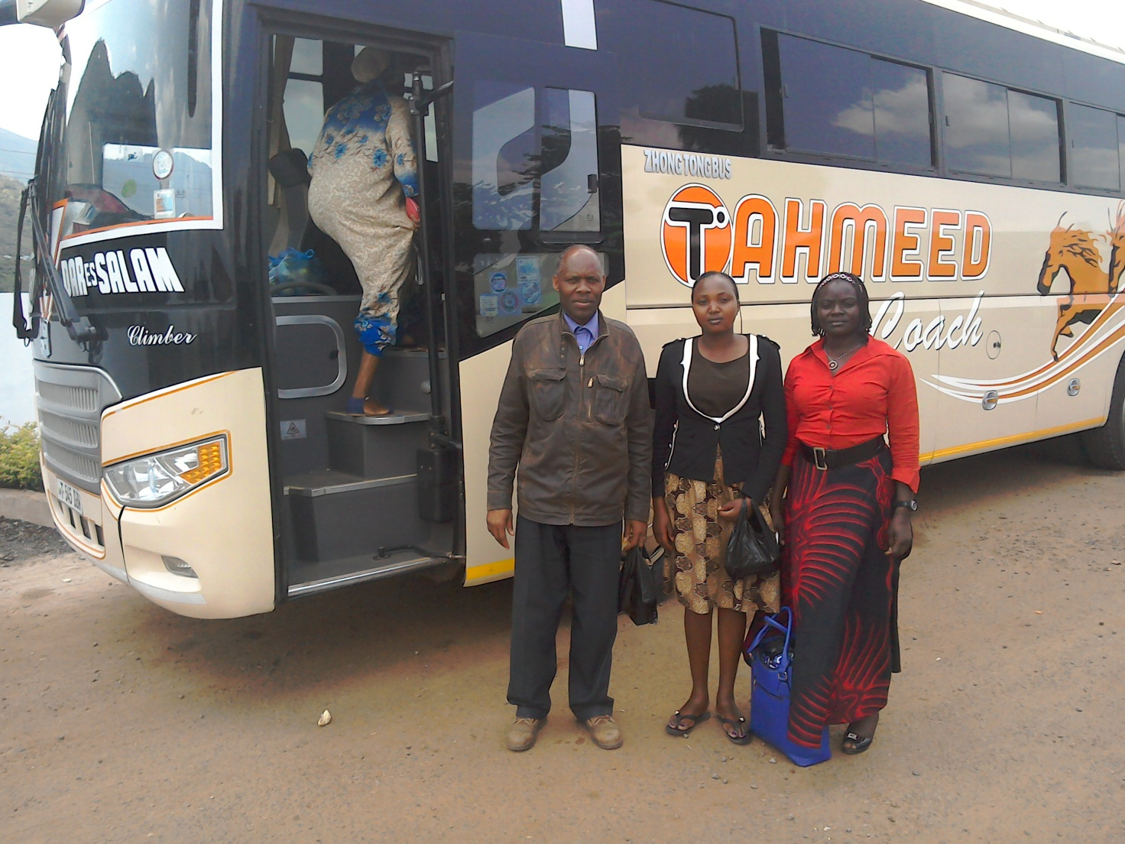

SEPTEMBER 2017
WIDOWS AND THE POOR PEOPLE'S PROJECTS NEED YOUR SUPPORT
PFJM has established a self-help project called ''Cluster Dynamics'' which are designed to pull together groups of 5, 10 or 15 people from within a community group who are mutually in great need. The groups are tasked with developing a micro-project which will generate income for the group in order that they can support themselves and their families.
The groups mainly made up of destitute women, are poor for a number of reasons but mainly due to the tragedy of HIV/AIDS which affects each family in one way or another. Some suffer from the disease themselves, others as a result of losing their husband by HIV/AIDS. The result is that the remaining partner (usually wife and mother) is left to support a number of children. PFJM can help these groups get established by providing one time initial set up grant of £500, 1000 and 1500 respectively, allowing them to get going with their project and bring in the much needed income that will grow the project and support the group and their dependants. PFJM will closely monitor the projects to ensure that they are profitable to the groups. You can invest in this worthy course that can profitably change lives of the poor widows and others for a life time. Currently, we have the groups of 5, 10 and 15 ready to move with any support that comes to them. ON 2ND JANUARY 2017, THE SECOND CLUSTER GROUP SHARED THEIR ANNUAL PROFITS. PLEASE HELP THESE POOR PEOPLE TRANSFORM THEIR LIVES BY YOUR ONE TIME SUPPORT.

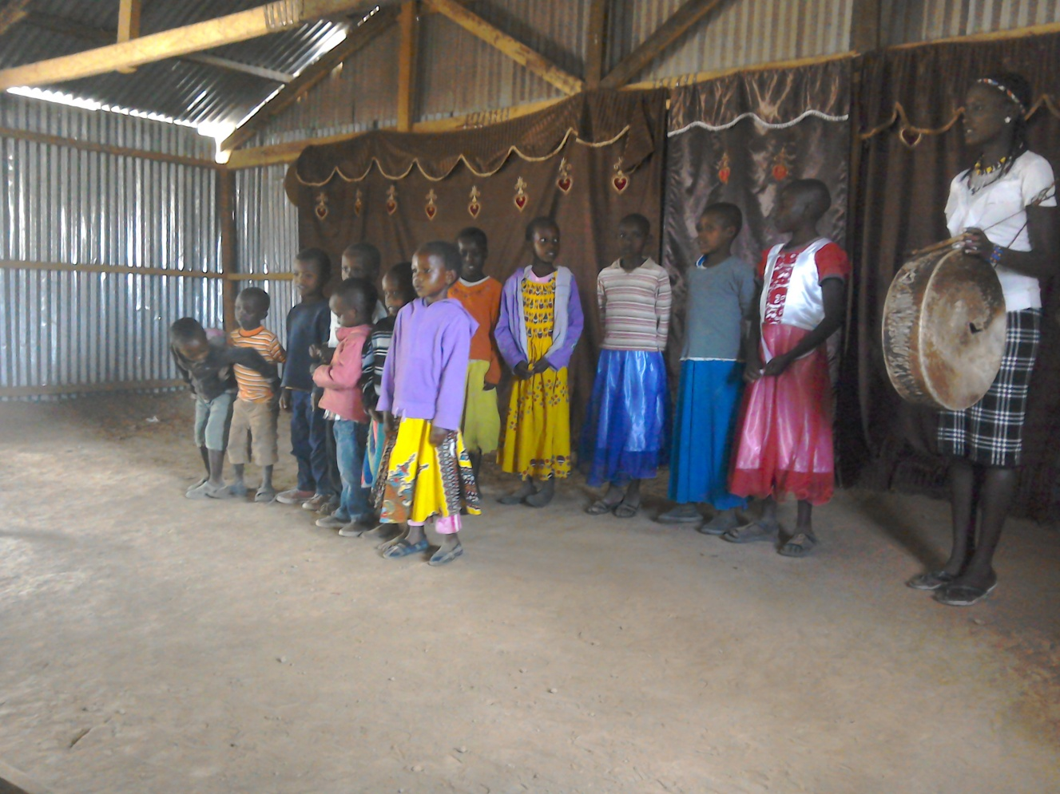

PHOTO ABOVE: SUNDAY SCHOOL CHILDREN SINGING AT OLOOLTOTO NAROK CHURCH SUNDAY WORSHIP SERVICE IN SEPTEMBER 2017.

PRAYER/PRAISE ITEMS AND PLANS & HOW TO BE PART OF THIS WORK
The mission work we are involved in is too dynamic and enormous for us to do on our own. We surely appreciate your partnership by prayer, support, and personal involvement.

- Narok Town Headquarters Church Land Purchase and Church Building at a cost of United Kingdom Pounds £22,000 or US$35,000. We thank all who have thus far donated. We have identified a piece of land in Narok town which costs US$15,000. The land is not yet bought due to insufficient funds. We still need more funds.
- Monthly Pastor's Family Support of US$300 (rural areas) or US$480 (urban areas)
- Orphans and Destitute children monthly support £20 or US$35. This year we have many needy children in the programme awaiting support.
- Needy College/University Students support and High School Students support needed.
- New Church Planting Mission in Pakistan at Lahore . Pakistan pastor being trained by PFJM so that he takes over the work. Other Church plants in Africa e.g.. in Ngong', Kitale, Mumias and Katolo in Kenya, Liberia, Uganda in Lira, etc.
- We need Church Sanctuary and Primary school buildings in Tanzania Church. School, orphanage, clinic and guest house Building proposals in Narok and in Kisumu areas in Kenya.
- Mission Emphasis Programmes and community development projects in Kenya going on throughout the year. Thanks to Africa Pastors Fellowship who gave us a chance to partner with them in Church leadership empowerment programmes.
- PFJM Tanzania Church needs prayers: To be officially registered by the Tanzania government. Bible school graduation to be held in August 2018. That church needs to build a sanctuary in different places we have Church plants.
- Thank God for a successful Youth Revival meeting held in Narok Kenya on 23rd through to 26th, August 2017.
- Thank God for the successful Missions/outreach council trip to Tanzania in August 20^{th—}29th 2017 at Dar Es Salam and Morogoro.
- Annual missions/outreach retreat/planning meeting to be held on 19th, 20th and 21st October 2017 at Ahero town in Kisumu county in Kenya.
- Thanks to God for providing funds for Kandaria secondary school kitchen and two classrooms.
- Pray for Church Annual General Meeting to be held on 25th November 2017. Pray for Church Annual National Church Leaders conference for 20th to 24th November 2017.
- Pray for the Big Meal 2017 events for the needy children feeding and awards programme on Christmas Day. Also pray for the End of Year seminar and end year prayer vigil.

SPECIAL THANKS TO ALL OF YOU FOR YOUR PRAYERS, SUPPORT AND ACTUAL PERSONAL PARTICIPATION IN THE WORK THAT WE DO. BECAUSE OF YOUR PARTNERSHIP, WE ARE ABLE TO MEET EDUCATION AND MATERIAL NEEDS OF MAASAI COMMUNITIES IN NAROK AND AROUND THE NATION OF KENYA, BESIDES SERVING OTHER PEOPLE. YOU HAVE ALSO ENABLED US TO PREACH THE TRUE GOSPEL AS WE MAKE DISCIPLES OF CHRIST IN KENYA AND IN OTHER NATIONS.
WE ASK YOU TO KEEP ON STANDING WITH US FOR THE SAKE OF THE WORK OF GOD'S KINGDOM AND FOR MINISTERING TO POOR/NEEDY COMMUNITIES.

THE YEAR 2017: THE YEAR OF OVERCOMING OBSTACLES FOR DISTINGUISHED SERVICE.
GENESIS 50:15-21

YOUR PARTNERSHIP IS GREATLY VALUED (PHILIPPIANS 1:5). THANK YOU!!!

