PEOPLE FOR JESUS MINISTRY,
P.O. BOX 1008,
Narok, 20500, KENYA,
EAST AFRICA
TEL: 254-721-204447 OR 254-736-574413
E-mail: peopleforjesusintmin@gmail.com

YOUR REF: ________ OUR REF: NRK/UP.4/2016 DATE: 31ST DECEMBER 2016

Dear Saints, Friends, well-wishers, and Partners,

HAPPY NEW YEAR 2017!!!
Receive new year's blessed greetings from us, People For Jesus Ministry (PFJM) family. We are busy as always with preaching of the gospel of the Kingdom of God in different places and in many diverse acts of demonstrating Christian love. Many activities have been going on for the whole of the year 2016 such as regular Church daily, weekly and monthly programmes and projects. Some of the evangelistic activities are given in the updates while many others are not included. The Church continues to work in communities with many poor orphans, widows, pupils, students, and people at risk who need our support but we thank God that we are able to help some of them with your partnership in this work. We trust God that you have began well in the year 2017.

OCTOBER 2016
New Church plant in Narok county at Iretet area was done. The Iretet branch Church has also began an outreach fellowship three kilometres away from Iretet Church at Enaikishomi village.

PHOTOS BELOW: Pastor Tom's graduation day at Pan Africa Christian University in Nairobi Kenya on 28th October 2016. He had a diploma in theology and he is still pursuing bachelor in theology. He needs your prayers and support. Thanks to all who have helped in one way or the other.
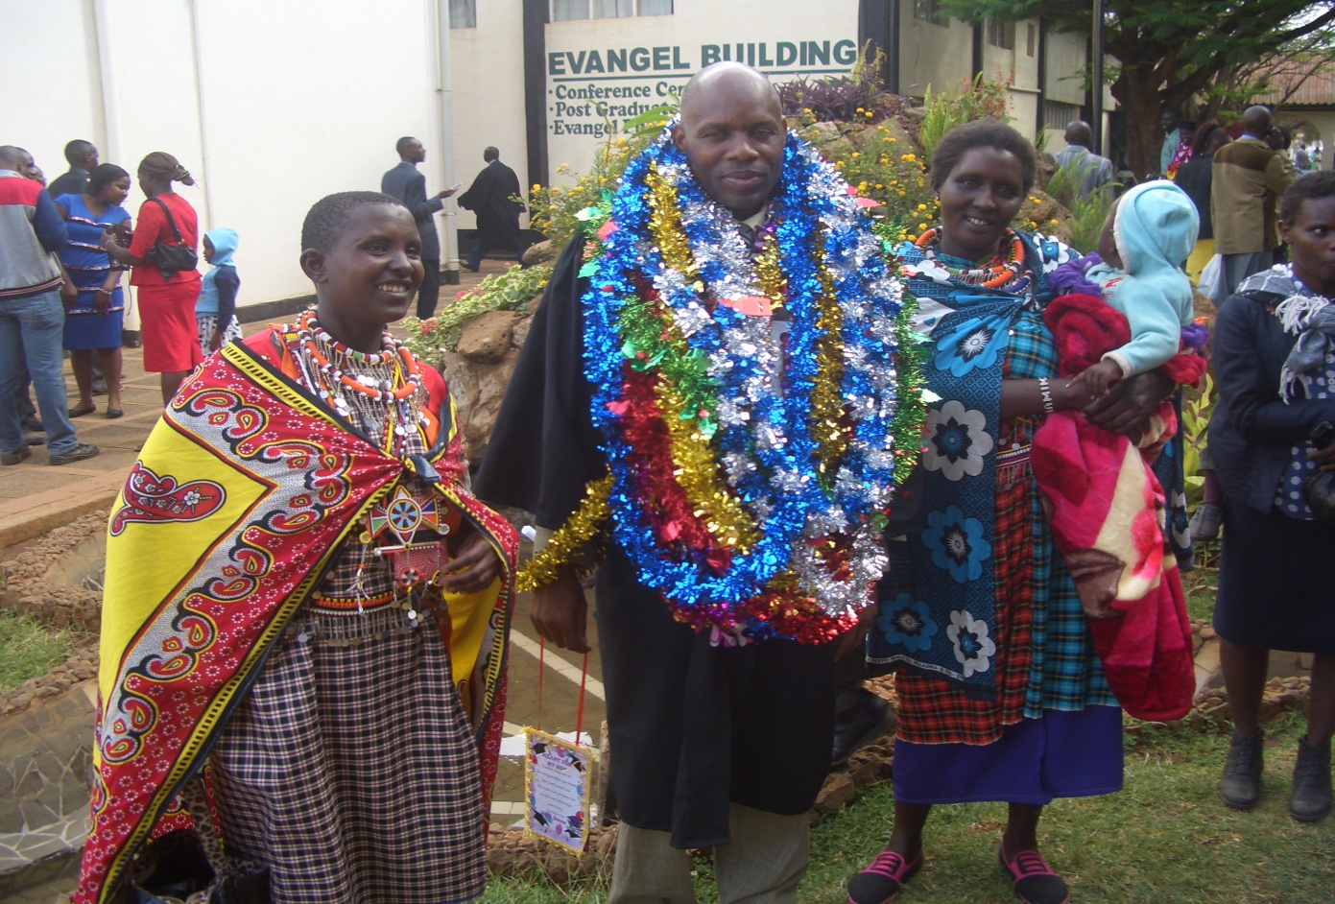

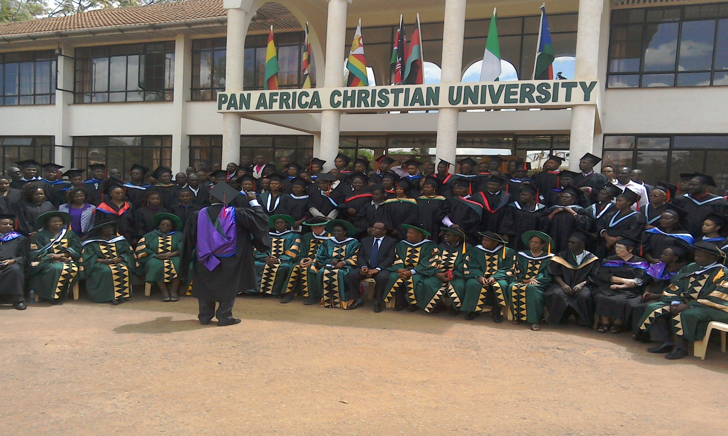
The Church has a disabled centre in Nairobi at Kayole known as Hekalu Disabled Support Centre. The PFJM Church and their partners support the disabled centre by giving wheel chairs, food, furniture, physiotherapy equipment, etc. The disabled centre is currently located within the PFJM Kayole Nairobi Church compound.

NOVEMBER 2016

PFJM NATIONAL LEADERS CONFERENCE AND ANNUAL GENERAL MEETING 2016:
The Church national and regional leaders conference was conducted in Narok town Church from 23RD –25TH November 2016. Thirty five leaders attended the meeting and we were surely taught very well in diferent aspects of church leadership for the 21st century. Leaders from different parts of Kenya were in attendance. We thank all of you who prayed with us, those who participated in person, and those who supported that worthy conference. It has now become an important annual event.
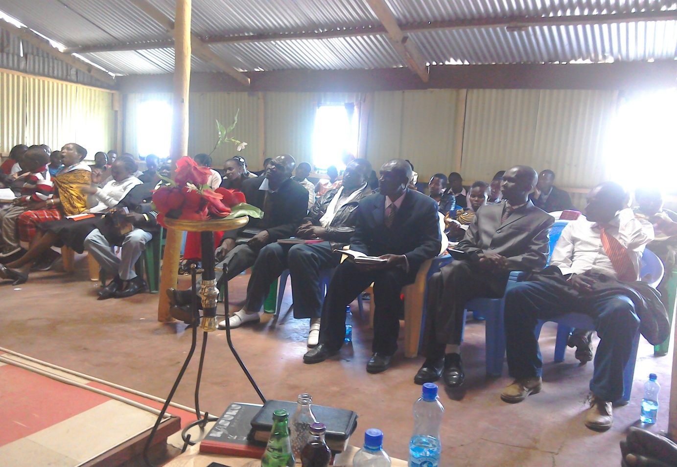
PHOTO ABOVE: PFJM NATIONAL CHURCH LEADERS EMPOWERMENT CONFERENCE IN NAROK KENYA IN NOVEMBER 2016

KANDARIA SECONDARY SCHOOL UPDATES
Kandaria secondary school is doing well. They did national secondary schools final exams in November 2016 for the second time. Four students who took national exams in the year 2015 qualified for university intake and two girls and one boy are already adimmtted to various universities in different fields of study.
The school has also perfomed very well in the 2016 national examination. Results have just been released. The school does not have enough classrooms. We actually need two more classrooms urgently. In the very near future the school will need dormitory facilities. Many students from far have applied to join the school but the school does not have a dormitory.
The school needs two extra classrooms to accommodate the ever increasing student numbers. Thanks to all who have been supporting the school.

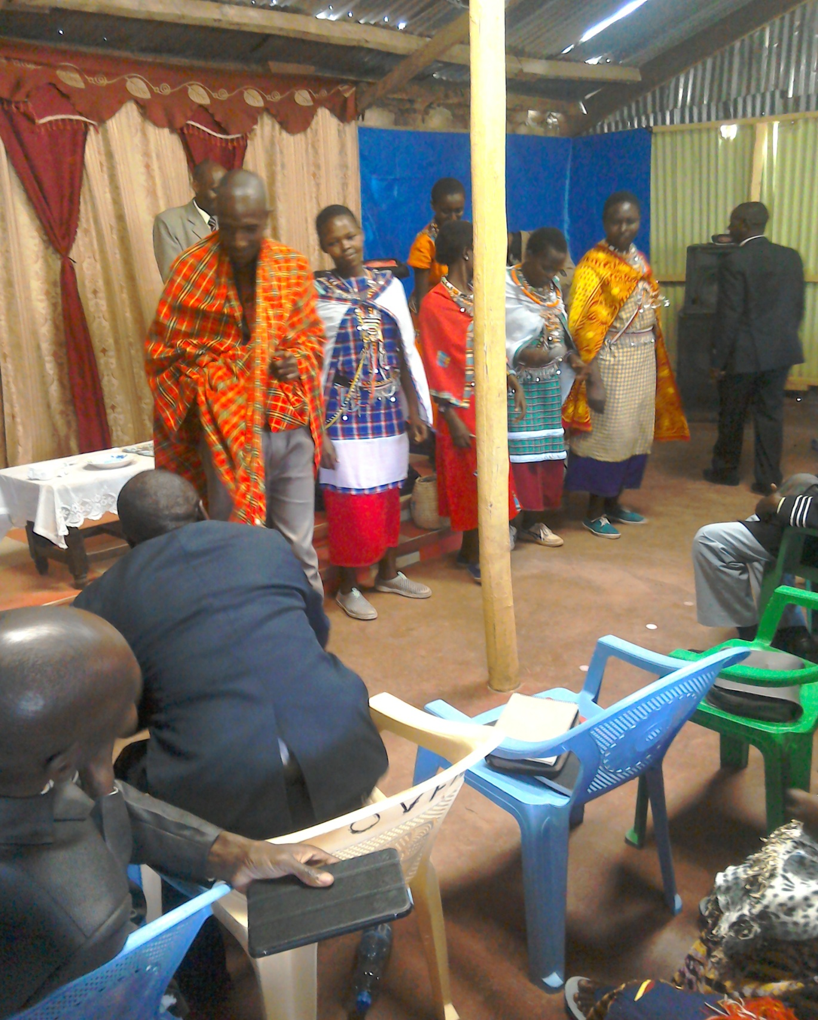
PHOTO ABOVE: MAASAI CHURCH LEADERS OF OLOOLTOTO BRANCH CHURCH SINGING AT THE PFJM 2016 CONFERENCE IN NAROK TOWN

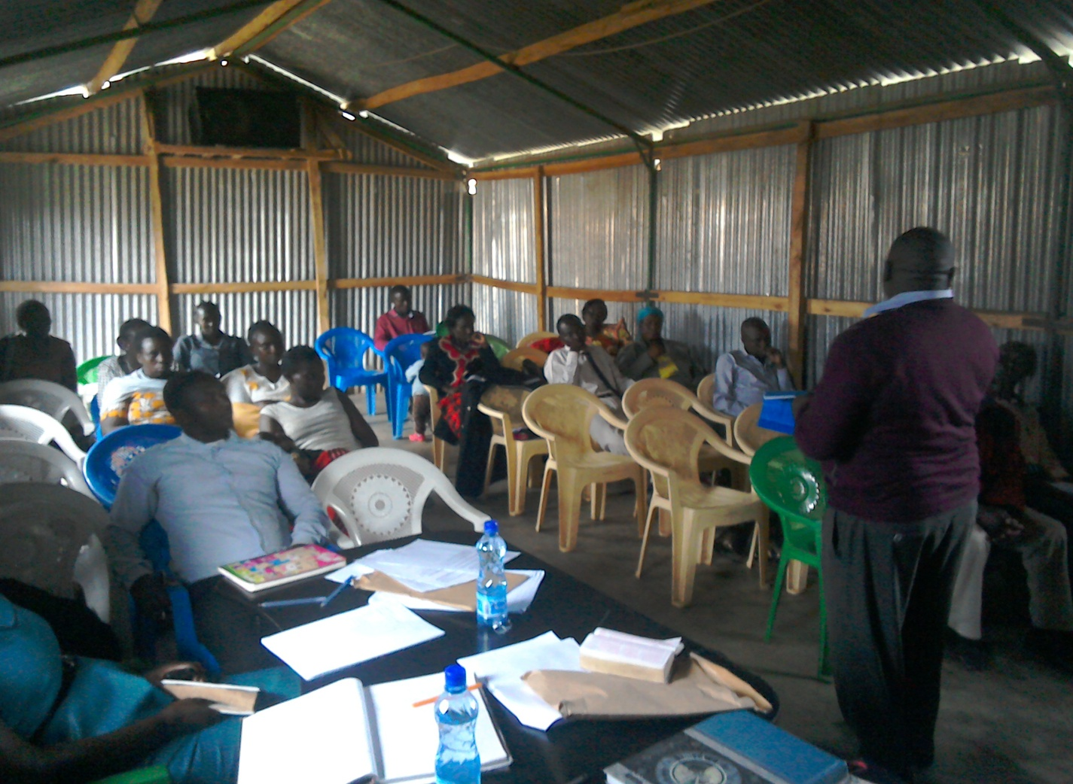
PHOTO ABOVE: PFJM Annual General Meeting of all PFJM Church leaders at Narok town Church headquarters in session on 26th November 2016

NAROK TOWN CHURCH LAND AND SANCTUARY
NAROK TOWN CHURCH IS STILL SEEKING FOR SUPPORT FOR THE PURCHASE OF LAND AND THE CONSTRUCTION OF A CHURCH SANCTUARY. PLEASE KEEP US IN PRAYERS SO THAT WE RAISE US$35,000 FOR THE CHURCH BUILDING PROJECT. CHURCH MEMBERS HERE IN NAROK KENYA CONTINUE TO CONDUCT SOME FUNDSDRIVES. THE VALUE OF LAND KEEPS RISING UP SO THE SOONER WE PURCHASE LAND THE BETTER. PLEASE JOIN US IN RAISING THE FUNDS.

PEOPLE FOR JESUS MINISTRY MISSION/OUTREACH TEAM COUNCIL
People For Jesus Ministry has a mission team or Mission Council that plans and implements local, regional and international missions programmes. That includes crusades, church planting, prayers and intercessory prayers, community evangelistic Outreach programmes and projects. The team also mobilizes, recruits, sends and support long-term and short-term missionaries and teams to different parts of the world. The Mission Team also hosts volunteer missionaries from every part of the world. The Mission Council meets every month to pray, plan and implement Church mission programmes. Please contact us for details on how you can participate.
PHOTO BELOW: JOSHUA HUGH, OUR YOUNGEST SON, CELEBRATES HIS SECOND BIRTHDAY ON 18TH NOVEMBER 2016
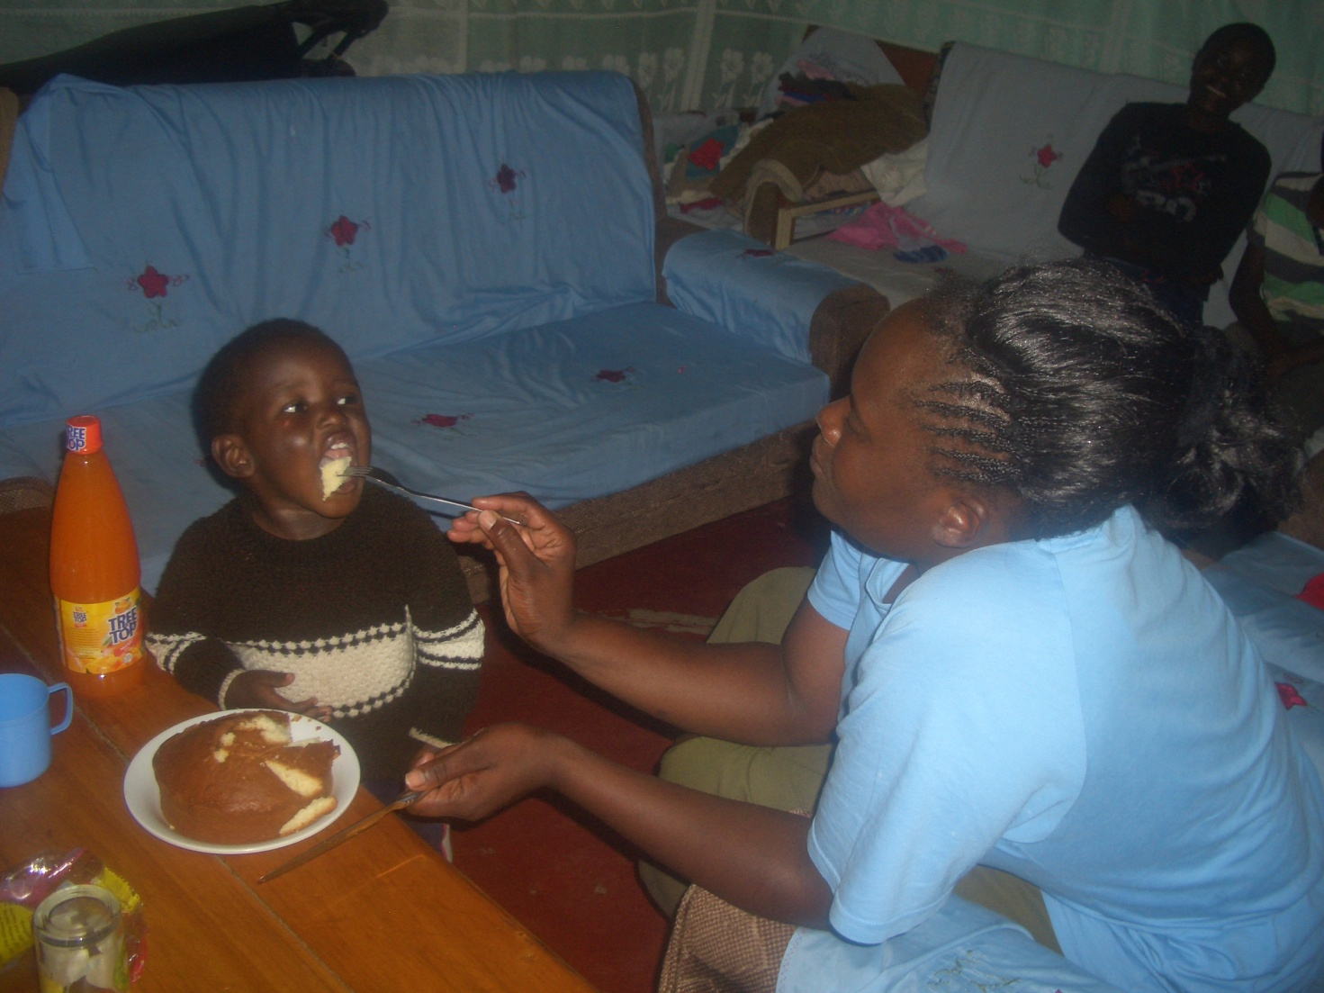

ORPHANS/VULNERABLE CHILDREN AND STUDENTS SUPPORT AND SPONSORSHIP:
The Church launched a serious 'school drop outs back to school' campaign programme in February 2014 as part of the Church sponsorship programme. The programme is targeting pupils/students who dropped out of school for various reasons especially among the Maasai communities in Narok county. We have thus far managed to support some pupils/students beneficiaries in the programme. Thanks to those who responded to our plea to help school drop outs plus those who have not been able to make it to school to go to school. We have not yet reached our target and many more children who need to go to school are increasing. YOU CAN GIVE AS LITTLE AS £15 PER MONTH OR £180 PER YEAR, US$25 PER MONTH OR US$300 PER YEAR TO ENABLE A STUDENT GO BACK TO GOVERNMENT DAY SECONDARY SCHOOL. About half of the funds is used for the purchase of school uniforms. You can also help a child go back to primary school by giving US$100 per year.

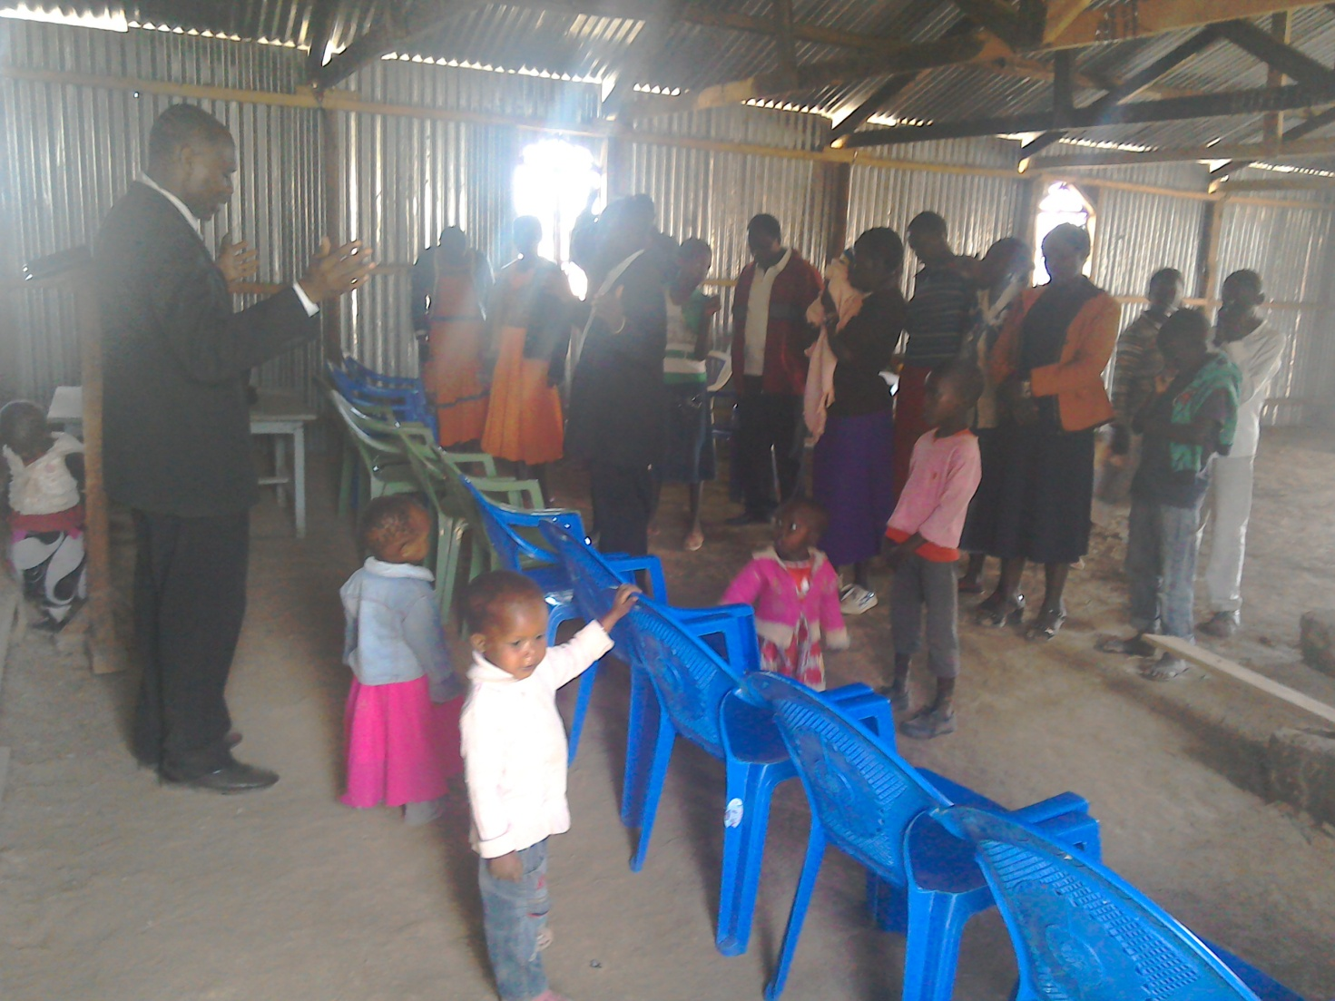
PHOTO ABOVE: PASTOR TOM OFFERS A PRAYER OF DEDICATION AT OLOOLTOTO MAASAI VILLAGE CHURCH FOR NEW CHAIRS BOUGHT IN NOVEMBER 2016 AFTER THIEVES BROKE INTO THE CHURCH AND STOLE ALL THE CHAIRS BUT GOD PROVIDED NEW CHAIRS.

ADULT/LITERACY EDUCATION: THE MAASAI VILLAGE ADULT/LITERACY CLASS IS GOING ON. 85% OF THE CLASS ARE WOMEN AND GIRLS. THE PROBLEM OF EARLY MARRIAGES AMONG THE MAASAI GIRLS NECESSITATES THAT THEY DROP OUT OF SCHOOL OR NEVER MAKE IT TO SCHOOL SO THAT THEY GET MARRIED AND EARN THEIR FAMILY A WEALTH OF MANY COWS PAID AS DOWRY. THE CHURCH IS ADDRESSING THAT EDUCATION GAP BY CONDUCTING CLASSES FOR THOSE WHO HAVE EITHER DROPPED OUT OF SCHOOL OR THOSE WHO NEVER MADE IT TO ANY SCHOOL. THANKS TO THOSE WHO HAVE BEEN ABLE TO SUPPORT US. PLEASE JOIN US IN THIS ENDEAVOUR AT USD$70 PER MONTH PER CLASS.

DECEMBER 2016

6TH THROUGH TO 10TH DECEMBER 2016: The Church conducted a powerful and spiritually life-transforming youth camp at the Olooltoto Maasai village Church which involved many youth coming to learn wholistic aspects of a well-rounded youth, coupled with life skills. We had senior youth and teenagers as two distinct groups at the youth camp. There were plenary and small groups sessions. Topics were diverse and interesting such as youth sexuality, youth and integrity, youth and career choice, health matters, youth and salvation and Christian service.

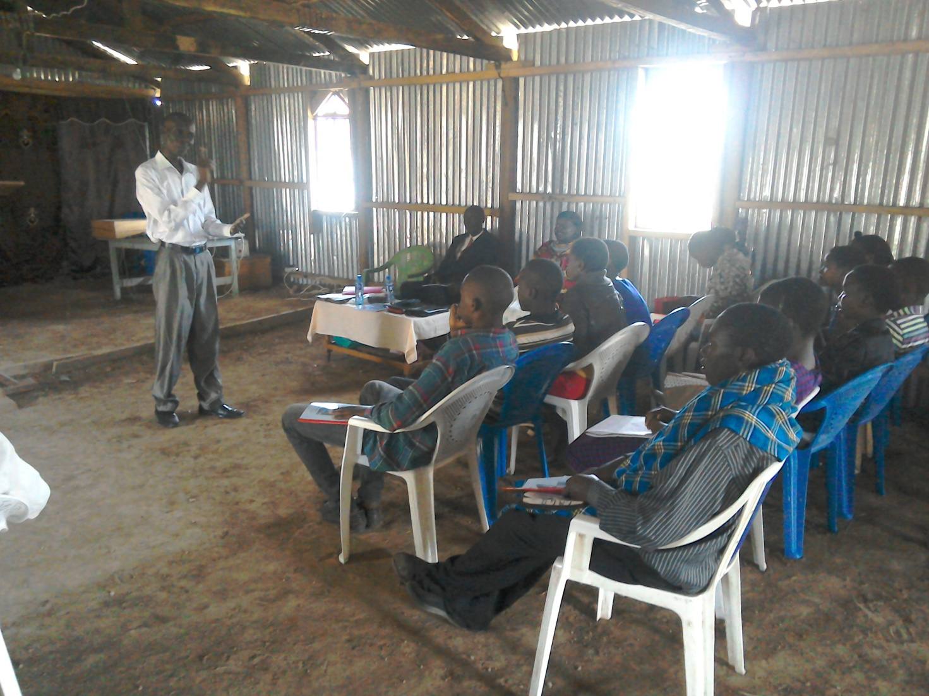
PHOTO ABOVE: PASTOR JOHNSON, PFJM YOUTH CAMP DIRECTOR 2016, TEACHING AT THE YOUTH CAMP AT OLOOLTOTO MAASAI VILLAGE CHURCH.

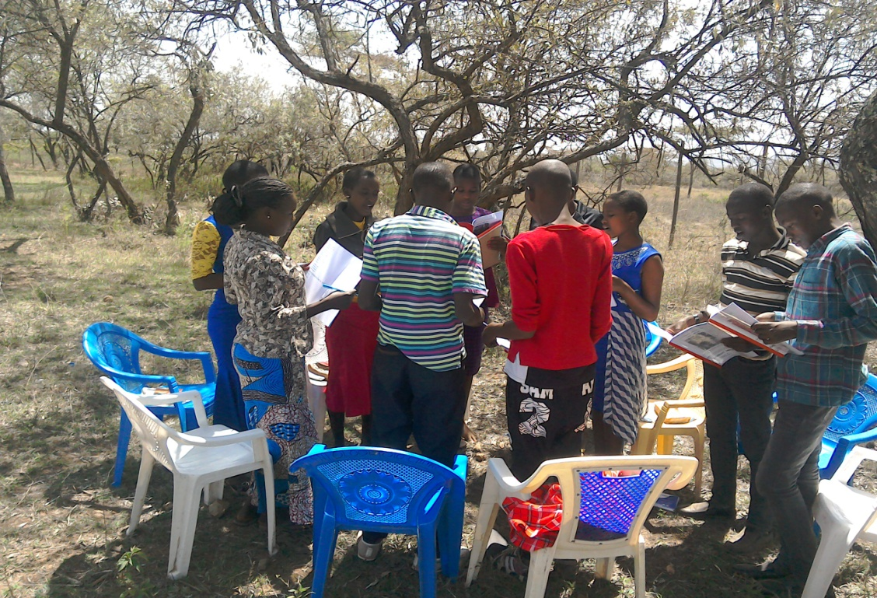
PHOTO ABOVE: TEENAGERS GROUP BIBLE STUDY SESSION DURING THE CHURCH YOUTH CAMP IN NAROK KENYA IN DECEMBER 2016

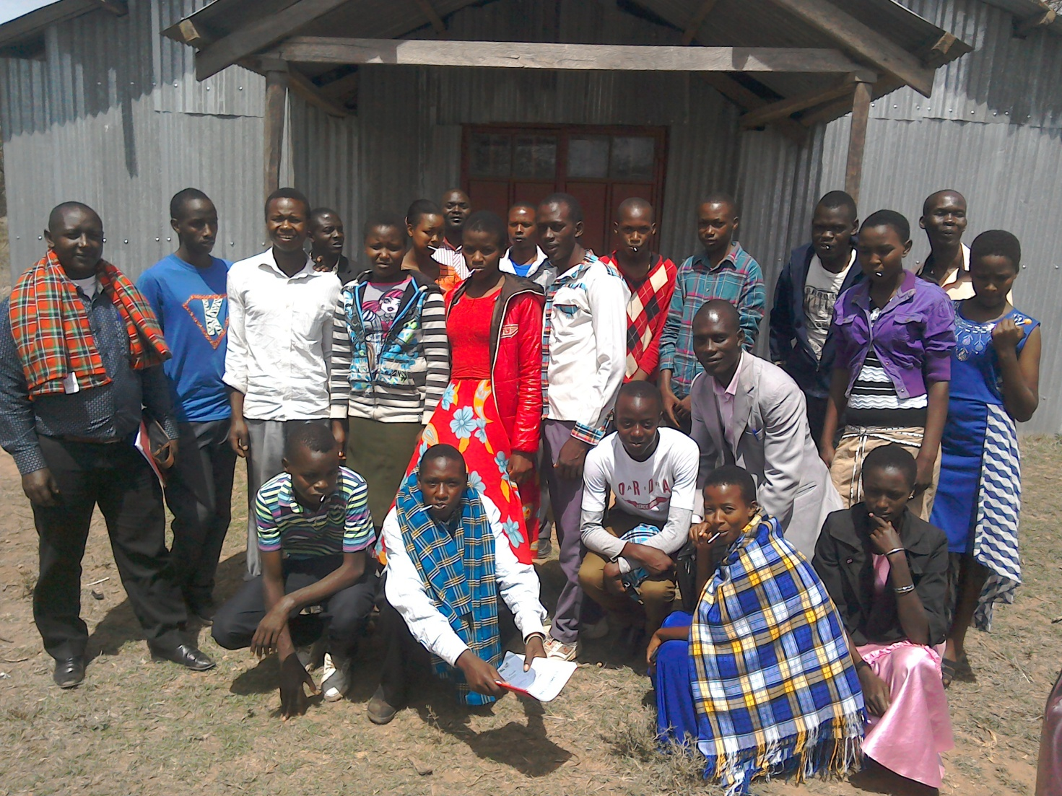
PHOTO ABOVE: THE YOUTH CAMPERS ON THE LAST DAY OF THE PFJM NATIONAL YOUTH CAMP 2016

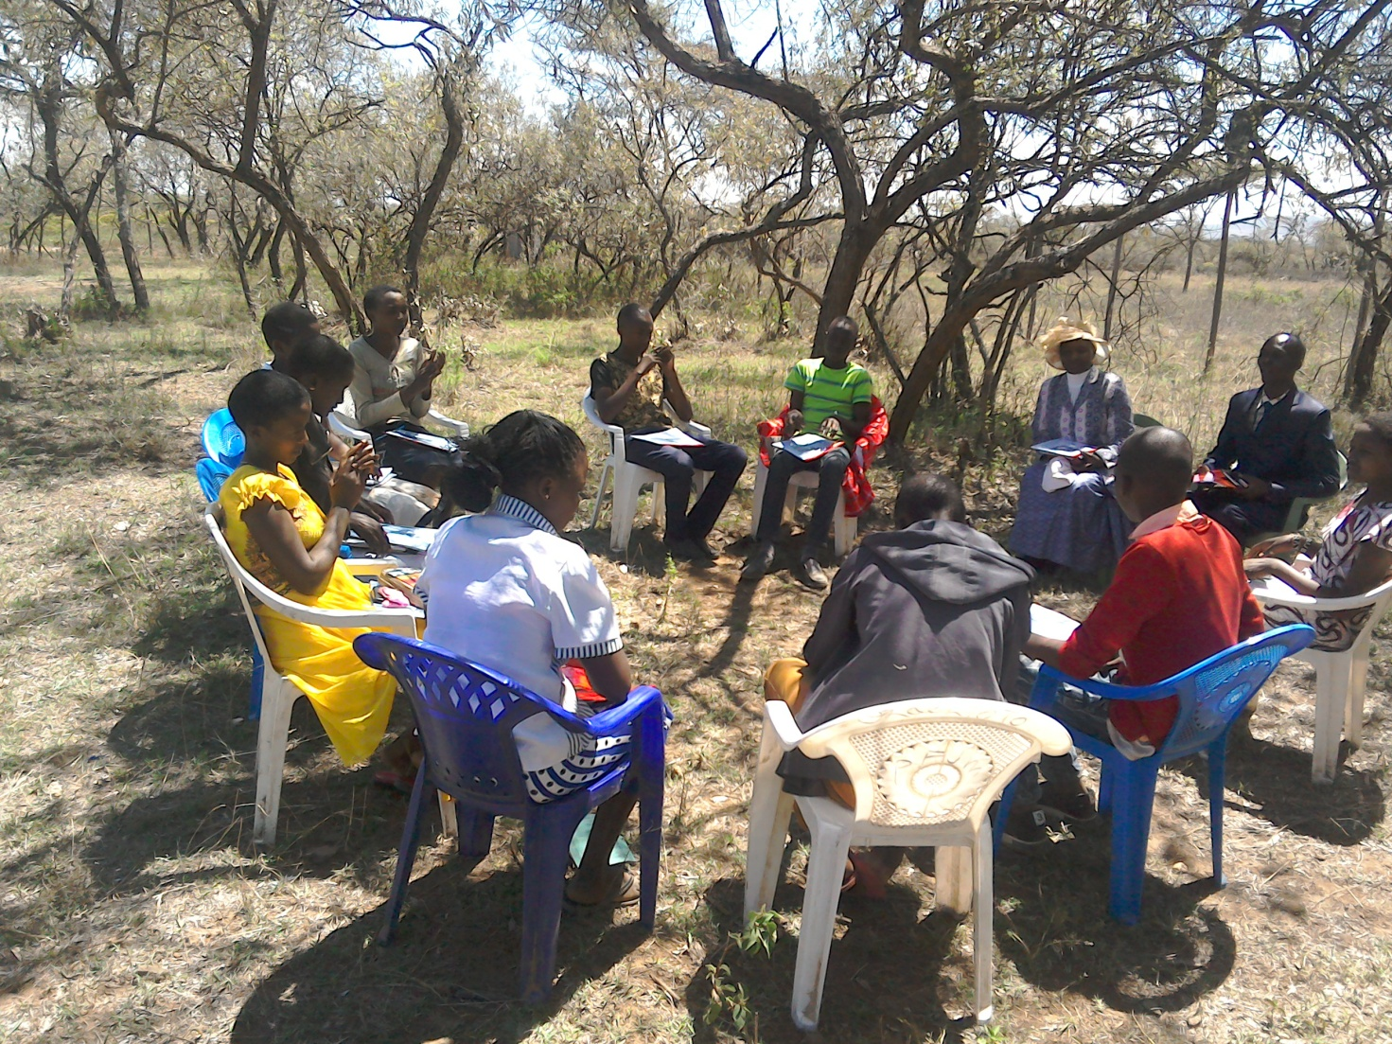
PHOTO ABOVE: TEENAGERS GROUP AT THE YOUTH CAMP 2016 HOLDING A GROUP DISCUSSION SESSION WITH THE DAY'S SPEAKER AND PASTOR JOHNSON.

SOME OF THE YEAR 2017 P.F.J.M PLANS

>>> Missions/Outreach Council: Church plants in Kenya at Eldoret and Ngong' in Kenya. Church plant in Pakistan in October 2017. Church planting survey in Liberia, and Uganda. Church plant visits in Kenya in Nyamkebe, Nyakach, Eldoret, Ongata Rongai, and Nairobi.
Mission trip and graduation of Bible class in PFJM Tanzania in August 2017. Gospel outreaches/evangelistic campaigns in Kenya.
>>> Adult/Literacy education classes among the Maasai community of Narok Kenya.
>>>Funds-drives for the Narok town Church purchase of land and building of Church Sanctuary.
>>> Supply computers and begin computer learning classes at PFJM Narok town Church.
>>> Education sponsorship programmes. Support programmes for poor and needy people/communities.
>>>Visit and support mobilization for disabled centres in Nairobi Kenya.
>>>Bible school establishment in Kenya.
>>>Children Vocational Bible School camp.
>>>Youth camp and quarterly youth rallies.
>>> Other Youth, women, children, programmes. End year celebration, Big meal celebration, etc.
>>> Annual General meeting in PFJM Narok town Church on 25th November 2017.

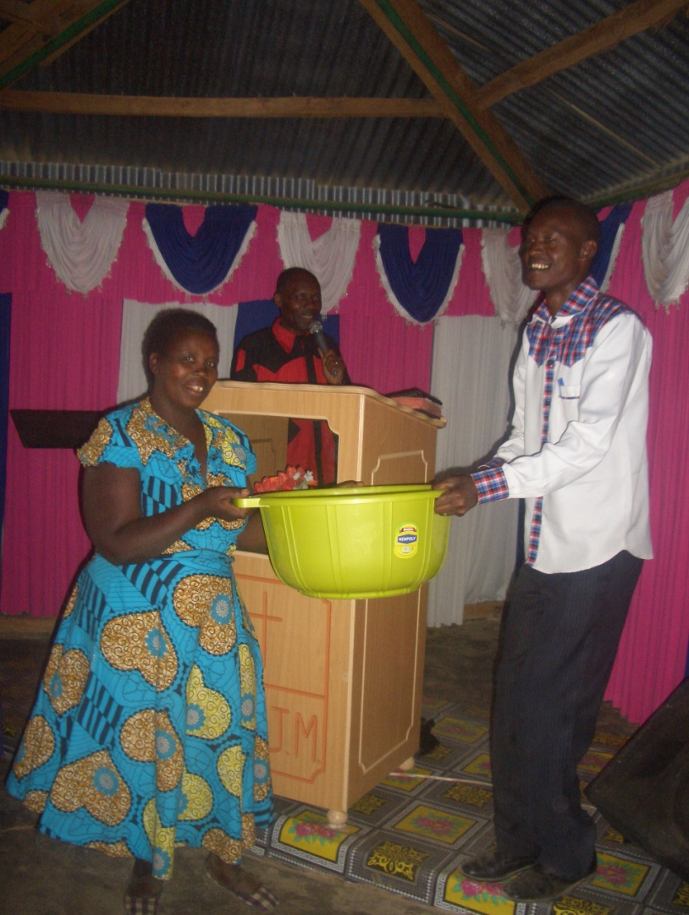
PHOTO ABOVE: A MAASAI WOMAN RECEIVES A GIFT FOR BEING THE 2ND BEST GIVER OF THE YEAR 2016 AT NAROK TOWN CHURCH. THAT WAS DONE AT OUR END YEAR 2016 THANKSGIVING CELEBRATION ON 17TH DECEMBER 2016.

BIG MEAL 2016:

WE WERE ABLE TO FEED NEEDY/POOR/ORPHAN CHILDREN ON DELICIOUS MEALS ON 25TH DECEMBER 2016 IN OUR ANNUAL EVENT DUBBED BIG MEAL. THIS YEAR 2016, WE HAD 350 CHILDREN FROM NAROK COUNTY WHICH INCLUDES NAROK TOWN CHURCH AND OLOOLTOTO CHURCH VENUES, 20 CHILDREN IN NAROBI COUNTY, 80 CHILDREN FROM KISUMU COUNTY (50 CHILDREN IN NYAKACH KENYA, 30 CHILDREN IN NYAMKEBE KENYA), AND 255 CHILDREN IN OUR TANZANIA CHURCHES OF MOROGORO AND DARESALAAM. WE TOOK CARE OF ABOUT 700 CHILDREN IN TOTAL IN BIG MEAL 2016. IT WAS A WONDERFUL TIME OF SINGING, POEMS, GOSPEL SHARING, AWARD GIVING FOR ALL KINDS OF CHILDREN IN DIFFERENT AREAS OF PARTICIPATION. WE CROWNED IT ALL WITH EATING DELICOIUS MEALS THAT THE CHILDREN COULD NOT FINISH. THEY ATE TO THE FULL AND STILL LEFT SOME FOOD. SOME OF THE CHILDREN CAME WITH THEIR PARENTS WHO ALSO ENJOYED BEING WITH THEIR CHILDREN.
I TRULY THANK THOSE WHO SUPPORTED THE BIG MEAL 2016.
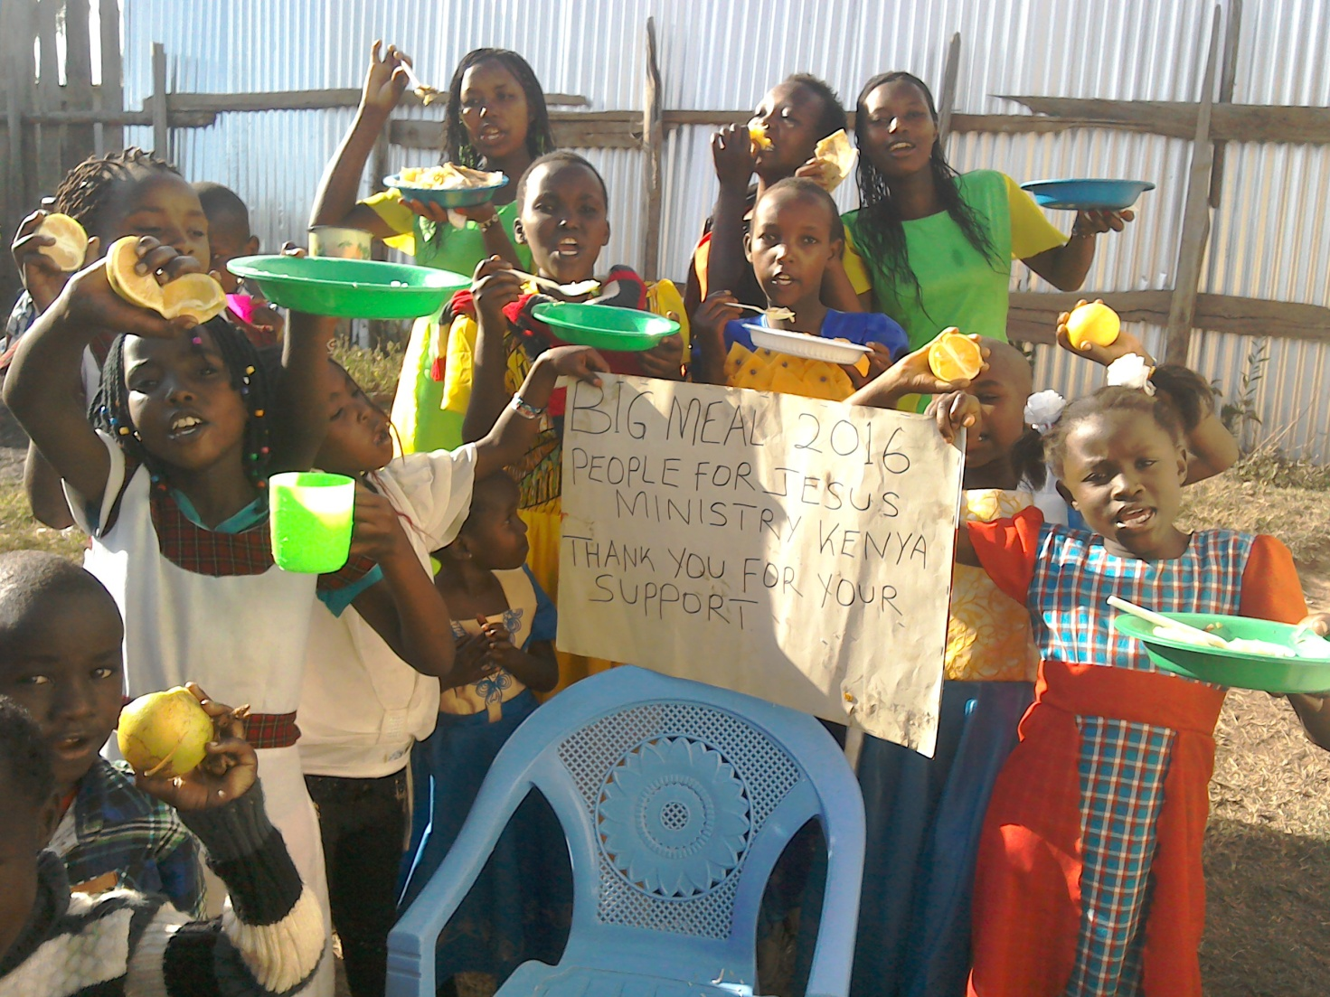
PHOTO ABOVE: PFJM BIG MEAL 2016 AT THE NAROK TOWN CHURCH ON 25TH DECEMBER 2016

WIDOWS AND THE POOR PEOPLE'S PROJECTS NEED YOUR SUPPORT
PFJM has established a self-help project called ''Cluster Dynamics'' which are designed to pull together groups of 5, 10 or 15 people from within a community group who are mutually in great need. The groups are tasked with developing a micro-project which will generate income for the group in order that they can support themselves and their families.
The groups mainly made up of destitute women, are poor for a number of reasons but mainly due to the tragedy of HIV/AIDS which affects each family in one way or another. Some suffer from the disease themselves, others as a result of losing their husband by HIV/AIDS. The result is that the remaining partner (usually wife and mother) is left to support a number of children. PFJM can help these groups get established by providing one time initial set up grant of £450, 900 and 1350 respectively, allowing them to get going with their project and bring in the much needed income that will grow the project and support the group and their dependants. PFJM will closely monitor the projects to ensure that they are profitable to the groups. You can invest in this worthy course that can profitably change lives of the poor widows and others for a life time. Currently, we have the groups of 5, 10 and 15 ready to move with any support that comes to them. ON 2ND JANUARY 2017, THE SECOND CLUSTER GROUP WILL BE SHARING AN ANNUAL PROFITS. PLEASE HELP THESE POOR PEOPLE TRANSFORM THEIR LIVES BY YOUR ONE TIME SUPPORT.

PRAYER/PRAISE ITEMS AND PLANS & HOW TO BE PART OF THIS WORK
The mission work we are involved in is too dynamic and enormous for us to do on our own. We surely appreciate your partnership by prayer, support, and personal involvement.

- Narok Town Headquarters Church Land Purchase and Church Building at a cost of United Kingdom Pounds £22,000 or US$35,000. We thank all who have thus far donated. We have identified a piece of land in Narok town which costs US$15,000. The land is not yet bought due to insufficient funds. We still need more funds.
- Monthly Pastor's Family Support of US$300 (rural areas) or US$480 (urban areas)
- Orphans and Destitute children monthly support £20 or US$35. This year we have many needy children in the programme awaiting support.
- Needy College/University Students support and High School Students support needed.
- New Church Planting Mission in Pakistan at Lahore . Pakistan pastor being trained by PFJM so that he takes over the work. Other Church plants in Africa e.g.. in Ngong', Kitale, Iretet Enaikishomi and Katolo in Kenya, Liberia, Uganda in Lira, etc.
- We need Church Sanctuary and Primary school buildings in Tanzania Church. School, orphanage, clinic and guest house Building proposals in Narok and in Kisumu areas in Kenya.
- Mission Emphasis Programmes and community development projects in Kenya going on throughout the year.
- PFJM Tanzania Church needs prayers: To be officially registered by the Tanzania government. Bible school graduation to be held in August 2017. That church needs to build a sanctuary.
- Pray for a mission/outreach trip to Tanzania Arusha in March 2017
- Pray for missions/outreach work scheduled for February 2017 in Iretet, April 2017 in Eldoret, Church plant survey in Liberia in November 2017, Tanzania outreach in August 2017 at Dar Esalaam and Morogoro.
- Annual missions/outreach emphasis months in June through to September 2017.
- Pray for the upcoming Crusade and Revival meeting in Narok County in April 2017..
- Pray for Church Annual General Meeting to be held on 25th November 2017.
- Thanks to God for the mission/outreach work that was done in Nyakach, Iretet, Dar Esalaam, Eldoret, Nairobi and Narok
- Pray for the Big Meal 2017 events for the needy children feeding and awards programme on Christmas Day. Also pray for the End of Year seminar and end year prayer vigil.

SPECIAL THANKS TO ALL OF YOU FOR YOUR PRAYERS, SUPPORT AND ACTUAL PERSONAL PARTICIPATION IN THE WORK THAT WE DO. YOU HAVE ENABLED US TO MEET EDUCATION, MATERIAL, PLUS OTHER NEEDS OF MAASAI COMMUNITIES IN NAROK AND AROUND THE NATION OF KENYA. YOU HAVE ALSO ENABLED US TO PREACH THE TRUE GOSPEL AS WE MAKE DISCIPLES OF CHRIST IN KENYA AND IN OTHER NATIONS.
BECAUSE OF YOUR PRAYERS AND SUPPORT, WE WERE ABLE TO SUCCEED IN THE YEAR 2016. WE ASK YOU TO KEEP ON STANDING WITH US FOR THE SAKE OF THE WORK OF GOD'S KINGDOM AND FOR MINISTERING TO POOR/NEEDY COMMUNITIES.

HAPPY NEW YEAR 2017. THE YEAR OF OVERCOMING OBSTACLES FOR DISTINGUISHED SERVICE.
GENESIS 50:15-21

WE CONTINUE TO TRULY VALUE YOUR PARTNERSHIP (PHILIPPIANS 1:5). THANK YOU!!!

