PEOPLE FOR JESUS MINISTRY,
P.O. BOX 1008,
Narok, 20500, KENYA,
EAST AFRICA
TEL: 254-721-204447 OR 254-736-574413
E-mail: peopleforjesusintmin@gmail.com

YOUR REF: ________ OUR REF: NRK/UP.4/2017 DATE: 31ST DECEMBER 2017

Dear Saints, Friends, well-wishers, and Partners,

GLORY TO THE LORD JESUS CHRIST!!! HAPPY NEW YEAR 2018!!!
We send warm new year greetings from the People For Jesus Ministry (PFJM) family. The Lord is surely faithful and His mercies endure forever. It is paradoxical that 12 months is gone and we are in a brand new year. God is good to us and we truly appreciate your partnership that has been an integral part of the ministry reaching this far. The whole Church has been engaged in many aspects of ministries and services locally, regionally and globally but we have just given a summary of what we have done in the last one year which is not exhaustive. The Church continues to work in communities with many poor orphans, the disabled, widows, pupils, prisons, students, and people at risk who need our support but we thank God that we are able to help some of them with your partnership in this work. It is our hope and earnest prayers that you are doing your very best in all your endeavours, especially in your service in the Kingdom of God and in different communities around the world.

OCTOBER 2017
PHOTO BELOW: SOME OF THE MAASAI CHURCH LEADERS AT NAROK OLOOLTOTO CHURCH RECEIVE THEIR NEW PASTOR JOHN KARANI (THIRD FROM RIGHT TO LEFT) ON 8TH OCTOBER 2017
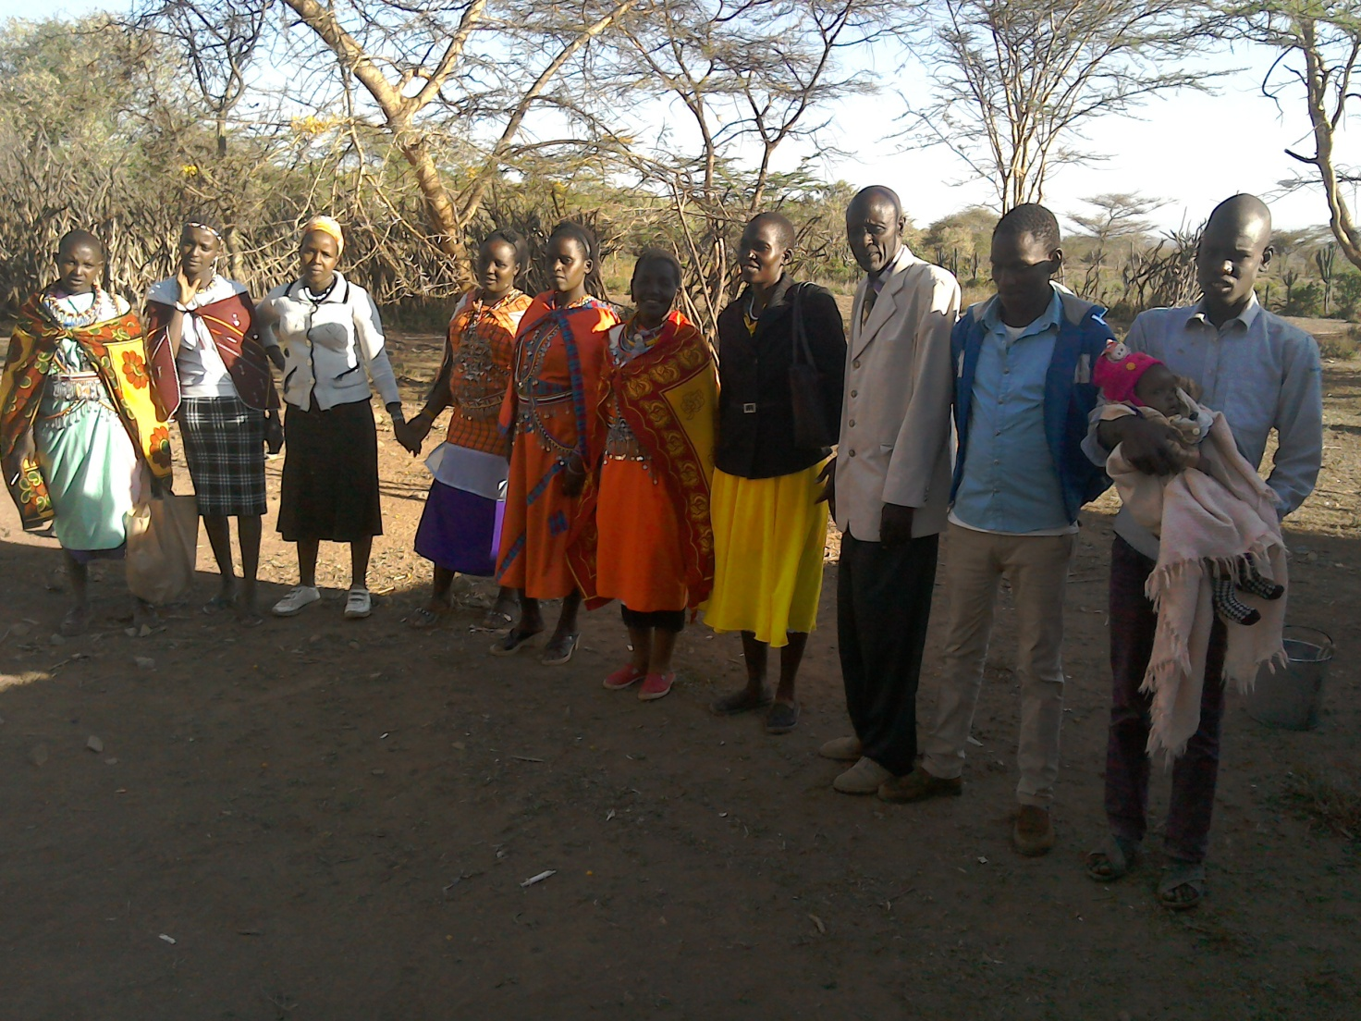

PEOPLE FOR JESUS MINISTRY MISSION/OUTREACH TEAM COUNCIL
People For Jesus Ministry has a mission team or Mission Council that plans and implements local, regional and international missions programmes. That includes crusades, church planting, prayers and intercessory prayers, community evangelistic Outreach programmes and projects. The team also mobilizes, recruits, sends and support long-term and short-term missionaries and teams to different parts of the world. The Mission Team also hosts volunteer missionaries from every part of the world. The Mission Council meets every month to pray, plan and implement Church missions and outreach programmes. Please contact us for details on how you can participate.
MISSIONS/OUTREACH COUNCIL RETREAT –19TH, 20TH AND 21ST OCTOBER 2017 AND KANDARIA SECONDARY SCHOOL UPDATES
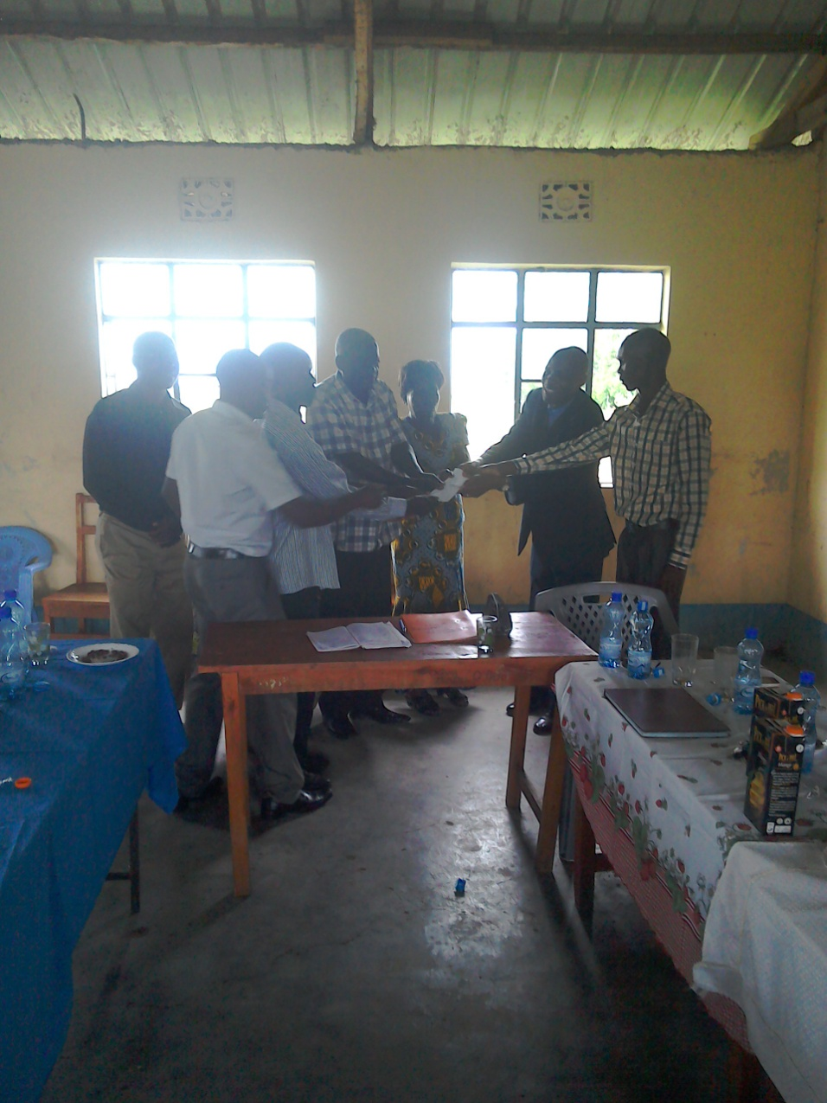
The PFJM Missions/outreach retreat was held in Ahero Evangelical School of Theology. During that time, the members of the council visited Kandaria Secondary school and conducted ground breaking ceremony for two classrooms and gave all the money for the project. They also gave success card wishes to the candidate class for the school. The council then embarked on a 2017 to 2018 planning programme of all missions and outreach plans of the Church. It was a great time.

PHOTO ABOVE: PASTOR TOM ISSUES KANDARIA SECONDARY SCHOOL PRINCIPAL , MADAM JANE, AND BOARD OF MANAGEMENT WITH A CHEQUE FOR THE CONSTRUCTION OF TWO EXTRA CLASSROOMS ON 19TH OCTOBER 2017
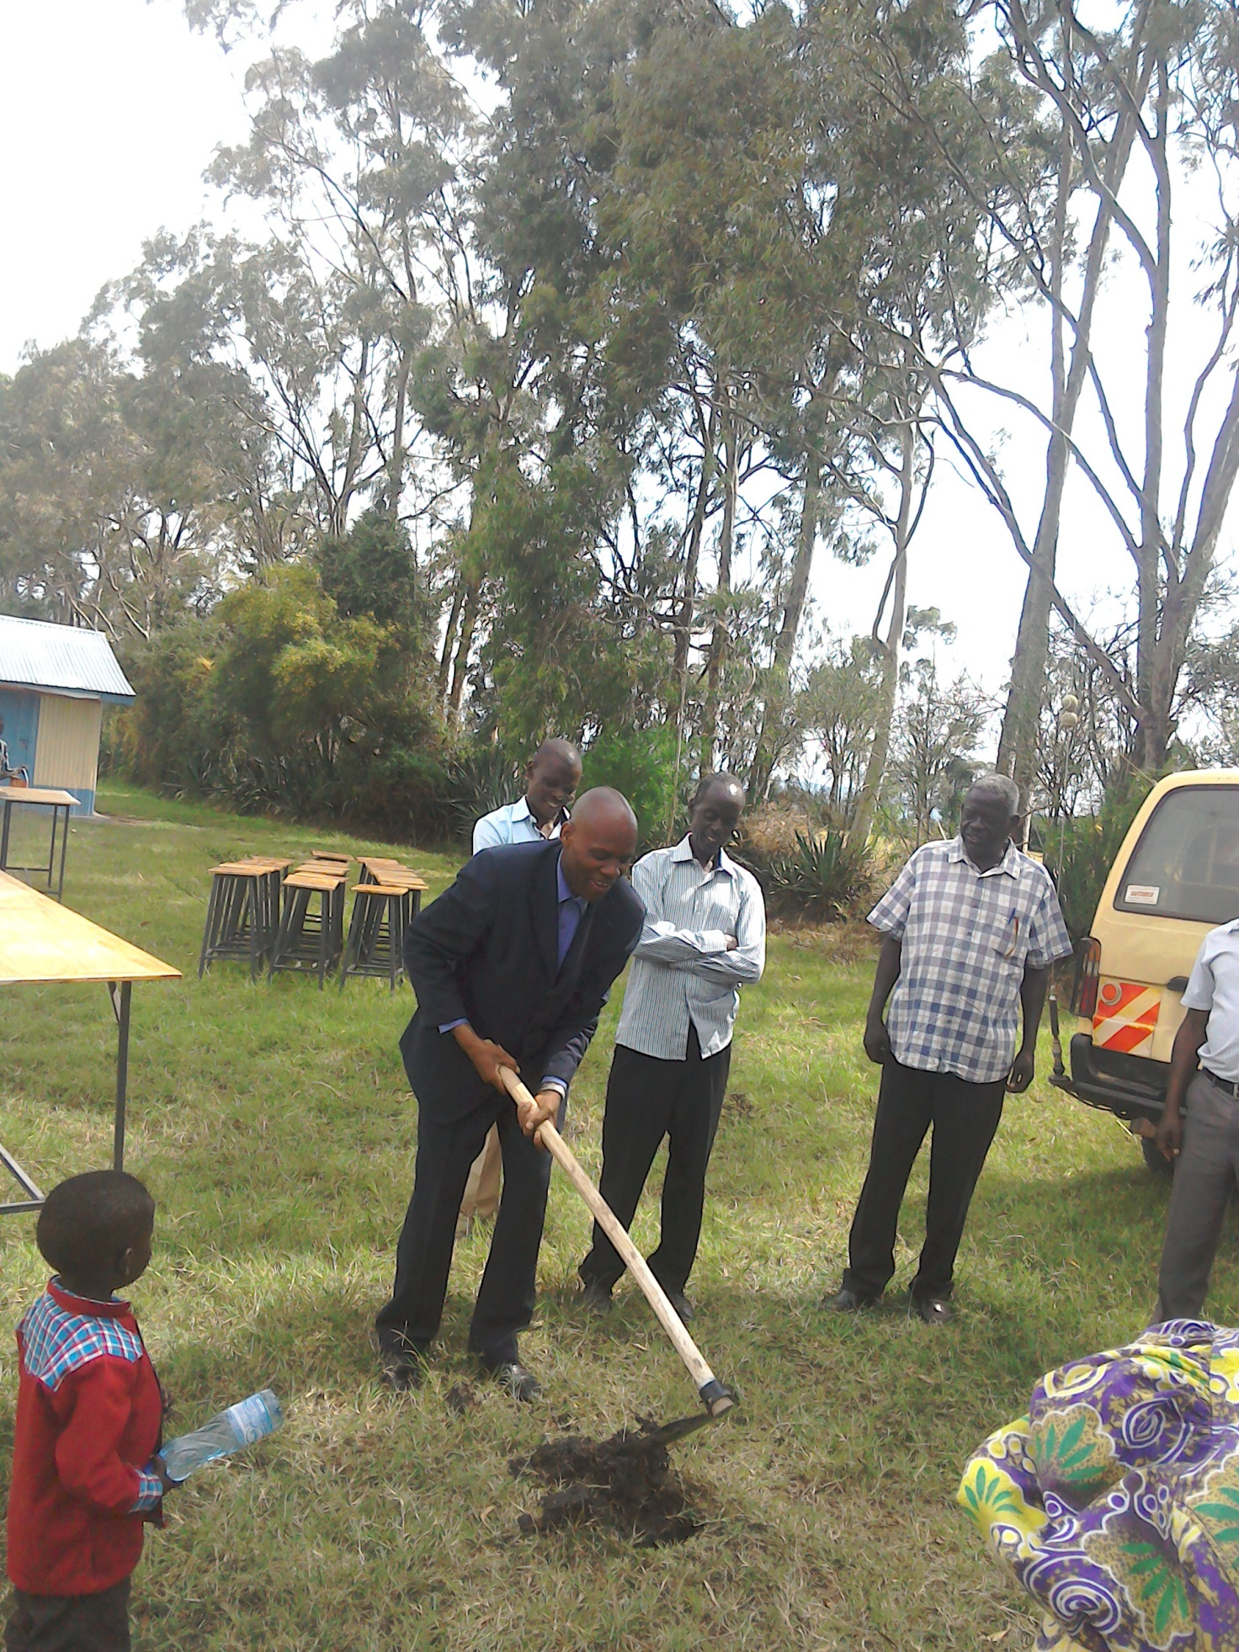
PHOTO ABOVE: PASTOR TOM CONDUCTING GROUND BREAKING CEREMONY FOR THE TWO EXTRA CLASSROOMS AT KANDARIA SECONDARY SCHOOL ON 19TH OCTOBER 2017. BABY JOSHUA HUGH LOOKS ON.
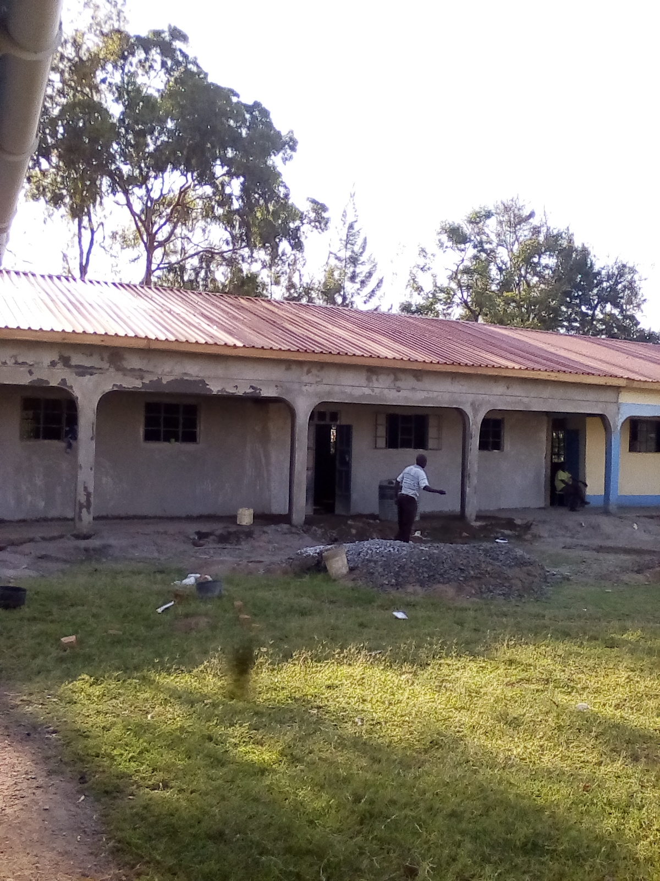
PHOTO ABOVE: THE TWO EXTRA CLASSROOMS OF KANDARIA SECONDARY SCHOOL ALMOST READY IN DECEMBER 2017

CHURCH DISABLE SUPPORT PROGRAMME
The Church has a disabled centre in Nairobi at Kayole known as Hekalu Disabled Support Centre. The PFJM Church and their partners support the disabled centre by giving wheel chairs, food, furniture, physiotherapy equipment, etc. The disabled centre is currently located within the PFJM Kayole Nairobi Church compound. The children are many. Brailes are needed for special reading and writing. Physiotherapy equipment and financial support is needed for the many needs of the disable children. The number of disabled children applicants who need help are increasing each day, but we cannot take in more since we do not have enough space and sufficient facilities for more than the number we currently assist.

PHOTO BELOW: STUDENTS TAKE LUNCH AT THEIR NEW KITCHEN AND FOOD STORE ON 19TH OCTOBER 2017 AT KANDARIA SECONDARY SCHOOL
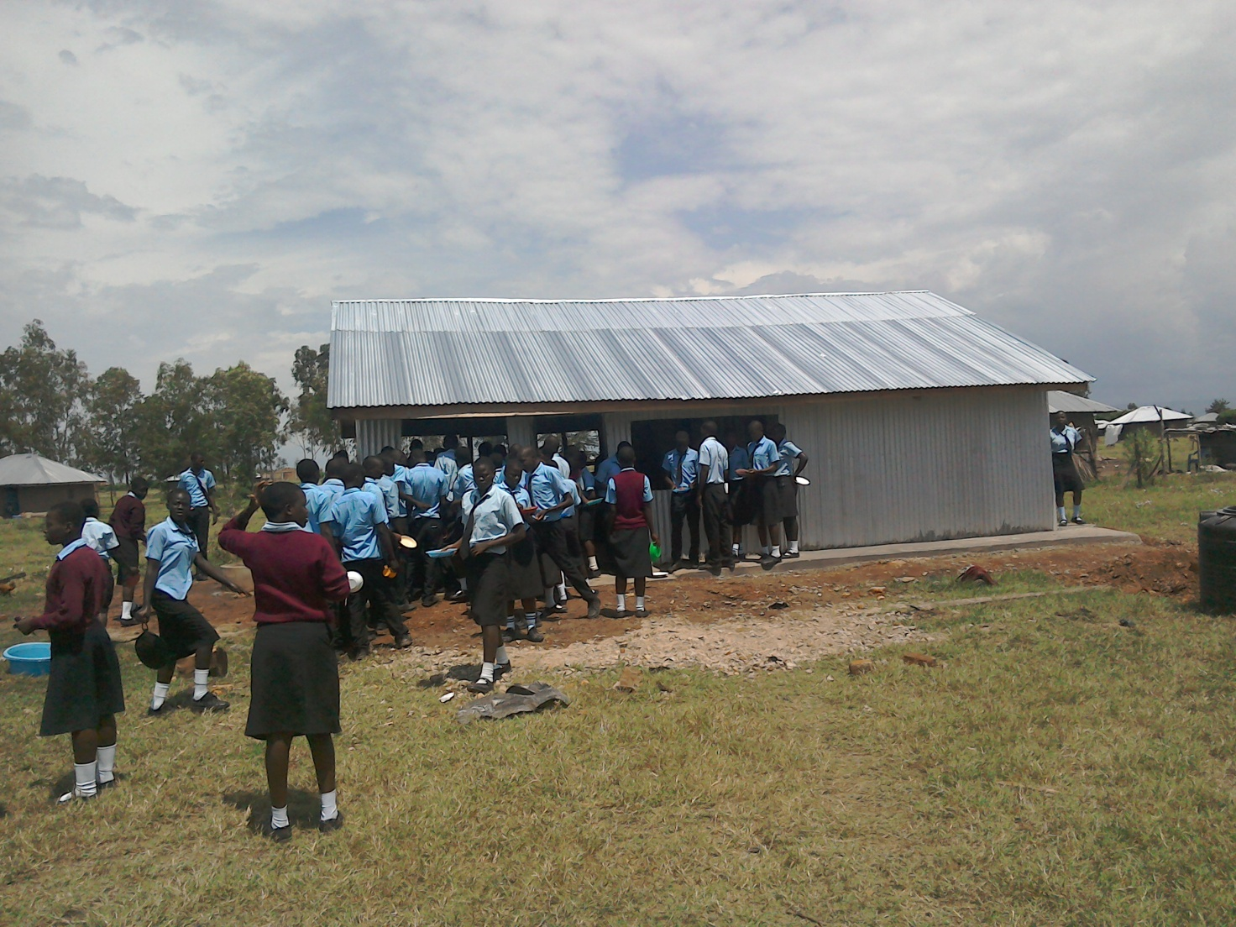

NAROK TOWN CHURCH LAND AND SANCTUARY
NAROK TOWN CHURCH IS STILL SEEKING FOR SUPPORT FOR THE PURCHASE OF LAND AND THE CONSTRUCTION OF A CHURCH SANCTUARY. PLEASE KEEP US IN PRAYERS SO THAT WE RAISE US$35,000 FOR THE CHURCH BUILDING PROJECT. CHURCH MEMBERS HERE IN NAROK KENYA CONTINUE TO CONDUCT SOME FUNDSDRIVES. THE VALUE OF LAND KEEPS RISING UP SO THE SOONER WE PURCHASE LAND THE BETTER. PLEASE JOIN US IN RAISING THE FUNDS. IF WE GET US$7000, WE CAN PAY THE REST OF THE MONEY SLOWLY FOR THE NEXT TWO YEARS. YOUR SUPPORT IS VALUABLE.

NOVEMBER 2017

FAMILY ISSUES: THE YOUNGEST SON TO PASTOR TOM, JOSHUA HUGH, WHO IS THREE YEARS AND TWO MONTHS OLD IS FINE. MY DAUGHTER DEBORAH OF 9 YEARS IS NOW IN PRIMARY 4 CLASS. PETER OF 12 YEARS OF AGE IS NOW A CANDIDATE IN PRIMARY SCHOOL AND JOINS SECONDARY SCHOOL IN THE YEAR 2019. MY HOUSE IN THE UPCOUNTRY VILLAGE IS NOT YET COMPLETE. WE NEED $20,000 TO COMPLETE THE CONSTRUCTION OF THE HOUSE. HELP IS SURELY NEEDED IN THAT ENDEAVOUR. EUNICE AND PASTOR TOM ARE BUSY AS USUAL WITH MISSIONS AND OUTREACH PROGRAMMES IN SERVICE TO THE LORD. THANKS FOR YOUR PRAYERS AND KEEP ON STANDING WITH US.

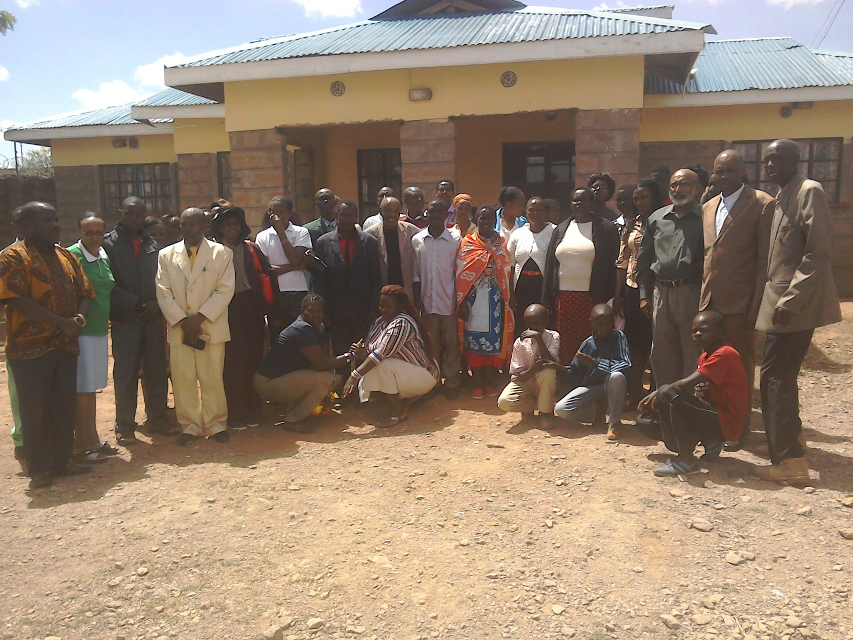
PHOTO ABOVE: PEOPLE FOR JESUS MINISTRY (PFJM) ANNUAL LEADERSHIP CONFERENCE PARTICIPANTS IN NOVEMBER 2017. BELOW: PART OF GROUP DISCUSSION DURING THE CONFERENCE IN NOVEMBER 2017
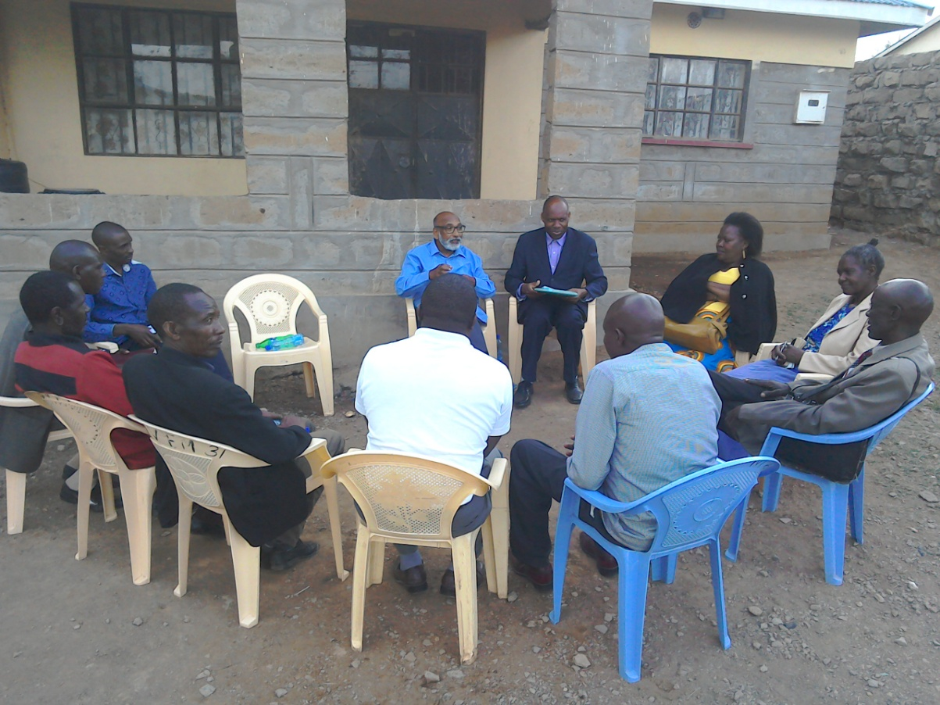

ORPHANS/VULNERABLE CHILDREN AND STUDENTS SUPPORT AND SPONSORSHIP:
The Church launched a serious 'school drop outs back to school' campaign programme in February 2014 as part of the Church sponsorship programme. The programme is targeting pupils/students who dropped out of school for various reasons especially among the Maasai communities in Narok county. We have thus far managed to support some pupils/students beneficiaries in the programme. Thanks to those who responded to our plea to help school drop outs plus those who have not been able to make it to school to go to school. We have not yet reached our target and many more children who need to go to school are increasing. YOU CAN GIVE AS LITTLE AS £15 PER MONTH OR £180 PER YEAR, US$25 PER MONTH OR US$300 PER YEAR TO ENABLE A STUDENT GO BACK TO GOVERNMENT DAY SECONDARY SCHOOL. About half of the funds is used for the purchase of school uniforms. You can also help a child go back to primary school by giving US$100 per year. THE CHILDREN/STUDENTS BEING SPONSORED ARE FINE AND DOING THEIR VERY BEST IN SCHOOL. WE THANK ALL SPONSORS HELPING THE ORPHANS AND VULNERABLE CHILDREN/STUDENTS.

ADULT/LITERACY EDUCATION:
THE MAASAI VILLAGE ADULT/LITERACY CLASS IS GOING ON. 85% OF THE CLASS ARE WOMEN AND GIRLS. THE PROBLEM OF EARLY MARRIAGES AMONG THE MAASAI GIRLS NECESSITATES THAT THEY DROP OUT OF SCHOOL OR NEVER MAKE IT TO SCHOOL SO THAT THEY GET MARRIED AND EARN THEIR FAMILY A WEALTH OF MANY COWS PAID AS DOWRY. THE CHURCH IS ADDRESSING THAT EDUCATION GAP BY CONDUCTING CLASSES FOR THOSE WHO HAVE EITHER DROPPED OUT OF SCHOOL OR THOSE WHO NEVER MADE IT TO ANY SCHOOL. THANKS TO THOSE WHO HAVE BEEN ABLE TO SUPPORT US. PLEASE JOIN US IN THIS ENDEAVOUR AT USD$70 PER MONTH PER CLASS. CURRENTLY, DROUGHT HAS BEEN DISRUPTING OUR CLASSES SINCE THE MAASAI COMMUNITY ARE BASICALLY PASTORALISTS AND THEY HAVE TO LOOK FOR PASTURE AND WATER FOR THEIR LIVESTOCK. THE CLASSES WILL SOON RESUME. WE HAVE INTERGRATED CLASSES WITH INCOME GENERATING ACTIVITY TO ENABLE ADULTS EARN A LIVING AS THEY LEARN. WE CALL IT 'FEED BOTH THE MIND AND THE BODY'.
TANZANIA CHURCH UPDATES
The Church in Dar Esalaam is doing well and there is a new leader. Our Tanzania Overseer, Pastor Samuel Mbanga, runs the Church School of Ministry at Morogoro province and also leads the Morogoro churches and Dar Esaalam Church. We have four local Churches in Morogoro and one local Church at Dar Esalaam. The Church runs a nursery school in Morogoro and in Dar Esalaam.
Keep us in prayers as Kenya missions/outreach team plans to travel there in August 2018. We need to build the Church sanctuaries and to build the School of Ministry and the nursery/primary schools in Dar Esalaam and Morogoro.

PHOTO BELOW: PASTOR TOM AND DR. ABRAHAM PHILIP, GUEST SPEAKER, SPEAKING DURING PFJM ANNUAL CONFERENCE IN NOVEMBER 2017. THE CONFERENCE HAD AN ASPECT OF FREE MEDICAL TREATMENT TO WOMEN. WE THANK DR. RACHEL VARGASE FOR PREACHING AND COMPASSIONATELY TREATING MORE THAN 100 WOMEN DURING THE CONFERENCE IN NAROK KENYA AMONG THE MAASAI COMMUNITY.

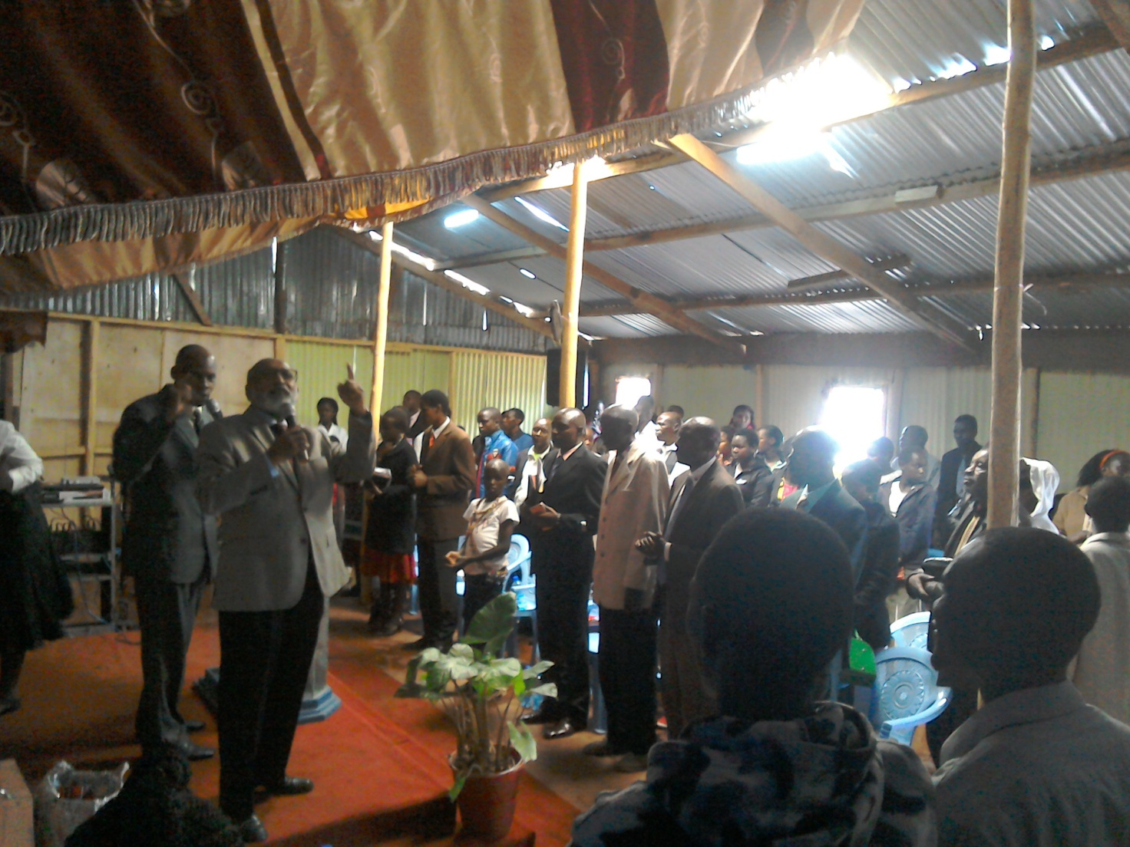

DECEMBER 2017

SOME OF THE YEAR 2018 P.F.J.M PLANS

>>> Missions/Outreach Council: Church plants in Kenya at Mount Elgon and Narok, and Oyugis in Kenya. Church plant in Pakistan in October 2018. Church planting survey in Liberia, and Uganda. Church plant visits in Kenya in Nyamkebe, Nyakach, and Nairobi. Mission trip to Kampala Uganda in March 2018.
Mission trip and graduation of Bible class in PFJM Tanzania in August 2018. Gospel outreaches/evangelistic campaigns in Kenya.
>>> Adult/Literacy education classes among the Maasai community of Narok Kenya.
>>>Funds-drives for the Narok town Church purchase of land and building of Church Sanctuary.
>>> Supply computers and begin computer learning classes at PFJM Narok town Church.
>>> Education sponsorship programmes. Support programmes for poor and needy people/communities.
>>>Visit and support mobilization for disabled centres in Nairobi Kenya.
>>>Bible school establishment in Kenya.
>>>Children Vocational Bible School camp.
>>>Youth camp and quarterly youth rallies.
>>> Other Youth, women, children, programmes. End year celebration, Big meal celebration, etc.
>>> Annual PFJM National leadership conference on 21st – 23rd November 2018. National Church Leadership Empowerment Conference at Narok.

>>>>> Annual General meeting in PFJM Narok town Church on 24th November 2018----Annual Church Strategic planning meetings and Evaluation (Annual General Meeting).

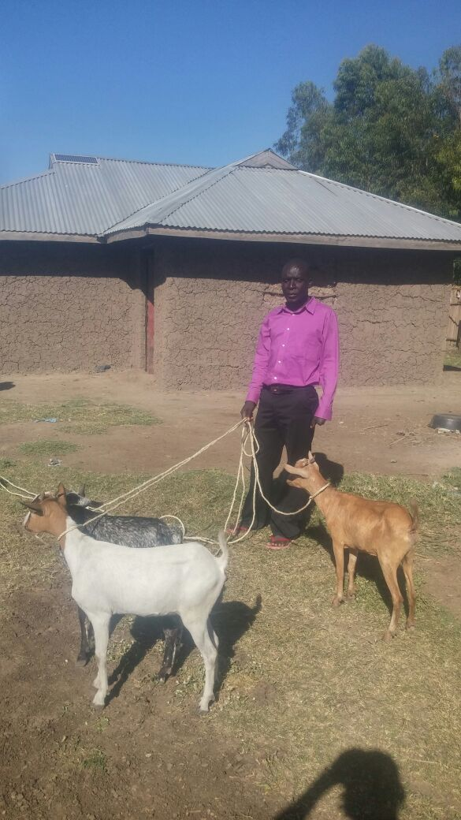

PHOTO ABOVE: JOSEPH OF KANDARIA VILLAGE IN KENYA WHO RECEIVED GIFTS OF GOATS FROM WELL WISHERS AS A CHRISTMAS 2017 SURPRISE ON THE EVE OF CHRISTMAS. HE LOST FOUR OF HIS LEFT HAND FINGERS IN OCTOBER 2017 AND IS NOW PARTLY DISABLED. LOTS OF TEARS OF JOY FLOWED FROM HIS EYES AND HE IS TRULY THANKFUL TO THE PERSON WHO GAVE HIM SUCH A GREAT SUPPORT. HE ALSO RECEIVED SOME FINANCIAL SUPPORT.
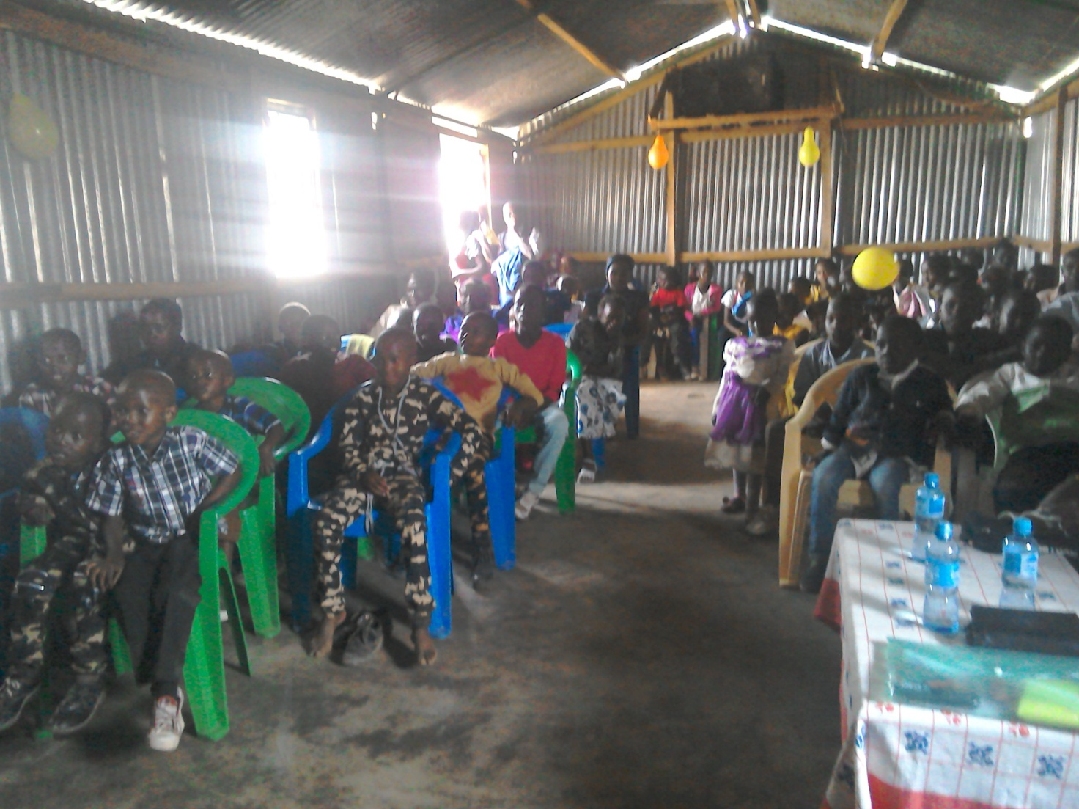
PHOTO ABOVE: PART OF CHILDREN SITTING IN CHURCH AT NAROK TOWN CHURCH BEFORE ENJOYING BIG MEAL 2017 ON 25TH DECEMBER 2017.

BIG MEAL 2017 REPORT
We held the annual Big Meal celebration event with children in Tanzania at Morogoro and Dar Esaalam Churches. Tanzania had about 300 children in total. In Kenya, the Big meal events were held at Nyamkebe Kisumu church, Olooltoto Narok Church, Iretet Narok Church and at Narok town Church main sanctuary. Nymkebe Church had 20 children and 7 adults. Olooltoto Church had 350 children and 100 adults. Iretet Narok Church had 172 children and 20 adults. Narok town Church had 170 children and 50 adults. We take the special opportunity to thank all who gave us the opportunity to enjoy Big Meal with needy children through the support you gave us. About 1012 had the Big meal 2017 delicious meals celebration on Christmas day through People For Jesus Ministry programmes. There was preaching done and gifts also given to many children as awards for various talents. The Church and communities that were served are very happy. May God bless you.

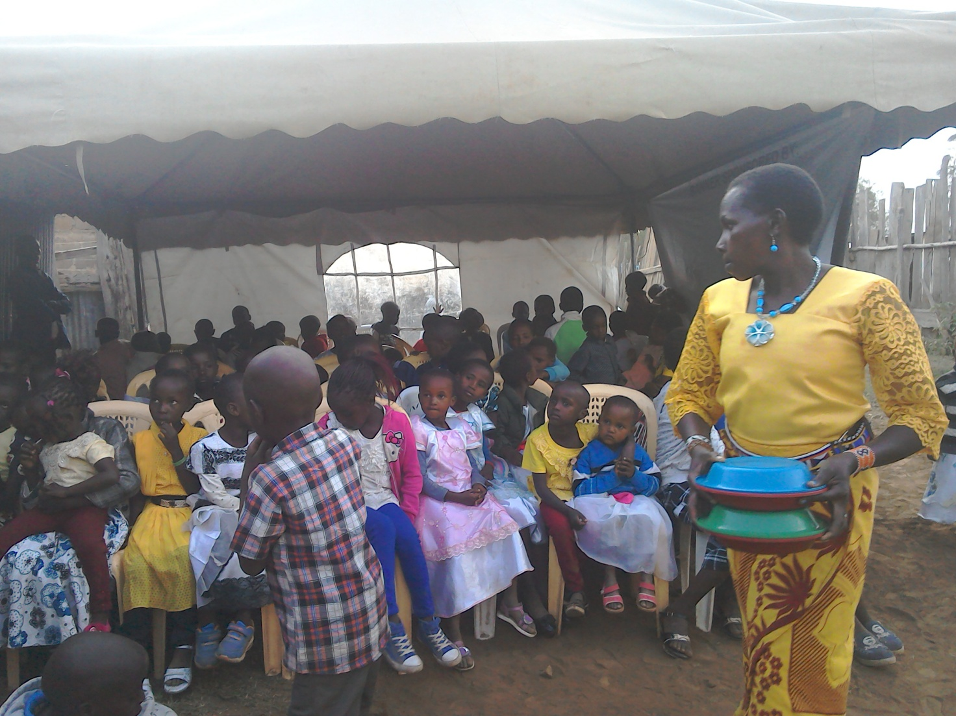
PHOTO ABOVE: CHILDREN IN THE OUTSIDE TENT AT NAROK TOWN CHURCH GETTING READY TO RECEIVE BIG MEAL 2017 DELICIOUS MEALS .

WIDOWS AND THE POOR PEOPLE'S PROJECTS NEED YOUR SUPPORT
PFJM has established a self-help project called ''Cluster Dynamics'' which are designed to pull together groups of 5, 10 or 15 people from within a community group who are mutually in great need. The groups are tasked with developing a micro-project which will generate income for the group in order that they can support themselves and their families.
The groups mainly made up of destitute women, are poor for a number of reasons but mainly due to the tragedy of HIV/AIDS which affects each family in one way or another. Some suffer from the disease themselves, others as a result of losing their husband by HIV/AIDS. The result is that the remaining partner (usually wife and mother) is left to support a number of children. PFJM can help these groups get established by providing one time initial set up grant of £500, 1000 and 1500 respectively, allowing them to get going with their project and bring in the much needed income that will grow the project and support the group and their dependants. PFJM will closely monitor the projects to ensure that they are profitable to the groups. You can invest in this worthy course that can profitably change lives of the poor widows and others for a life time. Currently, we have the groups of 5, 10 and 15 ready to move with any support that comes to them. ON 3RD JANUARY 2018, THE THIRDD CLUSTER GROUP SHARED THEIR ANNUAL PROFITS. PLEASE HELP THESE POOR PEOPLE TRANSFORM THEIR LIVES BY YOUR ONE TIME SUPPORT.

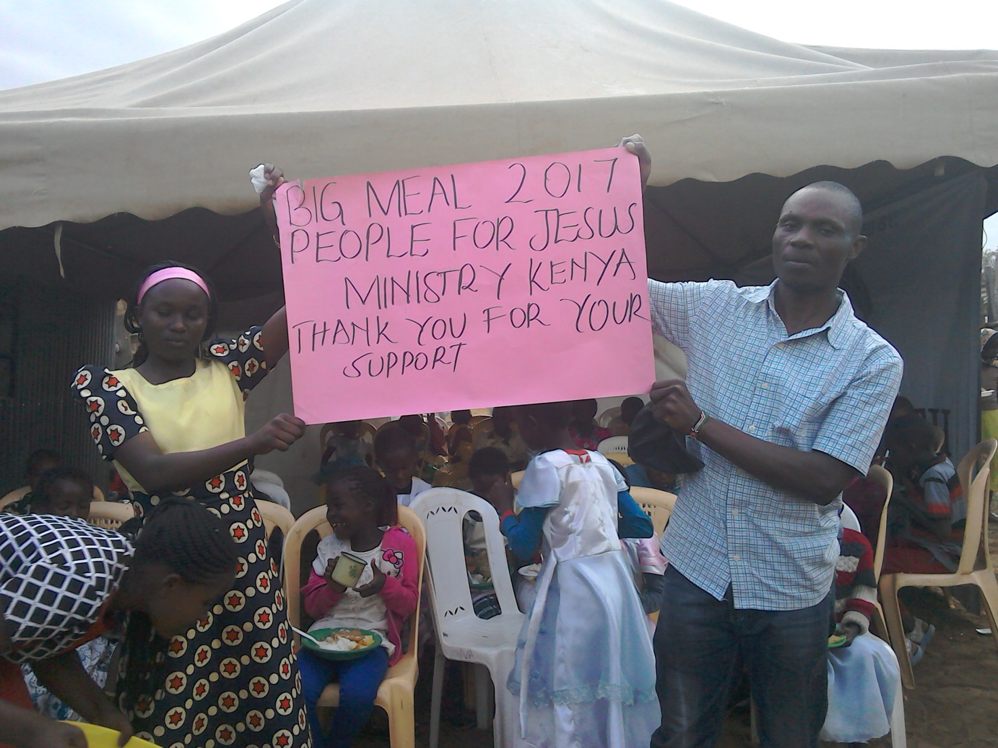
PHOTO ABOVE: BIG MEAL 2017 AT NAROK KENYA ON 25TH DECEMBER 2017

PRAYER/PRAISE ITEMS AND PLANS & HOW TO BE PART OF THIS WORK
The mission work we are involved in is too dynamic and enormous for us to do on our own. We surely appreciate your partnership by prayer, support, and personal involvement.

- Narok Town Headquarters Church Land Purchase and Church Building at a cost of United Kingdom Pounds £22,000 or US$35,000. We thank all who have thus far donated. We have identified a piece of land in Narok town which costs US$15,000. The land is not yet bought due to insufficient funds. We need to have US$7000 to pay deposit for land then we pay the rest for the next two years.
- Monthly Pastor's Family Support of US$300 (rural areas) or US$480 (urban areas)
- Orphans and Destitute children monthly support £20 or US$35. This year we have many needy children in the programme awaiting support.
- Needy College/University Students support and High School Students support needed.
- New Church Planting Mission in Pakistan at Lahore . Pakistan pastor being trained by PFJM so that he takes over the work. Other Church plants in Africa e.g.. in Ngong', Kitale, Mumias, Mt. Elgon, Narok Olopito, Katolo in Kenya, Liberia, Uganda in Lira, etc.
- We need Church Sanctuary and Primary school buildings in Tanzania Church. School, orphanage, clinic and guest house Building proposals in Narok and in Kisumu areas in Kenya.
- Mission Emphasis Programmes and community development projects in Kenya going on throughout the year. Africa Pastors Fellowship will launch a Bible reading app in Kampala Uganda in March 2018 in which People For Jesus Ministry will be participating.
- PFJM Tanzania Church needs prayers: To be officially registered by the Tanzania government. Bible school graduation to be held in August 2018. That church needs to build a sanctuary in five different places we have Church plants.
- Thank God for a successful leadership conference held in Narok town on 20th to 26th November 2017. Thanks to Dr. Abraham Philip and Dr. Rachel fher medical doctor sister for playing a key role in ensuring that the conference was a success because they were the key speakers and Dr. Rachel treated many women.
- Pray for missions/outreach work in the earlier part of the year at Mt. Elgon and in other places, Church plant survey in Liberia in November 2018, Tanzania outreach in August 2018 at Dar Esalaam and Morogoro.
- Annual missions/outreach emphasis months in June through to October 2018.
- Thanks to God for many outreach activities that took place in Narok and other parts of Kenya in April 2018.
- Pray for the Church missions/outreach retreat to be held on 1^{st ,} 2nd and 3rd November 2018
- Pray for Church Annual General Meeting to be held on 24th November 2018. Pray for Church Annual National Church Leaders conference for 21st to 23rd November 2018.
- Pray for the Big Meal 2018 events for the needy children feeding and awards programme on Christmas Day. Also pray for the End of Year seminar and end year prayer vigil.

SPECIAL THANKS TO ALL OF YOU FOR YOUR PRAYERS, SUPPORT AND ACTUAL PERSONAL PARTICIPATION IN THE WORK THAT WE DO. BECAUSE OF YOUR PARTNERSHIP, WE ARE ABLE TO MEET EDUCATION AND MATERIAL NEEDS OF MAASAI COMMUNITIES IN NAROK AND AROUND THE NATION OF KENYA, BESIDES SERVING OTHER PEOPLE. YOU HAVE ALSO ENABLED US TO PREACH THE TRUE GOSPEL AS WE MAKE DISCIPLES OF CHRIST IN KENYA AND IN OTHER NATIONS.
WE ASK YOU TO KEEP ON STANDING WITH US FOR THE SAKE OF THE WORK OF GOD'S KINGDOM AND FOR MINISTERING TO POOR/NEEDY COMMUNITIES.

THE YEAR 2018: THE THEME OF THE YEAR IS; ENLARGE YOUR TENT….STRENGTHEN YOUR STAKES.
ISAIAH 54:2

YOUR PARTNERSHIP IS GREATLY VALUED (PHILIPPIANS 1:5). THANK YOU!!!

